ANNUAL PROGRESS REPORT
(January 2024 to December 2024)

KRISHI VIGYAN KENDRA
RAYAGADA
ODISHA

 | Odisha University of Agriculture & Technology  Bhubaneswar -751003  Odisha

ANNUAL REPORT 2024 (January-December 2024)

1. GENERAL INFORMATION ABOUT THE KVK

1.1. Name and address of KVK with phone, fax and e-mail

Address | Telephone |  | E mail
 | Office | FAX
Krishi Vigyan Kendra  AT/PO- Gunupur  Dist.: Rayagada (Odisha)  Pin – 765022 | 06857 -250255 | 06857 -250255 | kvk.rayagada@ouat.ac.in  kvkrayagada.ouat@gmail.com

1.2 .Name and address of host organization with phone, fax and e-mail

Address | Telephone |  | E mail
Address | Office | FAX
Directorate of Extension Education  Odisha University of Agriculture and Technology  Bhubaneswar – 751003  State-Odisha | 0674- 2397362 | 0674-2397933 | dee@ouat.ac.in  deanextensionouat@yahoo.com  deanextension_ouat@rediffmail.com

1.3. Name of Senior Scientist and Head with phone & mobile No.

Name | Telephone / Contact
 | Residence | Mobile | Email
Dr. (Mrs.) Susmita Mohanty | Bebarta Sahi  At/PO- Gunupur  District- Rayagada | 9937789325 | susmitamohant46@gmail.com

1.4. Year of sanction of KVK: March 2005

1.5. Staff Position (as on 1st January, 2024)

Sl.  No. | Sanctioned post | Name of the incumbent | Designation | Discipline | Pay  Scale with present basic | Date of joining | Permanent/Temporary | Category (SC/ST/  OBC/  Others)
1 | Senior Scientist& Head | Dr. (Mrs.) Susmita Mohanty | Senior Scientist& Head | Home Science | Basic 166400 | 07.07.2023(F.N) | Permanent | Others
2 | Subject Matter  Specialist | Mr. Rajib Tudu | SMS | Plant Protection | Basic: 65000 | 15.11.2018 (F.N) | Permanent | ST
3 | Subject Matter  Specialist | Dr. Naram Ramu | SMS | Agronomy | Basic: 65000 | 15.07.2023 (F.N) | Permanent | Others
4 | Subject Matter  Specialist | Mrs. Madhumita Sarangi | Scientist | Home Science | Basic: 68800 | 31.05.2021 (FN) | Permanent | Others
5 | Subject Matter  Specialist | Vacant
6 | Subject Matter  Specialist | Vacant
7 | Subject Matter  Specialist | Vacant
8 | Programme Assistant | Mr. Parimal Tarai | Programme Assistant | Seed Science and Technology | Basic: 44900 | 1.01.2016 (FN) | Permanent | SC
9 | Computer  Programmer | Mrs. Sumitra Mohanty | Programme Assistant (Computer) | Computer Application | Basic:60400 | 19.01.2006(FN) | Permanent | Others
10 | Farm Manager | Vacant
11 | Accountant / Superintendent | Vacant
12 | Stenographer | Mrs. Gitanjali Das | Junior Steno-cum-Computer Operator | Arts and Stenography | Basic:28700 | 19.03.2019 (FN) | Permanent | SC
13. | Driver | Mr. Jagannath Pradhan | Driver-cum-Mechanic | Arts | Basic: 27600 | 21.07.2015 (FN) | Permanent | ST
14. | Driver | Mr.Gopinath Kuanr | Driver-cum-Mechanic | Arts | Basic: 27600 | 04.06.2021 (FN) | Permanent | SC
15. | Supporting staff | Mr. Gajendra Pradhan | Peon-cum-Watchman | - | Basic:22200 | 04.08.2022 (FN) | Permanent | OBC
16. | Supporting staff | Vacant

1.6. Total land with KVK (in ha) :

S. No. | Item | Area (ha)
1 | Under Buildings | 1.7
2. | Under Demonstration Units | 0.5
3. | Under Crops | 6.3
4. | Orchard/Agro-forestry | 2.5
5. | Others with details | 1.5
 | Total | 12.5 ha
Total area should be matched with breakup

1.7. Infrastructure Development:

A) Buildings and others

S. No. | Name of infrastructure | Not yet started | Completed up to plinth level | Completed up to lintel level | Completed up to roof level | Totally completed | Plinth area (sq.m) | Under use or not* | Source of funding
1. | Administrative  Building |  |  |  |  | Totally completed on 2008 |  | Under use (needs to be renovated) | ICAR
2. | Farmers Hostel |  |  |  |  | Totally completed on 2011 |  | Under use (needs to be renovated) | RKVY
3. | Staff Quarters (6) | Not yet started
4. | Piggery unit | Not yet started
5 | Fencing |  |  |  |  | Not completed |  |  | RKVY
6 | Rain Water harvesting structure | Not yet started
7 | Threshing floor |  |  |  |  | Totally completed |  | Under use | ICAR
8 | Farm godown | Not yet started
9. | Dairy unit | Not yet started
10. | Poultry unit |  |  |  |  | Completed on 2010 |  | Under use (needs to be renovated) | RKVY
11. | Goatary unit | Not yet started
12. | Mushroom Lab |  |  |  |  | Totally completed |  | Under use | RKVY
13. | Mushroom production unit | Not yet started
14. | Shade house |  |  |  |  | Totally completed |  | Under use | RKVY
15. | Soil test Lab | Not yet started
16 | Others, Please Specify

* If not in use then since when and reason for non-use

B) Vehicles

Type of vehicle | Year of purchase | Cost (Rs.) | Total km. Run | Present status
Tractor | 2023 | 750000 | 482 hr. | Functioning
Renault Triber | 2021 | 800000 | 43348 km | Functioning
Two wheeler : Passion Pro | 2010 | 52600 | 16665 km | Functioning

C) Equipment & AV aids

Name of equipment | Year of purchase | Cost (Rs.) | Present status | Source of fund
a. Lab equipment
Equipment’s of soil lab | 2017 | 1700000 | Not started | ICAR
Mushroom Spawn Unit | 2010 | 250000 | Working | RKVY
b. Farm machinery
Power Tiller | 2017 | 193000 | Working | ICAR
Tractor | 2022 | 750000 | Working | ICAR
c. AV Aids
Laptop | 2018 | 49500 | Working | ICAR
Desktop Computer | 2018 | 49500 | Working | ICAR
LED TV | 2017 | 38691 | Working | ICAR
LED Projector | 2017 | 22000 | Working | ICAR
Display Board | 2017 | 8000 | Working | ICAR
White Board | 2017 | 4800 | Working | ICAR
Desktop Computer | 2021 | 40000 | Working | ICAR
Projector | 2022 | 68930 | Working | ICAR
Camera | 2022 | 35000 | Working | ICAR
Printer (EPSON) | 2022 | 37862 | Working | ICAR
LCD (BenQ motorized) projector screen | 2023 | 12176 | Working | ICAR
Printer (Brother) | 2023 | 12500 | Working | ICAR

D) Farm implements

Name of equipment | Year of purchase | Cost (Rs.) | Present status | Source of fund
Pump set | 2017 | 24525 | Working | ICAR
Self-propelled Rice Transplanter | 2017 | 194291 | Working | ICAR
MB Plough | 2017 | 25000 | Working | ICAR
Disc Plough | 2017 | 25000 | Working | ICAR
Cultivator | 2016 | 22000 | Working | ICAR
Leveller | 2017 | 11000 | Working | ICAR
Brush cutter | 2017 | 24150 | Working | ICAR
Digger | 2024 | 10992 | Working | ICAR
Chain Saw | 2024 | 5999 | Working | ICAR
Foot Sprayer | 2024 | 19500 | Working | ICAR

1.8. Details of SAC meeting* conducted in the year

Sl. No. | Date | Number of Participants | Salient Recommendations | Action taken | If not conducted, state reason
1. | 16.02.2024 | 31 | Organic management as well as ITK practices may be tested in addition to chemical one for FLDs and OFTs of Plant Protection discipline. | - Brinjal plot with organic management of disease pest has been trialed in crop cafetaria at KVK campus.  - Assessment of management of wilt complex in tomato by using Jivamrita and Bijamrita is continuing in 7 locations covering 3 villages (Rupapadar, Ghanatri, Gugurpang).  - No. of trainings conducted (Disease pest management using broad spectrum botanicals) – 3  No. of Villages covered -5  Nos. of farmers and farm women covered-82 | -
1. | 16.02.2024 | 31 | Training on management of backyard poultry should be imparted in convergence mode with line department to farmers and farm women, CIGs and SHGs for better output. | - In addition to demonstration on backyard poultry of different dual purpose breed (Vanaraj, Kadaknath, Vezaguda, RIR), training on feed management housing management and disease management has been conducted in convergence with district department.  - Poultry demo unit with different breeds is maintained at KVK campus for visiting farmers& farmwomen.  - Awareness is created on Govt. schemesattached to poultry rearing for income enhancement of farmers, farm women and SHGs.  - Poultry rearing as income generating activities for SHGs &No of trainings conducted- 2  No. of villages covered- 17  No. of farmers and farm women covered- 163 | -
1. | 16.02.2024 | 31 | Demonstration on Crossandra cultivation should be taken up as an income generating activity for farmers, farm women and SHGs. | - Awareness programme on cultivation of Crossandra as income generating activity for SHG & farm women arranged in different villages of Kuturu, Khadasi, Sinjamguda, Gunupur, Putasing, Pradhaniguda.  - Training on scientific cultivation of Crossandra with emphasis on it’ spost harvest handling for higher profitis also arranged in Khadasi& Srirampur involving farmers, farm women and SHG group .  - Exposure of SHGs women to Crossandra field of Mr. B. Krishna of Gunupur and Mr. K. Siba Kumar of village Kuturu also has been conducted.  No. of trainings conducted- 3  SHGs covered- 4  No. of villages covered: 7 | -
1. | 16.02.2024 | 31 | KVK is suggested to go for diversification in thematic areas for its mandatory activities.  . | - Availability of 3 nos. of scientists i.e Plant Protection, Agril. Extension, Agril. Engineering has limited the coverage of diversified thematic areas in OFT FLD (fishery, livestock).  - However training has been conducted in multifarious theme in liasoning with district departments and resources from ring partners.  - With posting of scientist from Livestock management, Fishery, Horticulture and Soil Science discipline KVK will be able to cover diversified field in agriculture and allied sector. | -
1. | 16.02.2024 | 31 | For higher adoption of IFS unit by farming communities in district, exposure visit of farmers to model IFS units may be placed in action plan. | - IFS units has been maintained at farmers field with regular technological support, guidance and supervision of KVK scientists.  - In addition to it training programme on scientific management of IFS and a number of awareness programme also been conducted covering different blocks to increase knowledge of the farmers& farm women and motivate them for adoption of IFS units in higher scale.  - Exposure visit of 25 nos. of farmer is also been organized to model IFS units at Ramanaguda and Gunupur.  No. of trainings conducted- 8  Farmers and farm women covered- 224  No. of villages covered- 8  (Srirampur, Tikarpada, Kuturu, Rupapadar, Pradhaniguda, Khilapadar, Omding and Laxmipur, Gumuda). | -
1. | 16.02.2024 | 31 | Demonstration on cultivation of Arka Samrat should be conducted for its higher yield. | - Demonstration on triple resistant tomato hybrid Arka Samrat conducted at 4 location during Rabi,2022-23.  - Seedlings of this variety has been supplied to farmers and farm women under TSP programme during kharif and Rabi, 2023-24.  - In convergence with IIWM, farmers and farm women of Khaira village has been technologically supported for cultivation of this variety.  - However on demand of the farmers/ farm women, KVK will supply the seedlings of triple resistant tomato hybrid Arka Samrat.  No. of trainings conducted- 2  Farmers and farm women covered- 120  No. of villages covered- 12
1. | 16.02.2024 | 31 | Farmers, farm women, rural youth and SHGs should be trained on income generating activities suitable to local condition. | - Training on vermin compost preparation, honey bee rearing, mushroom cultivation, value addition of millet, floriculture, backyard poultry rearing has been taken up on regular basis under income generating activities.  - During 2024 a number of programme will be conducted on value addition on tamarind, cashew apple, pine apple, jack fruit etc.  No. of trainings conducted- 16  Farmers and farm women covered- 750  No. of villages covered- 23 | -
1. | 16.02.2024 | 31 | More numbers of capacity building programme on mushroom cultivation and its post harvest management should be carried out. | - As per the approved action plan KVK is approaching to cover maximum blocks through cultivation of both paddy straw and oyster mushroom.  - It is the only institution in the district who is making availability of quality spawn throughout the year.  - During 2023-24, trainings on mushroom cultivation with emphasis on spawn production and post harvest management conducted in convergence with different institutions.  - This year with availability of RKVY funding skill training will be imparted enrolling beneficiaries from 11 blocks.  No. of trainings conducted- 16  Farmers and farm women covered- 2127  No. of villages covered- 54 | -
1. | 16.02.2024 | 31 | Ongoing and upcoming events of KVK activities should be uploaded regularly. | - Ongoing activities are being uploaded regularly in KVK website and ICAR portal.  - Training calendar is also uploaded for prior information on upcoming training schedule. However care has been taken for uploading the upcoming event. | -
1. | 16.02.2024 | 31 | Impact on successful technologies has to be documented and communicated to district for references. | - Documentation of success stories of farmers through KVK intervention is a regular mandatory activity. Example of doubling farmers income (110 nos.) has been documented and communicated to ICAR-ATARI, Kolkata.  - During SAC meeting we are also presenting some success in farmers’ field through adoption of scientific practices. | -
* Salient recommendation of SAC in bullet form
Attach a copy of SAC proceedings along with list of participants

PROCEEDINGS OF THE 19th SCIENTIFIC ADVISORY COMMITTEE MEETING OF
KRISHI VIGYAN KENDRA, RAYAGADA, GUNUPUR.
The 19th Scientific Advisory Committee meeting of KVK, Rayagada was held at 11 AM on dt.16.02.2024 in offline-online mode at KVK instructional farm, Gunupur under the Chairmanship of Dean Extension Education Prof. Prasannajit Mishra, Directorate of Extension Education, O.U.A.T, Bhubaneswar & Dr. P.K Mohanty, Deputy Director, DEE participated in the meeting as Co-Chairman. Dr. K. S. Das, Principal Scientist, ICAR- ATARI, Kolkata attended the meeting.
After an introductory remark on agro-scenario of the district, Chairman briefed participants about the importance of the meeting and participation of the members. Then he asked Sr. Scientist & Head to start the proceedings as per the agenda.
Agenda – 1: Approval of the proceedings of last SAC meeting.
The Senior Scientist & Head stated that the proceedings of last SAC meeting were circulated to all the members. He also presented the proceedings in brief. The Chairman taking the consent of the house approved the proceedings.

Action taken on the proceedings of the last (18th) SAC meeting.
The Senior Scientist & Head presented the actions taken by the KVK on the recommendation of the last SAC meeting as follows:-
Salient recommendations of last (18th) SAC and action taken.
Sl. No. | Recommendation of last year SAC meeting | Action Taken
 | Organic management as well as ITK practices may be tested in addition to chemical one for FLDs and OFTs of Plant Protection discipline. | - Brinjal plot with organic management of disease pest has been trialed in crop cafetaria at KVK campus.  - Assessment of management of wilt complex in tomato by using Jivamrita and Bijamrita is continuing in 7 locations covering 3 villages (Rupapadar, Ghanatri, Gugurpang).  - No. of trainings conducted (Disease pest management using broad spectrum botanicals) – 3  No. of Villages covered -5  Nos. of farmers and farm women covered-82
 | Training on management of backyard poultry should be imparted in convergence mode with line department to farmers and farm women, CIGs and SHGs for better output. | - In addition to demonstration on backyard poultry of different dual purpose breed (Vanaraj, Kadaknath, Vezaguda, RIR), training on feed management housing management and disease management has been conducted in convergence with district department.  - Poultry demo unit with different breeds is maintained at KVK campus for visiting farmers& farmwomen.  - Awareness is created on Govt. schemes attached to poultry rearing for income enhancement of farmers, farm women and SHGs.  - Poultry rearing as income generating activities for SHGs &No of trainings conducted- 2  No. of villages covered- 17  No. of farmers and farm women covered- 163
 | Demonstration on Crossandra cultivation should be taken up as an income generating activity for farmers, farm women and SHGs. | - Awareness programme on cultivation of Crossandra as income generating activity for SHG & farm women arranged in different villages of Kuturu, Khadasi, Sinjamguda, Gunupur, Putasing, Pradhaniguda.  - Training on scientific cultivation of Crossandra with emphasis on it’spost harvest handlingfor higher profitis also arranged in Khadasi& Srirampur involving farmers, farm women and SHG group .  - Exposure of SHGs women to Crossandra field of Mr. B. Krishna of Gunupur and Mr. K. SibaKumar of village Kuturu also has been conducted.  No. of trainings conducted- 3  SHGs covered- 4  No. of villages covered: 7
 | KVK is suggested to go for diversification in thematic areas for its mandatory activities.  . | - Availability of 3 nos. of scientists i.e Plant Protection, Agril. Extension, Agril. Engineering has limited the coverage of diversified thematic areas in OFT FLD (fishery, livestock).  - However training has been conducted in multifarious theme in liasoning with district departments and resources from ring partners.  - With posting of scientist from Livestock management, Fishery, Horticulture and Soil Science discipline KVK will be able to cover diversified field in agriculture and allied sector.
 | For higher adoption of IFS unit by farming communities in district, exposure visit of farmers to model IFS units may be placed in action plan. | - IFS units has been maintained at farmers field with regular technological support, guidance and supervision of KVK scientists.  - In addition to it training programme on scientific management of IFS and a number of awareness programme also been conducted covering different blocks to increase knowledge of the farmers& farm women and motivate them for adoption of IFS units in higher scale.  - Exposure visit of 25 nos. of farmer is also been organized to model IFS units at Ramanaguda and Gunupur.  No. of trainings conducted- 8  Farmers and farm women covered- 224  No. of villages covered- 8  (Srirampur, Tikarpada, Kuturu, Rupapadar, Pradhaniguda, Khilapadar, Omding and Laxmipur, Gumuda).
 | Demonstration on cultivation of Arka Samrat should be conducted for its higher yield. | - Demonstration on triple resistant tomato hybrid Arka Samrat conducted at 4 location during Rabi,2022-23.  - Seedlings of this variety has been supplied to farmers and farm women under TSP programme during kharif and Rabi, 2023-24.  - In convergence with IIWM, farmers and farm women of Khaira village has been technologically supported for cultivation of this variety.  - However on demand of the farmers/ farm women, KVK will supply the seedlings of triple resistant tomato hybrid Arka Samrat.  No. of trainings conducted- 2  Farmers and farm women covered- 120  No. of villages covered- 12
 | Farmers, farm women, rural youth and SHGs should be trained on income generating activities suitable to local condition. | - Training on vermin compost preparation, honey bee rearing, mushroom cultivation, value addition of millet, floriculture, backyard poultry rearing has been taken up on regular basis under income generating activities.  - During 2024 a number of programme will be conducted on value addition on tamarind, cashew apple, pine apple, jack fruit etc.  No. of trainings conducted- 16  Farmers and farm women covered- 750  No. of villages covered- 23
 | More numbers of capacity building programme on mushroom cultivation and its post harvest management should be carried out. | - As per the approved action plan KVK is approaching to cover maximum blocks through cultivation of both paddy straw and oyster mushroom.  - It is the only institution in the district who is making availability of quality spawn throughout the year.  - During 2023-24, trainings on mushroom cultivation with emphasis on spawn production and post harvest management conducted in convergence with different institutions.  - This year with availability of RKVY funding skill training will be imparted enrolling beneficiaries from 11 blocks.  No. of trainings conducted- 16  Farmers and farm women covered- 2127  No. of villages covered- 54
 | Ongoing and upcoming events of KVK activities should be uploaded regularly. | - Ongoing activities are being uploaded regularly in KVK website and ICAR portal.  - Training calendar is also uploaded for prior information on upcoming training schedule. However care has been taken for uploading the upcoming event.
 | Impact on successful technologies has to be documented and communicated to district for references. | - Documentation of success stories of farmers through KVK intervention is a regular mandatory activity. Example of doubling farmers income (110 nos.) has been documented and communicated to ICAR-ATARI, Kolkata.  - During SAC meeting we are also presenting some success in farmers’ field through adoption of scientific practices.

Agenda-2: Achievements made by the KVK:
The Sr. Scientist &Head presented the overall achievements made by the K.V.K during the period Rabi- 2022-23 & Kharif-2023 & Rabi-2023-24 and action plan for 2024-25.
Summary of achievements forRabi- 2022-23 and Kharif-2023
1. Trainings-KVK has conducted 45 nos. of trainings for practicing farmers and farmwomen, 12 nos. of rural youth trainings and 4 nos. of in-service trainings involving 1390 nos. of beneficiaries.
2. On Farm Testing–A total of 6 nos. of OFTs were conducted on assessment. of weed management in onion,assessment of poultry breed in backyard, assessment of different planting times for better market price of tomato, assessment of medium duration rice varieties under rainfed condition, assessment of sucking pest management in chilli, assessment of humidity management in paddy straw mushroom production involving38 nos. of farmers and farm women during Rabi- 2022-23 & Kharif-2023.

- In assessment of weed management in onion TO₁ : Application of oxyflurofen 23.5 EC @ 2 ml/lt with one manual weeding at 40-60 DAT weed population reduced 63% and WCE increased72.88% over farmers’ practice.

- In assessment of poultry breed in backyard TO₁- Backyard rearing of Poultry breed “RIR” recorded increase in meat 117.7% followed by Poultry breed “Vezaguda”98.6% higher yield over farmer’s practice.

- In assessment of different planting times for better market price of tomato. TO₂- Planting of seedlings 1 month after completion of normal planting period,resulted higher BC ratio 4.47 than normal planting time followed by farmers i.e planting in the month of November with BC ratio of 4.09.

- Inassessment of medium duration rice varieties under rainfed conditionTO₁- Kalinga Dhan 1203 recorded 11.2% higher yield than FP var. MTU 1001with BC ratio 1.69.

- While assessing sucking pest management in chilli TO₂-Seed treatment with Imidachloprid 600FS @ 5ml /kg seed and Foliar spraying of Spiromesifen 22.9% SC @ 0.8 ml/ llt of water twice at 30 and 45 DATproved to be more effective thanTO₁- Foliar spray of Spiromesifen 22.9% SC @400 ml/ha &89% reduction in pest infestation over FP is also recorded.

- In assessment of humidity management in paddy straw mushroom production. TO₂- Mushroom production by using bundled paddy straw substrate (3 layers) with Installation of Fogger and hanging of folding type of Gunny bag outside the shade net resulted highest mushroom i.e 0.8 kg / bed with BC ratio of 2.4 in comparison to FP with mushroom yield 0.35 kg/bed & BC ratio of 1.26.

3. Front Line Demonstration- KVK has conducted 10 nos. of FLDs i.e demonstration of HYV Ragi var. Arjuna, demonstration on weed management in Maize, demonstration on sheath blight management in rice,demonstration on pod borer management in pigeon pea,demonstration on nutritional garden for Improving Nutritional Security of farm family,demonstration on integrated weed management in groundnut, demonstration on INM in Blackgram, demonstration on collar rot management in groundnut, demonstration on backyard poultry breed Sonali & demonstration on scientific honey bee rearing.

- In demonstration of HYV Ragi var. RP-.Arjuna gives 37.6 % more yield than farmers existing variety Budha mandia and higher BC ratio 1.67 as compared to FP is 1.33.

- In demonstration on weed management in Maize, RP-Pre-emergence application of Atrazine 50 % wp @1.0 kg ai/ha followed by Tembotrione 287.5 ml/ha at 21 DAS ( 4-5 leaf stage) + one hand weeding at 40DASresulted in 31% decrease in weed density in demo. plot as compared to FP as well as increase of BC ratio from 1.38 to 1.68.

- Approx. 27% reduction in control of sheath blight as well as 31% higher yield was recorded over farmers’ practice in RP- Spraying of the combination fungicide Azoxystrobin+ Difenoconazole @ 1ml./l. twice at 15 days interval starting from initiation of the infection in demonstration on sheath blight management in rice.

- In demonstration on pod borer management in pigeon pea, RP- Maize as border crop, installation of pheromone traps & helilure @ 20 nos./ha, Spraying of Azadiractin 0.15% at 50% flowering followed by Flubendiamide 48SC at pod formation stage and Bt at 15 days intervals gives 39.13% more yield and increase in BC ratio from 1.86 to 2.24 than farmers practice.

- In demonstration on nutritional garden for Improving Nutritional Security of farm family RP-Nutritional Gardening in proper lay out involving vegetables(Spinach, Amaranthus, Coriander, Green peas, Carrot, Broccoli, Radish, Tomato, Onion, Cowpea, cucurbits and one drumstick) and fruits (Two Papaya Plants, One Lime and two Banana) for getting available nutrition year round recorded 75.7% increase in daily intake of vegetable/day /head and increase in BC ratio to 2.05 in comparison to FP with BC ratio1.6.

- To address the problem of collar rot incidence in ground nut through seed treatment with (Carboxin 37.5% + Thiram 37.5 %) @ 2.5 g/kg seeds and alternate spraying with Chlorothalonil 75% WP @ 1.5 g/L and Carbendazim 2 g/L at 15 days interval resulted 69% reduction in disease instances and 31.09% increase in yield.
):2.0
- In demonstration on integrated weed management in groundnut, pre-emergence application of pendimethalin 30% + imazethyper 2%@1.0 kg/ha ready mix fb post emergence application of quizalfop-p-ethyl @50g/ha at 20 DASgives 19.7 % more yield than farmers’ practice and it has higher BC ratio 1.95 as compared to FP is 1.73.
- In demonstration on INM in Blackgramuse of soil test based fertilizers application+ organic integration (FYM @ 5t/ha or vermicompost 2.5t/ha) + seed inoculation of Rhizobium @1.25kg/25 kg of seed.resulted17.85 % more yield than farmers’ practice and it has higher BC ratio of 1.74 as compared to FP is 1.62.
- In demonstration on scientific honey bee rearing with Apisceranaindica RP -Regular and periodic bottom board cleaning, maintaining healthy and populous colony, regular and periodic dearth feeding, removal of old combs and allowing new comb construction, need based brood comb alteration and need based colony union or division fetched an additional income of Rs. 3600.00 / box/ year to the farmer & farmwomen.
- Demonstration on Poultry in backyardabout 62% increase in meat and 51% increase in egg is recorded in poultry breed Sonali in comparison to local breed
Other Extension Activities:-
Sr. Scientist & Head indicated that apart from the regular demonstration and training activities, KVK has also conducted 1111 nos. of extension activities covering about 64306 nos of beneficiaries which includes field days, kisan melas, soil testing campaign, diagnostic field visits, Kissan gosthi, Radio & TV talk, Ex-trainees sammelon etc.
Cluster Front Line Demonstration:
Cluster Demonstration on Pigeon pea var, LRG-52 was conducted in 40 ha. area covering 100 nos. of beneficiaries. Improved package of practices has been demonstrated for increasing the productivity of Pigeon pea var. LRG-52 during Kharif 2023. Average yield obtained is 12.1 q/ha as compared to 8.2 q/ha in farmers’ practice.
Cluster Demonstration on Groundnut was conducted in 20 ha. area enrolling 50 nos. of beneficiaries. Improved package of practices has been demonstrated for increasing the productivity of Groundnut var. Smruti (OG 52-1) & var. Nithya Haritha during rabi 2022-23 & Kharif 2023 with an average yield of 19.8 q/ha and 19.7 q/ha respectively as compared to 14..6 q/ha and 14.5 q/ha in farmers practice .
Agenda-3: Action Plan, 2024-25
1.Training-The Sr. Scientist & Head presented the detailed action plan of KVK for the year 2024-25 which includes 54 nos. of F/FW training programmes, 12 nos. of RY trainings 06 nos. of IS trainings covering 1590 nos. beneficiaries.
2. On Farm Testing-Total 6 nos. of OFTs will be conducted viz. assessment of medium duration rice varieties under rainfed condition, assessment of high yielding varieties of sesame, assessment of management of wilt complex in tomato by using Jivamrita and Bijamrita, assessment of Brinjal fruit and shoot borer management, assessment of humidity management in paddy straw mushroom production & assessment of processing and packaging methods of Jackfruit.
3. Front Line Demonstration- In a total 12 nos. of FLD will be conducted viz.demonstration on weed management in maize,demonstration of high yielding fodder varieties for round the year production, demonstration on Integrated Nutrient Management in Cabbage, demonstration on integrated weed management in groundnut, demonstration on sucking pest management in chilli,demonstration on fruit borer management in okra, demonstration on Anthracnose disease management in Mango, demonstration on collar rot management in groundnut,demonstration of nutritional garden for Improving Nutritional Security of farm family,demonstration on preparation of value added product from Tamarind, demonstration on brooding management in chicks, demonstration of oyster mushroom Blue oyster in winter.

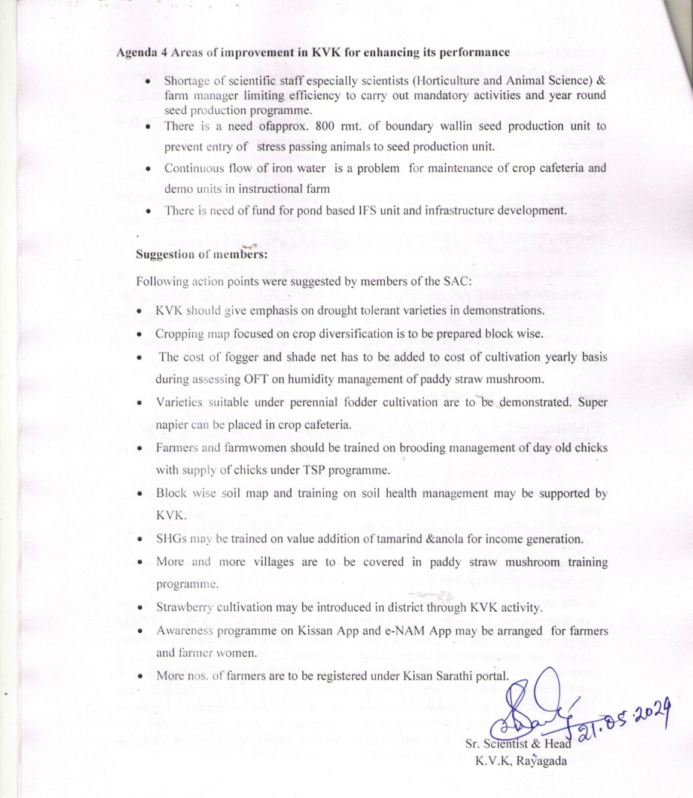

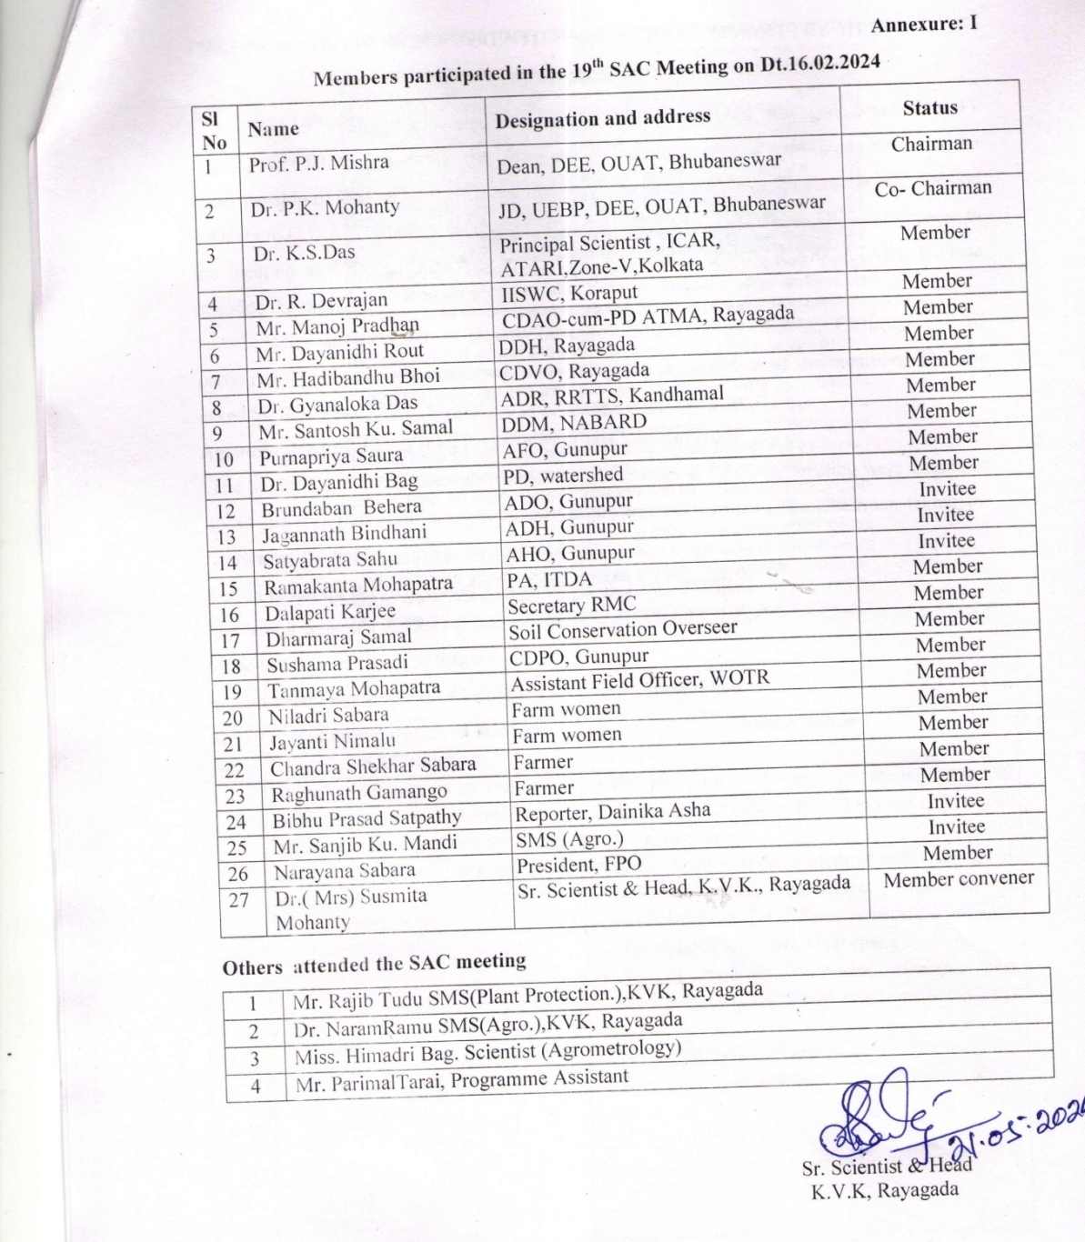

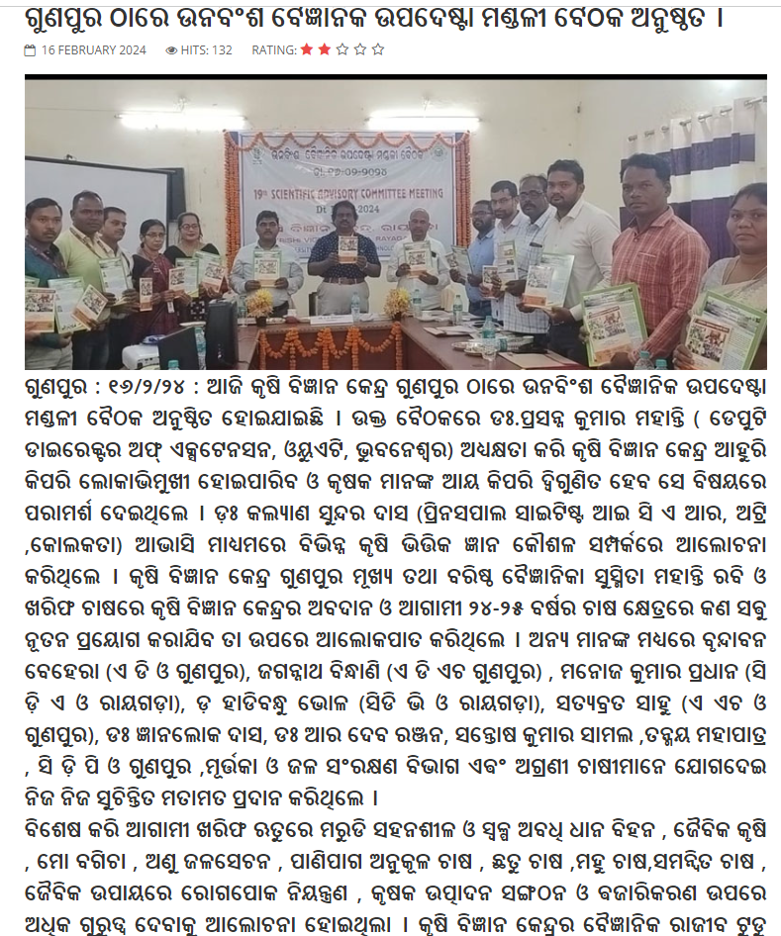

2.a. District level data on agriculture, livestock and farming situation (2024)
Sl. no. | Item | Information
1 | Major Farming system/enterprise | Rice- fallow  Rice-pulse ( Horse gram, Green gram, Black gram)  Rice-sunflower,  Rice- vegetables (Solanac., Cole crops and cucurbits)  Pulses - fallow (pigeon pea )  Vegetable (Tomato, Radish, Cabbage, Cauliflower-Vegetables)  Ground nut - fallow  Paddy- Ground nut + Poultry  Mushroom Production
2 | Agro-climatic Zone | North Eastern Ghat Zone
3 | Agro ecological situation | 1.Hilly and plateau, rainfed, high elevation  2. Hilly and plateau, moderate irrigation, moderate
4 | Soil type | The red or mixed red soil is 52.8%, followed by latterite soil 30.71%, alluvial soil 14.76%, black soil 1.43% and brown forest soil
5 | Productivity of major 2-3 crops under cereals, pulses, oilseeds, vegetables, fruits and others | Cereals- Paddy – 56.1q/ha, cotton – 20.05 q/ha, ragi- 17.5 q/ha, maize- 56.85 q/ha,  Pulses- Pigeon pea – 16.36/ha, Black gram- 3.22 q/ha, Green gram- 3.38/ha  Oilseeds- Groundnut- 24.5 /ha, Sunflower- 13.88 q/ha, Sesame- 3.88 /ha,  Vegetables- 83.35 q/ha
6 | Mean yearly temperature, rainfall, humidity of the district | Temperature- Max- 44⁰ C and Min- 8⁰C  Annual rainfall- 1315.1 mm in 165 rainy days
7 | Production of major livestock products like milk, egg, meat etc. | Milk - 1.1 MT / year , poultry meat- 140.0 (MT Meat), Goatary - 710.0 (MT Meat)
Note: Please give recent data only

2.b. Details of operational area / villages (2024)

Sl.  No. | Name of Taluk | Name of the block | Name of the villages | Major crops  & enterprises | Major problems identified (crop-wise) | Identified Thrust Areas
 | Gunupur | Padmapur | Laxmanguda | Paddy, maize, blackgram | Paddy- Line transplanting, weed infestation, blast disease, BPH attack, stem borer, mechanization, distress sale drought, water scarcity  Maize- INM, weed infestation,  Blackgram- Line sowing, INM, YMV disease, pod borer | Integrated weed management in maize, rice and cotton  Management of acid soil with paper mill sludge
 | Gunupur | Ramnaguda | Garanda | Paddy, cotton, pigeon pea, maize | Paddy- Line transplanting, weed infestation, blast disease, BPH attack, stem borer, mechanization, distress sale, drought, water scarcity  Cotton- weed problem, mealy bug, boll worm  Pigeon pea- local variety, weed infestation, INM, Rhizobium culture, sterility mosaic virus, pod and shoot borer  Maize- INM, weed infestation | Integrated weed management in maize, rice and cotton  Improved production technology in cotton  Integrated Pest Management and Integrated Disease Management in Paddy, Maize, Cotton
 | Gunupur | Gunupur | Pagadabilli | Paddy, cotton , pigeon pea, maize | Paddy- Line transplanting, weed infestation, blast disease, BPH attack, stem borer, mechanization, distress sale, drought, water scarcity  Cotton- weed problem, mealy bug, boll worm  Pigeon pea- local variety, weed infestation, INM, Rhizobium culture, sterility mosaic virus, pod and shoot borer  Maize- INM, weed infestation | Integrated weed management in maize, rice and cotton  Management of acid soil with paper mill sludge  Integrated Pest Management and Integrated Disease Management in Paddy, Maize, Cotton
 | Gunupur | Gunupur | Pradhaniguda | Paddy, cotton , pigeon pea, maize | Paddy- Line transplanting, weed infestation, blast disease, BPH attack, stem borer, mechanization, distress sale, drought, water scarcity  Cotton- weed problem, mealy bug, boll worm  Pigeonpea- local variety, weed infestation, INM, Rhizobium culture, sterility mosaic virus, pod and shoot borer  Maize- INM, weed infestation | Integrated weed management in maize, rice and cotton  Integrated Pest Management and Integrated Disease Management in Paddy, Maize, Cotton
 | Gunupur | Gunupur | Turkaniguda | Paddy, cotton , pigeon pea, maize | Paddy- Line transplanting, weed infestation, blast disease, BPH attack, stem borer, mechanization, distress sale, drought, water scarcity  Cotton- weed problem, mealy bug, boll worm  Pigeonpea- local variety, weed infestation, INM, Rhizobium culture, sterility mosaic virus, pod and shoot borer  Maize- INM, weed infestation | Integrated weed management in maize, rice and cotton  Management of acid soil with paper mill sludge  Integrated Pest Management and Integrated Disease Management in Paddy, Maize, Cotton
 | Gunupur | Gunupur | Gadiakhala | Paddy, cotton , pigeon pea, maize | Paddy- Line transplanting, weed infestation, blast disease, BPH attack, stem borer, mechanization, distress sale, drought, water scarcity  Cotton- weed problem, mealy bug, boll worm  Pigeonpea- local variety, weed infestation, INM, Rhizobium culture, sterility mosaic virus, pod and shoot borer  Maize- INM, weed infestation | Integrated weed management in maize, rice and cotton  Improved production technology in Cotton  Integrated Pest Management and Integrated Disease Management in Paddy, Maize, Cotton
 | Gunupur | Gudari | Sanhuma | Paddy, cotton , pigeon pea, maize | Paddy- Line transplanting, weed infestation, blast disease, BPH attack, stem borer, mechanization, distress sale, drought, water scarcity  Cotton- weed problem, mealy bug, boll worm  Pigeon pea- local variety, weed infestation, INM, Rhizobium culture, sterility mosaic virus, pod and shoot borer  Maize- INM, weed infestation | Integrated weed management in maize, rice and cotton  Improved production technology in Cotton  Integrated Pest Management and Integrated Disease Management in Paddy, Maize, Cotton
 | Gunupur | Ramnaguda | Armada | Paddy, cotton , pigeon pea, groundnut | Paddy- Line transplanting, weed infestation, blast disease, BPH attack, stem borer, mechanization, distress sale, drought, water scarcity  Cotton- weed problem, mealy bug, boll worm  Pigeonpea- local variety, weed infestation, INM, Rhizobium culture, sterility mosaic virus, pod and shoot borer  Groundnut – INM, collar rot, defoliation, high yielding variety, availability of seed | Integrated weed management in maize, rice and cotton  Improved production technology in Cotton  Improved production technology in Oilseeds  Integrated Pest Management and Integrated Disease Management in Paddy, Maize, Cotton
 | Gunupur | Ramnaguda | Nilamguda | Paddy, cotton , pigeon pea, maize, groundnut | Paddy- Line transplanting, weed infestation, blast disease, BPH attack, stem borer, mechanization, distress sale, drought, water scarcity  Cotton- weed problem, mealy bug, boll worm  Pigeon pea- local variety, weed infestation, INM, Rhizobium culture, sterility mosaic virus, pod and shoot borer  Groundnut – INM, collar rot, defoliation, high yielding variety, availability of seed | Improved production technology in pulses  Improved production technology in Oilseeds  Integrated Pest Management and Integrated Disease Management in Paddy, Maize, Cotton
 | Gunupur | Ramnaguda | Nalpanda | Paddy, cotton , pigeon pea, maize | Paddy- Line transplanting, weed infestation, blast disease, BPH attack, stem borer, mechanization, distress sale, drought, water scarcity  Cotton- weed problem, mealy bug, boll worm  Pigeon pea- local variety, weed infestation, INM, Rhizobium culture, sterility mosaic virus, pod and shoot borer  Maize- INM, weed infestation | Improved production technology in pulses  Integrated weed management in maize, rice and cotton  Improved production technology in Cotton
 | Gunupur | Gunupur | Kalma | Paddy, cotton , maize | Paddy- Line transplanting, weed infestation, blast disease, BPH attack, stem borer, mechanization, distress sale, drought, water scarcity  Cotton- weed problem, mealy bug, boll worm  Maize- INM, weed infestation | Integrated weed management in maize, rice and cotton  Improved production technology in Cotton
 | Gunupur | Gunupur | Chalkamba | Paddy, cotton , maize | Paddy- Line transplanting, weed infestation, blast disease, BPH attack, stem borer, mechanization, distress sale, drought, water scarcity  Cotton- weed problem, mealy bug, boll worm  Maize- INM, weed infestation | Integrated weed management in maize, rice and cotton  Improved production technology in Cotton  Integrated Pest Management and Integrated Disease Management in Paddy, Maize, Cotton
 | Gunupur | Gunupur | Rupapadar | Paddy, cotton , maize, vegetable | Paddy- Line transplanting, weed infestation, blast disease, BPH attack, stem borer, mechanization, distress sale, drought, water scarcity  Cotton- weed problem, mealy bug, boll worm  Maize- INM, weed infestation  Vegetables- high yield varieties, INM, fruit and shoot borer in brinjal, wilting in tomato and brinjal, distress sale of vegetables, no value addition | Integrated weed management in maize, rice and cotton  Seed production of important cereals, pulses and vegetable crops  Integrated Pest Management and Integrated Disease Management in Paddy, Maize, Cotton, Vegetables,
 | Gunupur | Rayagada | Kuljing | Paddy, maize, ragi | Paddy- Line transplanting, weed infestation, blast disease, BPH attack, stem borer, mechanization, distress sale, drought, water scarcity  Maize- INM, weed infestation  Ragi- local varieties, INM, value addition, processing | Integrated weed management in maize, rice and cotton  Integrated Pest Management and Integrated Disease Management in Paddy, Maize, Cotton
 | Gunupur | Ramnaguda | Gulumunda | Paddy, cotton , pigeon pea, maize | Paddy- Line transplanting, weed infestation, blast disease, BPH attack, stem borer, mechanization, distress sale, drought, water scarcity  Cotton- weed problem, mealy bug, boll worm  Pigeon pea- local variety, weed infestation, INM, Rhizobium culture, sterility mosaic virus, pod and shoot borer  Maize- INM, weed infestation | Improved production technology in pulses  Integrated Pest Management and Integrated Disease Management in Paddy, Maize, Cotton
 | Gunupur | Gunupur | Regeda | Paddy, cotton , pigeon pea, maize | Paddy- Line transplanting, weed infestation, blast disease, BPH attack, stem borer, mechanization, distress sale, drought, water scarcity  Cotton- weed problem, mealy bug, boll worm  Pigeon pea- local variety, weed infestation, INM, Rhizobium culture, sterility mosaic virus, pod and shoot borer  Maize- INM, weed infestation | Improved production technology in pulses  Integrated Pest Management and Integrated Disease Management in Paddy, Maize, Cotton
 | Gunupur | Ramnaguda | Majhiguda | Paddy, cotton , pigeon pea, maize | Paddy- Line transplanting, weed infestation, blast disease, BPH attack, stem borer, mechanization, distress sale drought, water scarcity  Cotton- weed problem, mealy bug, boll worm  Pigeon pea- local variety, weed infestation, INM, Rhizobium culture, sterility mosaic virus, pod and shoot borer  Maize- INM, weed infestation | Crop Diversification  Improved production technology in pulses  Integrated Pest Management and Integrated Disease Management in Paddy, Maize, Cotton
 | Gunupur | Gunupur | Bijaypur | Paddy, cotton , pigeon pea, maize | Paddy- Line transplanting, weed infestation, blast disease, BPH attack, stem borer, mechanization, distress sale, drought, water scarcity  Cotton- weed problem, mealy bug, boll worm  Pigeon pea- local variety, weed infestation, INM, Rhizobium culture, sterility mosaic virus, pod and shoot borer  Maize- INM, weed infestation | Crop Diversification  Improved production technology in pulses  Integrated Pest Management and Integrated Disease Management in Paddy, Maize, Cotton
 | Gunupur | Ramnaguda | Rajbikrampur | Paddy, cotton , pigeon pea, maize | Paddy- Line transplanting, weed infestation, blast disease, BPH attack, stem borer, mechanization, distress sale, drought, water scarcity  Cotton- weed problem, mealy bug, boll worm  Pigeonpea- local variety, weed infestation, INM, Rhizobium culture, sterility mosaic virus, pod and shoot borer  Maize- INM, weed infestation | Improved production technology in pulses  Integrated Pest Management and Integrated Disease Management in Paddy, Maize, Cotton
 | Gunupur | Ramnaguda | Bhamini | Paddy, cotton , pigeon pea, maize | Paddy- Line transplanting, weed infestation, blast disease, BPH attack, stem borer, mechanization, distress sale, drought, water scarcity  Cotton- weed problem, mealy bug, boll worm  Pigeon pea- local variety, weed infestation, INM, Rhizobium culture, sterility mosaic virus, pod and shoot borer  Maize- INM, weed infestation | Improved production technology in pulses  Integrated Pest Management and Integrated Disease Management in Paddy, Maize, Cotton
 | Gunupur | Gunupur | Bhaleri kudia | Paddy, cotton , pigeon pea | Paddy- Line transplanting, weed infestation, blast disease, BPH attack, stem borer, mechanization, distress sale, drought, water scarcity  Cotton- weed problem, mealy bug, boll worm  Pigeonpea- local variety, weed infestation, INM, Rhizobium culture, sterility mosaic virus, pod and shoot borer | Improved production technology in pulses  Integrated Pest Management and Integrated Disease Management in Paddy, Cotton, pigeon pea
 | Gunupur | Gunupur | Dandaguda | Paddy, cotton , pigeon pea, groundnut | Paddy- Line transplanting, weed infestation, blast disease, BPH attack, stem borer, mechanization, distress sale, drought, water scarcity  Cotton- weed problem, mealy bug, boll worm  Pigeonpea- local variety, weed infestation, INM, Rhizobium culture, sterility mosaic virus, pod and shoot borer  Groundnut – INM, collar rot, defoliation, high yielding variety, availability of seed | Improved production technology in oilseeds and pulses
 | Gunupur | Ramnaguda | Bangi | Paddy, cotton , pigeon pea, groundnut | Paddy- Line transplanting, weed infestation, blast disease, BPH attack, stem borer, mechanization, distress sale, drought, water scarcity  Cotton- weed problem, mealy bug, boll worm  Pigeon pea- local variety, weed infestation, INM, Rhizobium culture, sterility mosaic virus, pod and shoot borer, drought, water scarcity  Groundnut – INM, collar rot, defoliation, high yielding variety, availability of seed | Improved production technology in oilseeds and pulses  Integrated Pest Management and Integrated Disease Management in Paddy, cotton, pigeon pea
 | Gunupur | Ramnaguda | Gumunda | Paddy, cotton , pigeon pea, Mushroom production | Paddy- Line transplanting, weed infestation, blast disease, BPH attack, stem borer, mechanization, distress sale, drought, water scarcity  Cotton- weed problem, mealy bug, boll worm  Pigeon pea- local variety, weed infestation  Mushroom production- availability of strain, availability of spawn, sanitation problem, disease, skill of production | Improved production technology in pulses  Integrated Pest Management and Integrated Disease Management in Paddy, cotton, pigeon pea
 | Gunupur | Gunupur | Putasingh | Paddy, cotton , pigeon pea, maize | Paddy- Line transplanting, weed infestation, blast disease, BPH attack, stem borer, mechanization, distress sale, drought, water scarcity  Cotton- weed problem, mealy bug, boll worm  Pigeon pea- local variety, weed infestation, INM, Rhizobium culture, sterility mosaic virus, pod and shoot borer  Maize- INM, weed infestation | Improved production technology in pulses  Integrated Pest Management and Integrated Disease Management in Paddy, cotton, pigeon pea, maize
 | Gunupur | Gunupur | Nuagaon | Paddy, cotton , pigeon pea | Paddy- Line transplanting, weed infestation, blast disease, BPH attack, stem borer, mechanization, distress sale, drought, water scarcity  Cotton- weed problem, mealy bug, boll worm  Pigeon pea- local variety, weed infestation, INM, Rhizobium culture, sterility mosaic virus, pod and shoot borer | Improved production technology in pulses
 | Gunupur | Gunupur | Talana | Paddy, cotton , pigeon pea | Paddy- Line transplanting, weed infestation, blast disease, BPH attack, stem borer, mechanization, distress sale, drought, water scarcity  Cotton- weed problem, mealy bug, boll worm  Pigeon pea- local variety, weed infestation, INM, Rhizobium culture, sterility mosaic virus, pod and shoot borer | Integrated Pest Management and Integrated Disease Management in Paddy, cotton, pigeon pea  Improved production technology in pulses
 | Gunupur | Gunupur | Bagsala | Paddy, cotton , pigeon pea, maize | Paddy- Line transplanting, weed infestation, blast disease, BPH attack, stem borer, mechanization, distress sale, drought, water scarcity  Cotton- weed problem, mealy bug, boll worm  Pigeon pea- local variety, weed infestation, INM, Rhizobium culture, sterility mosaic virus, pod and shoot borer  Maize- INM, weed infestation | Improved production technology in pulses  Integrated Pest Management and Integrated Disease Management in Paddy, cotton, pigeon pea
 | Gunupur | Padmapur | Khilapadar | Paddy, cotton, maize | Paddy- Line transplanting, weed infestation, blast disease, BPH attack, stem borer, mechanization, distress sale, drought, water scarcity  Cotton- weed problem, mealy bug, boll worm  Maize- INM, weed infestation | Integrated Pest Management and Integrated Disease Management in Paddy, cotton, pigeon pea
 | Gunupur | Ramnaguda | Srirampur | Paddy, cotton , pigeon pea | Paddy- Line transplanting, weed infestation, blast disease, BPH attack, stem borer, mechanization, distress sale, drought, water scarcity  Cotton- weed problem, mealy bug, boll worm  Pigeon pea- local variety, weed infestation, INM, Rhizobium culture, sterility mosaic virus, pod and shoot borer | Integrated Pest Management and Integrated Disease Management Paddy, cotton , pigeon pea  Improved production technology in pulses
 | Gunupur | Gudari | Bentiguda | Paddy, cotton , pigeon pea | Paddy- Line transplanting, weed infestation, blast disease, BPH attack, stem borer, mechanization, distress sale, drought, water scarcity  Cotton- weed problem, mealy bug, boll worm  Pigeon pea- local variety, weed infestation, INM, Rhizobium culture, sterility mosaic virus, pod and shoot borer | Integrated Pest Management and Integrated Disease Management Paddy, cotton , pigeon pea  Improved production technology in pulses
 | Gunupur | Ramnaguda | Hazardangi | Paddy, cotton , pigeon pea | Paddy- Line transplanting, weed infestation, blast disease, BPH attack, stem borer, mechanization, distress sale , drought, water scarcity  Cotton- weed problem, mealy bug, boll worm  Pigeon pea- local variety, weed infestation, INM, Rhizobium culture, sterility mosaic virus, pod and shoot borer | Integrated Pest Management and Integrated Disease Management Paddy, cotton , pigeon pea  Improved production technology in pulses
 | Gunupur | Ramnaguda | Subai | Paddy, cotton | Paddy- Line transplanting, weed infestation, blast disease, BPH attack, stem borer, mechanization, distress sale  Cotton- weed problem, mealy bug, boll worm | Integrated Pest Management and Integrated Disease Management Paddy, cotton pigeon pea
 | Gunupur | Padmapur | Indupur | Paddy, blackgram | Paddy- Line transplanting, weed infestation, blast disease, BPH attack, stem borer, mechanization, distress sale, drought, water scarcity  Blackgram- local variety, availability of seeds, YMV, INM | Crop diversification  Improved production technology in pulses
 | Gunupur | Gunupur | Taramala | Paddy, cotton , pigeon pea | Paddy- Line transplanting, weed infestation, blast disease, BPH attack, stem borer, mechanization, distress sale, drought, water scarcity  Cotton- weed problem, mealy bug, boll worm  Pigeonpea- local variety, weed infestation, INM, Rhizobium culture, sterility mosaic virus, pod and shoot borer | Crop diversification  Improved production technology in pulses
 | Gunupur | Gunupur | Bhimpurguda | Paddy, cotton , pigeon pea, Black gram | Paddy- Line transplanting, weed infestation, blast disease, BPH attack, stem borer, drought, water scarcity  Cotton- weed problem, mealy bug, boll worm  Pigeonpea- local variety, weed infestation, INM, Rhizobium culture, pod and shoot borer | Crop diversification  Improved production technology in pulses  Integrated Pest Management and Disease Management in field crops
 | Gunupur | Ramnaguda | Gugurupanga | Paddy, cotton, Pigeon pea, vegetables | Paddy- weed infestation, blast disease, BPH attack, stem borer, drought, water scarcity  Cotton- weed problem, mealy bug, boll worm  Vegetables- Sucking pest problem | Integrated Pest and Disease Management field and vegetable crops

2. c. Details of village adoption programme:

Name of the villages adopted by PC and SMS (2024) for its development and action plan

Name of village | Block | Action taken for development
Gugurpang | Ramnaguda | Conducted FLD, CFLD, OFT, training (farmers/ farm women/rural youth), field day and other extension activities, Swachha Bharat programme
Arei | Padmapur | Conducted FLD, CFLD, OFT, training (farmers/ farm women/rural youth), field day and other extension activities, Swachha Bharat programme
Srirampur | Ramnaguda | Conducted FLD, CFLD, OFT, training (farmers/ farm women/rural youth), field day and other extension activities, Swachha Bharat programme
Bhaleri Kudia | Gunupur | Conducted FLD, CFLD, OFT, training (farmers/ farm women/rural youth), field day and other extension activities, Swachha Bharat programme
L. L. Pur | Gudari | Conducted FLD, CFLD, OFT, training (farmers/ farm women/rural youth), field day and other extension activities, Swachha Bharat programme

2.1 Priority thrust areas
S. No. | Thrust area
 | Management of problematic soil
 | Crop diversification
 | Integrated Nutrient Management
 | Integrated Pest Management
 | Integrated Disease Management
 | Farm Mechanization
 | Intercropping of different crops
 | Bio-control of insects and pests
 | Weed management in field crops
 | Crop Production Technology
 | Seed production technology
 | Management of horticultural crops
 | Post harvest Technology
 | Processing and value addition
 | Nursery raising technique
 | Entrepreneurial development
 | Income generating activities
 | Organic farming
 | Promotion of Small scale agro-industries
 | Water harvesting technology for moisture conservation
 | Development of kitchen garden for nutritional security
 | Production of organic inputs

3. TECHNICAL ACHIEVEMENTS

3.A. Details of target and achievement of mandatory activities by KVK during the year
OFT |  |  |  |  |  |  |  |  |  |  |  | FLD
No. of technologies tested: |  |  |  |  |  |  |  |  |  |  |  | No. of technologies demonstrated:
Number of OFTs |  | Number of farmers |  |  |  |  |  |  |  |  |  | Number of FLDs |  | Number of farmers
Target | Achievement | Target | Achievement |  |  |  |  |  |  |  |  | Target | Achievement | Target | Achievement
 |  |  | SC |  | ST |  | Others |  | Total |  |  |  |  |  | SC |  | ST |  | Others |  | Total
 |  |  | M | F | M | F | M | F | M | F | T |  |  |  | M | F | M | F | M | F | M | F | T
8 | 7 | 56 | 0 | 0 | 34 | 14 | 1 | 0 | 35 | 14 | 49 | 32 | 24 | 576 | 0 | 0 | 246 | 162 | 27 | 1 | 273 | 163 | 436

Training |  |  |  |  |  |  |  |  |  |  |  | Extension activities
Number of Courses |  | Number of Participants |  |  |  |  |  |  |  |  |  | Number of activities |  | Number of participants
Target | Achievement | Target | Achievement |  |  |  |  |  |  |  |  | Target | Achievement | Target | Achievement
 |  |  | SC |  | ST |  | Others |  | Total |  |  |  |  |  | SC |  | ST |  | Others |  | Total
 |  |  | M | F | M | F | M | F | M | F | T |  |  |  | M | F | M | F | M | F | M | F | T
101 | 99 | 2290 | 21 | 8 | 1396 | 620 | 141 | 33 | 1586 | 665 | 2240 | - | 4077 | - | 325 | 153 | 40422 | 18981 | 4030 | 1893 | 44777 | 21027 | 65570

Impact of capacity building |  |  |  |  |  |  |  |  |  |  | Impact of Extension activities
Number of Participants trained |  | Number of Trainees got employment (self/ wage/ entrepreneur/ engaged as skilled manpower) |  |  |  |  |  |  |  |  |  | Number of Participants attended |  | Number of participants got employment (self/ wage/ entrepreneur/ engaged as skilled manpower)
Target | Achievement | SC |  | ST |  | Others |  | Total |  |  |  | Target | Achievement | SC |  | ST |  | Others |  | Total
 |  | M | F | M | F | M | F | M | F | T |  |  |  | M | F | M | F | M | F | M | F | T
180 | 195 | - | - | 29 | 4 | - | - | 29 | 4 | 33 |  | - | 65570 | 8 | 103 | 522 | 176 | 656 | 43 | 1186 | 322 | 1508

Seed production (q) |  | Planting material (in Lakh)
Target | Achievement | Target | Achievement
165.0 | 140.2 | 2.0 | 1.569

Livestock strains and fish fingerlings produced (in lakh)* |  | Soil, water, plant, manures samples tested (in lakh)
Target | Achievement | Target | Achievement
- | - | 300 | 262
- * Give no. only in case of fish fingerlings

Publication by KVKs
Item | Number | No. circulated | No. of Research papers in NAAS rated Journals | Highest NAAS rating of any publication | Average NAAS rating of the publications | Details of awarded publication, if any | Details of Award given to the publication
Research paper
Seminar/conference/ symposia papers
Books | 3 | 300
Bulletins
News letter | 1 | 500
Popular Articles
Book Chapter
Extension Pamphlets/ literature | 1 | 1000
Technical reports | 70 | -
Electronic Publication (CD/DVD etc)
TOTAL

3.1 Achievements on technologies assessed and refined
OFT-1
1. | Title of On farm Trial | Assessment of medium duration rice varieties under rainfed condition
2. | Problem diagnosed | Low yield due to blast, sheath blight, leaf folder and sucking pest
3. | Details of technologies selected for assessment/refinement  (Mention either Assessed or Refined) | Assessed  TO₁- Rice var. Kalinga Dhan 1205  TO₂- Rice var. Kalinga Dhan 1203
4. | Source of Technology (ICAR/ AICRP/SAU/other, please specify) | OUAT, SLREC 2022-23
5. | Production system and thematic area | Rice – pulse and varietal evaluation
6. | Performance of the Technology with performance indicators | Plant height(PH), ear bearing tillers (EBT)/plant, grains/panicle, 1000 grain weight
7. | Final recommendation for micro level situation | Medium duration rice var. Kalinga Dhan 1203 gives 11.2% higher yield than var. MTU 1001, suitable for rain-fed medium land, maturity: 130-135 days and moderately resistant to sheath blight and leaf folder.
8. | Constraints identified and feedback for research | No such constraints faced
9. | Process of farmers participation and their reaction | Farmer scientists’ interaction
Thematic area: Varietal evaluation
Problem definition: Low yield due to blast, sheath blight, leaf folder and sucking pest

OFT-2
1. | Title of On farm Trial | Assessment of high yielding varieties of sesame
2. | Problem diagnosed | Low yield of sesame due to traditional/ old varietal
3. | Details of technologies selected for assessment/refinement  (Mention either Assessed or Refined) | Assessed  TO₁- Sesame Var. Subhra  TO₂- Sesame Var. Smarak  TO₃- Sesame Var. Kalinga sesame 3-1
4. | Source of Technology (ICAR/ AICRP/SAU/other, please specify) | OUAT, SLREC 2022-23
5. | Production system and thematic area | Rice – vegetable - sesame and Varietal evaluation
6. | Performance of the Technology with performance indicators | Plant height(PH), ear bearing tillers (EBT)/plant, grains/panicle, 1000 grain weight
7. | Final recommendation for micro level situation | Cultivation of sesame var. Smarak resulted 27.1% higher yield than farmers’ practice and moderately resistant to phyllody blight.
8. | Constraints identified and feedback for research | No such constraints faced
9. | Process of farmers participation and their reaction | Farmer scientists’ interaction
Thematic area: Varietal evaluation
Problem definition: Low yield of sesame due to traditional/ old varietal
OFT-3

1. | Title of On farm Trial | Assessment of different Chilli Varieties
2. | Problem diagnosed | Low yield and income due existing variety
3. | Details of technologies selected for assessment/refinement  (Mention either Assessed or Refined) | Assessed  TO₁- Variety :Arka Meghna, F1 hybrid, duration 140-150 days, tolerant to powdery mildew and viruses, green chilli yield- 257 q/ha  TO₂- F1 hybrid, duration-210 days, resistant to leaf curl virus, suitable for green and dry chilly, green chilli yield potential- 210 q/ha
4. | Source of Technology (ICAR/ AICRP/SAU/other, please specify) | IIHR, Bangaluru, 2021
5. | Production system and thematic area | Vegetable – vegetable and varietal evaluation
6. | Performance of the Technology with performance indicators | Plant height (cm), No. of branches/plant, Fruit length(cm), Fruit girth(cm) No. of fruits/plant, PDI (%) ,Yield(q/ha)
7. | Final recommendation for micro level situation | Variety :Arka Meghna can be recommended for cultivation against leaf curl virus
8. | Constraints identified and feedback for research | Low yield due to infestation of some disease and pest
9. | Process of farmers participation and their reaction | Training, demonstration and field visit
Thematic area: Varietal evaluation
Problem definition: Low yield and income due existing variety

OFT-4

1. | Title of On farm Trial | Assessment of onion varieties in rabi
2. | Problem diagnosed | Low income from existing variety
3. | Details of technologies selected for assessment/refinement  (Mention either Assessed or Refined) | Assessed  TO₁- Bhima Shakti- onions are red and have attractive bulbs that turn red immediately after harvest. It matures in 125–135 days after transplanting, it can yield 32–36 tons per hectare and can be stored for 5–6 months.  TO₂- Bhima Dark Red–it has dark red, flat-globe bulbs which matures at 95–100 days after transplanting and has an average marketable yield of 20–22 tons per hectare.
4. | Source of Technology (ICAR/ AICRP/SAU/other, please specify) | DOGR, MH, 2022
5. | Production system and thematic area | Vegetable – Vegetable and Income generation
6. | Performance of the Technology with performance indicators | No. of days to harvest, Bulb Diameter(cm), Bulb weight(g), yield(q/ha)
7. | Final recommendation for micro level situation | Variety : Bhima Shakti can be recommended for cultivation for better self life and yield
8. | Constraints identified and feedback for research | Inadequate irrigation facility and improper post harvest management
9. | Process of farmers participation and their reaction | Training, demonstration and field visit
Thematic area: Varietal evaluation
Problem definition: Low income from existing variety

OFT-5

1. | Title of On farm Trial | Assessment of IPM Modules for the management of Brinjal fruit and shoot borer.
2. | Problem diagnosed | Low yield and poor marketability.
3. | Details of technologies selected for assessment/refinement  (Mention either Assessed or Refined) | Assessed  TO₁- Erection of Pheromone traps @ 20 nos./ha, release of T. chilonis @ 50,000/ha 6 times from 21 DAT at weekly interval, spraying of Bt at flowering @ 2ml/l two times in 10 days interval. Spraying of Emamectin benzoate 5% SG @ 200 g/ha at ETL > 5% .  TO₂-Clipping of infested shoots & fruits regularly, pheromone traps @ 25/ha at 30 DAT, spraying of Azadiractin 1500 ppm @ 3 ml/l at 20 DAT, spraying of Bt @ 2 ml/l twice at 30 DAT and 45 DAT, spraying of Chlorantraniliprole 18.5% SC @ 0.25 ml/l at 60 DAT.
4. | Source of Technology (ICAR/ AICRP/SAU/other, please specify) | TO-I :OUAT, AR, 2018  TO-II: OUAT, AR, 2019
5. | Production system and thematic area | Vegetable- vegetable and Integrated pest management
6. | Performance of the Technology with performance indicators | Shoot infestation (%) and Fruit infestation (%)
7. | Final recommendation for micro level situation | Clipping of infested shoots & fruits regularly, use of pheromone traps, spraying of Azadiractin, spraying of Bt and spraying of Chlorantraniliprole performed better as compared to farmers’ practice, where shoot infestation minimized from 39% to 7% and fruit infestation has been reduced from 31% to 5 % with 33.49% higher yield.
8. | Constraints identified and feedback for research | More numbers of farmers are facing these problems.
9. | Process of farmers participation and their reaction | Farmers have involved directly by using these technologies and interested to spreading these technologies to other farmers.
Thematic area: Varietal evaluation
Problem definition: Low yield and poor marketability.

OFT-6

1. | Title of On farm Trial | Assessment of management of wilt complex in tomato by using Jivamrita and Bijamrita.
2. | Problem diagnosed | Low yield due to wilt incidence
3. | Details of technologies selected for assessment/refinement  (Mention either Assessed or Refined) | Assessed  TO₁- Jibamruta application – Application of 200 lit of Jibamruta per acre with irrigation water or with spray machine at an interval of 15-20 days on standing crop @ 5-6 spray.  TO₂- TO₁ +Bijamruta application-Application of prepared Bijamruat for seed treatment of 100 kg seeds, mix it with the seeds well so that bijamruta will be well coated on seeds, dry the mixture under shade before 24 hrs of sowing.
4. | Source of Technology (ICAR/ AICRP/SAU/other, please specify) | Manual of national centre for organic and natural farming, Gaziabad
5. | Production system and thematic area | Rice- vegetable and Integrated Disease Management
6. | Performance of the Technology with performance indicators | PDI
7. | Final recommendation for micro level situation | Application of organic concentrates incurred very less cost and the application is not tedious than the chemical methods. So seed treatment with bijamrit and soil application of Jivamrit starting from 25 DAT and at 15-20 days interval for 5 to 6 times in a cropping period should be followed.
8. | Constraints identified and feedback for research | More numbers of farmers are not acquainted to use this technology.
9. | Process of farmers participation and their reaction | Farmers are very much appreciated with this management of wilt complex in tomato
Thematic area: Integrated Disease Management
Problem definition: Low yield due to wilt incidence
OFT-7

1. | Title of On farm Trial | Assessment of humidity management in paddy straw mushroom production
2. | Problem diagnosed | Low yield due to improper production technique
3. | Details of technologies selected for assessment/refinement  (Mention either Assessed or Refined) | Assessed  TO₁- Mushroom production by using bundled paddy straw substrate (3 layers) with covering the floor with 2 inch sand in moist condition and spreading wet gunny bag along the windows/ walls  TO₂- Mushroom production by using bundled paddy straw substrate (3 layers) with Installation of Fogger and hanging of folding type of Gunny bag outside the shade net
4. | Source of Technology (ICAR/ AICRP/SAU/other, please specify) | CTMRT (2015)
5. | Production system and thematic area | Integrated farming and SSIGA
6. | Performance of the Technology with performance indicators | Yield (kg/bed), bio-efficiency (%)
7. | Final recommendation for micro level situation | Production of paddy straw mushroom during summer covering the floor with et sand and spreading wet gunny bag in window/walls as a low cost technology is accepted by farm women.
8. | Constraints identified and feedback for research | Heavy moisture stress and rise in temperature upto 40⁰C + during May and June has limited the farmers and farm women even adoption of this technology.
9. | Process of farmers participation and their reaction | However farmers are satisfied with use of this technology particularly during April and October month
Thematic area: SSIGA
Problem definition: Low yield due to improper production technique
Technology assessed:
Table:
Technology option | No. of trials | Yield component |  |  | Disease/ insect pest incidence (%) | Yield  (q/ha) | Cost of cultivation  (Rs./ha) | Gross return (Rs/ha) | Net return  (Rs./ha) | BC ratio
Technology option | No. of trials | No. of effective tillers/hill | No. of spikelet per panicle | Test wt. (100 grain wt.)
Assessment of medium duration rice varieties under rainfed condition | 7 | Plant height (PH)  FP- 102.3  TO₁- 107.2  TO₂- 115.6 | Ear bearing tillers (EBT) /plant  FP- 10  TO₁- 11  TO₂- 12 | Grains /panicle  FP- 187.1  TO₁- 230.2  TO₂- 246.6 | 1000 grain weight  FP- 23.5  TO₁- 21.15  TO₂- 24.23 | FP- 41.5  TO₁₋ 43.87 TO₂₋ 46.25 | FP- 65180  TO₁-66930  TO₂- 66930 | FP- 84660  TO₁- 89495  TO₂- 94350 | FP-19480  TO₁- 22565  TO₂- 27420 | FP- 1.30  TO₁- 1.38  TO₂- 1.41
Assessment of high yielding varieties of sesame. | 7 | No. of capsule/ plant-  FP-25.43  TO₁ – 40.86  TO₂ - 60.36  TO₃ - 75.2 | No. of seeds/ Capsule-  FP- 29.14  TO₁ – 49.71  TO₂ -58.34  TO₃ - 61.2 |  |  | FP-3.82  TO₁₋4.50  TO₂₋4.80  TO₃ -5.4 | FP- 20180  TO₁- 19850  TO₂- 19850  TO₃ -18606 | FP - 33740  TO₁₋ 41300  TO₂₋ 42700  TO₃ - 43856 | FP - 13560  TO₁- 21450  TO₂₋ 22850  TO₃ -25250 | FP – 1.52  TO₁- 1.80  TO₂- 1.86  TO₃ -1.92
Assessment of different Chilli Varieties | 7 | Plant height (cm)  FP-63.2  TO₁ – 80.1  TO₂ -65.8 | No. of branches/ plant  FP-10.6  TO₁ – 12.2  TO₂ -11.4 | Fruit length(cm), Fruit girth(cm) No. of fruits/plant  FP-8, 9, 126  TO₁ -13, 1.2,144  TO₂ - 9, 1.2, 142 |  | FP-164  TO₁ - 191  TO₂ -184 | FP-105000  TO₁ - 105000  TO₂ -105000 | FP-328000  TO₁ - 382000  TO₂ -368000 | FP-223000  TO₁ - 277000  TO₂ -263000 | FP-2.12  TO₁ – 2.63  TO₂ -2.50
Assessment of onion varieties in rabi. | 7 | No. of days to harvest  FP-90  TO₁ - 125  TO₂ - 96 | Bulb diameter (cm)  FP-5.2  TO₁ – 5.9  TO₂ - 5.3 | Bulb weight (gm)  FP-80  TO₁ - 100  TO₂ -80 |  | FP-172  TO₁ - 199  TO₂ -192 | FP-110000  TO₁ - 110000  TO₂ -110000 | FP-344000  TO₁ - 398000  TO₂ -384000 | FP-234000  TO₁ -288000  TO₂ -274000 | FP-2.12  TO₁ – 2.61  TO₂ -2.49
Assessment of IPM Modules for the management of Brinjal fruit and shoot borer | 7 | Shoot infestation (%)  FP- 39  TO₁- 10  TO₂- 7 | Fruit infestation  FP- 31  TO₁- 9  TO₂- 5 | - | - | FP- 203  TO₁- 268  TO₂- 271 | FP- 146600  TO₁- 146800  TO₂- 147400 | FP- 365400  TO₁-482400  TO₂- 487800 | FP- 218800  TO₁- 335600  TO₂- 340400 | FP- 2.49  TO₁- 3.26  TO₂- 3.30
Assessment of management of wilt complex in tomato by using Jivamrita and Bijamrita. | 7 | - | - | - | % of Disease incidence  FP- 14  TO₁- 6  TO₂- 4 | FP- 196.0  TO₁- 189.0  TO₂- 194.0 | FP- 123000  TO₁- 95000  TO₂- 95600 | FP- 372400  TO₁- 359100  TO₂- 368600 | FP- 249400  TO₁- 264100  TO₂- 273000 | FP- 3.02  TO₁ -3.78  TO₂- 3.85
Assessment of humidity management in paddy straw mushroom production | 7 | Bud size in length (cm)  TO₁-4.5  TO₂-5 |  |  |  | Yield  (Kg/ bed)  TO1-0.62  TO2-0.85 | TO₁- 95  TO₂- 105 | TO₁- 217  TO₂- 298 | TO₁- 122  TO₂- 193 | TO₁- 2.28  TO₂-2.83

Results:

Good quality photographs of different treatments:
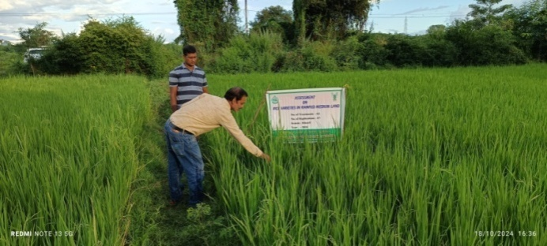  Assessment of medium duration rice varieties under rainfed condition | 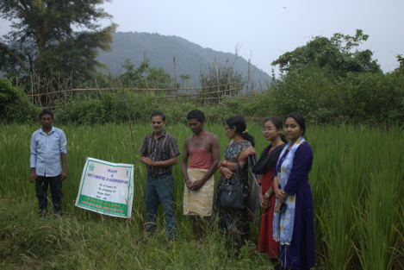
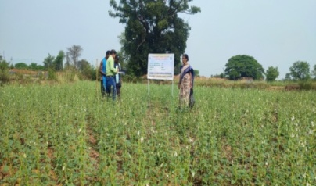  Assessment of high yielding varieties of sesame | 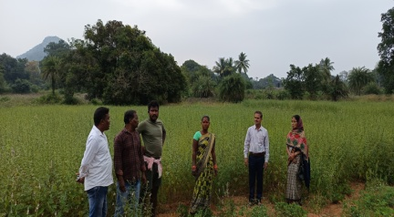
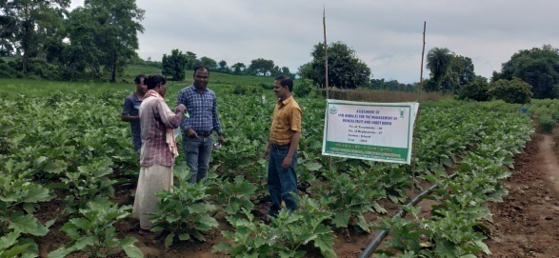  Assessment of IPM Modules for the management of Brinjal fruit and shoot borer | 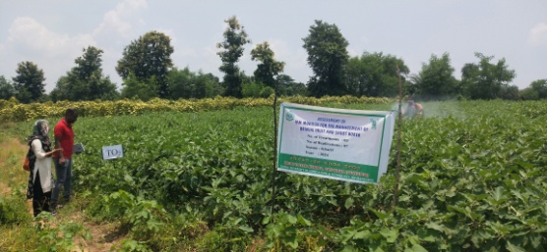
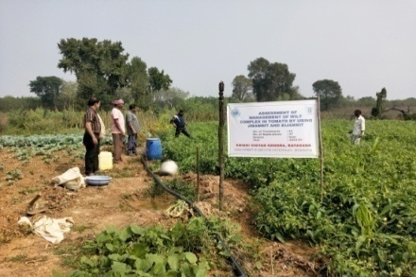  Assessment of management of wilt complex in tomato by using Jivamrita and Bijamrita. | 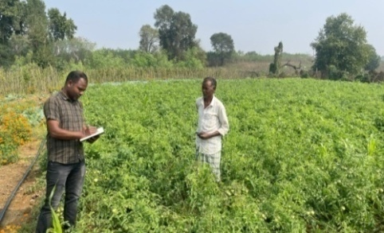

Please provide all the OFTs in same format

3.2 Achievements of Frontline Demonstrations

A. Details of FLDs conducted during the year

Cereals
Sl.  No. | Crop | Thematic area | Technology Demonstrated with detailed treatments | Area (ha) |  | No. of farmers/  demonstration |  |  |  |  |  |  |  |  | Reasons for shortfall in achievement
 |  |  |  | Proposed | Actual | SC |  | ST |  | Others |  | Total
 |  |  |  |  |  | M | F | M | F | M | F | M | F | T
1. | Maize | Crop Production | Demonstration on weed management in Maize | 2 | 2 | - | - | 10 | - | - | - | 10 |  | 10 | -
2. | Finger millet | Crop Production | Demonstration on weed management in Finger millet | 2 | 2 | 1 | - | 6 | 2 | 1 | - | 8 | 2 | 10 | -

Details of farming situation

Crop | Season | Farming situation (RF/Irrigated) | Soil type | Status of soil  (Kg/ha) |  |  | Previous crop | Sowing date | Harvest date | Seasonal rainfall (mm) | No. of rainy days
 |  |  |  | N | P₂O₅ | K₂O
Maize | Kharif, 2024 | Rainfed-upland | Sandy clay | 159.5 | 9.6 | 350.6 | Fallow | 02.7.2024 | 27.10.2024
Finger millet | Kharif, 2024 | Rainfed-upland | Sandy clay | 168.5 | 8.9 | 420.5 | Fallow | 01.08.2024 | 26.11.2024

In both the Tables, information of same crop should be provided. For example, if in Table 3.2A crops are mentioned as a,b,c,d etc., in the table for Details of farming situation, the same crop should be mentioned in the identical sequence.

Performance of FLD

Oilseeds:

Frontline demonstrations on oilseed crops

Crop | Thematic Area | Name of the technology demonstrated | No. of Farmers | Area  (ha) | Yield (q/ha) |  | % Increase | *Economics of demonstration (Rs./ha) |  |  |  | *Economics of check  (Rs./ha)
 |  |  |  |  | Demo | Check | % Increase | Gross  Cost | Gross  Return | Net Return | **  BCR | Gross  Cost | Gross  Return | Net Return | **  BCR
Groundnut | Plant protection | Demonstration on collar rot management in groundnut | 10 | 2 | 21.0 | 16.5 | 27.2 | 68600 | 130200 | 61600 | 1.89 | 67800 | 102300 | 34500 | 1.50
Total

* Economics to be worked out based on total cost of production per unit area and not on critical inputs alone.
** BCR= GROSS RETURN/GROSS COST

Pulses
Frontline demonstration on pulse crops
Crop | Thematic Area | Name of the technology demonstrated | No. of Farmers | Area  (ha) | Yield (q/ha) |  | % Increase | *Economics of demonstration (Rs./ha) |  |  |  | *Economics of check  (Rs./ha)
 |  |  |  |  | Demo | Check | % Increase | Gross  Cost | Gross  Return | Net Return | **  BCR | Gross  Cost | Gross  Return | Net Return | **  BCR
Blackgram | Crop Production | Demonstration on INM in Blackgram | 10 | 2 | 6.8 | 4.9 | 38 | 32500 | 54400 | 21900 | 1.67 | 24500 | 39200 | 14700 | 1.60
 | Total

* Economics to be worked out based on total cost of production per unit area and not on critical inputs alone.
** BCR= GROSS RETURN/GROSS COST
Other crops
Crop | Thematic area | Name of the technology demonstrated | No. of Farmer | Area  (ha) | Yield (q/ha) |  | % change in yield | Other parameters |  | *Economics of demonstration (Rs./ha) |  |  |  | *Economics of check  (Rs./ha)
 |  |  |  |  | Demons  ration | Check |  | Demo | Check | Gross  Cost | Gross  Return | Net Return | **  BCR | Gross  Cost | Gross  Return | Net Return | **  BCR
Maize | Crop Production | Demonstration on weed management in Maize | 10 | 2 | 52100 cobs/ha | 46400 cobs/ha | 12.3 | Weed density-24.39-, Length of cobs(cm)- 22.7, weight of fruits(gm)- 476 | Weed density-55.54, Length of cobs(cm)- 19.6  weight of fruits(gm)- 349 | 85000 | 156300 | 71300 | 1.83 | 79000 | 116000 | 37000 | 1.47
Finger millet | Crop Production | Demonstration on weed management in Finger millet | 10 | 2 | 13.5 | 9.25 | 20.0 | No of fingers/ear head- 10.9 , Tillers/sq. m. -74 | No of fingers/ear head- 8.1, Tillers/sq. m. -58 | 21200 | 35000 | 13800 | 1.65 | 17500 | 25900 | 8400 | 1.48
Cabbage | Vegetable cultivation | Demonstration on Integrated Nutrient Management in Cabbage | 10 | 2 | 199 | 158 | 35 | Average head weight/plant- 950gm | Average head weight/plant- 650 gm | 80500 | 199000 | 118500 | 2.47 | 72500 | 158000 | 85500 | 2.17
Guava | Fruit cultivation | Demonstration of bending technology in guava for increasing productivity | 10 | 1 | 200 | 120 | 40 | No. of shoots /plant- 40-50, No. of fruits/plant-45-50 | No. of shoots /plant- 12-18, No. of fruits/plant-15-20 | Contd.
Tomato | Vegetable cultivation | Demonstration on high yielding tomato variety Kalinga Tomato 121 | 10 | 0.4 | 280 | 394 | -40 | No. of fruits/plant-33  Wt. of fruit (gm)-55 | No. of fruits/plant-40  Wt. of fruit (gm)- 85 | 80000 | 252000 | 172000 | 2.15 | 80000 | 354600 | 274600 | 3.43
Marigold | Flower cultivation | Demonstration on marigold variety Bidhan Marigold -2 | 10 | 0.4 | 450 | 380 | 20 | No. of flowers/ plant-170  yield/plant- 2.5 kg | No. of flowers/ plant-130  yield/plant- 2.0 kg | 80000 | 304000 | 224000 | 2.8 | 90000 | 360000 | 270000 | 3.0
Mango | Orchard management | Demonstration of growth promoter for improving fruit retention, yield and quality of Mango | 10 | 2 |  |  |  | No. of fruits/ panicle-2 | No. of fruits/ panicle-1 | Contd.
Chilli | Plant protection | Demonstration on integrated management of thrips and mite in Chilli | 10 | 1 | 121.2 | 91.75 | 32.09 | % of thrips and mite infestation-4, Infested plants/10 m²-2 | % of thrips and mite infestation-41, Infested plants/10 m²-16 | 123250 | 424200 | 300950 | 3.43 | 123000 | 321125 | 198125 | 2.61
Okra | Plant protection | Demonstration on fruit borer management in okra | 10 | 2 | 182 | 137 | 30.93 | Pest infestation %-6 | Pest infestation %-33 | 148600 | 418600 | 270000 | 2.81 | 147900 | 315100 | 167200 | 2.13
Mango | Plant protection | Demonstration on Anthracnose disease management in Mango | 10 | 1 | Contd.
Tube rose | Women empowerment | Demonstration of tuberose cultivation for income generation of farm women | 10 | 0.02 | 4.31 | - | 4.14- 4.97 | No. of flowers/ spikelets-16.87 | - | 138666 | 387900 | 249234 | 2.7 | - | - | - | -
 | Total

Livestock
Category | Thematic  area | Name of the technology demonstrated | No. of Farmer | No. of units | Major parameters |  | % change in major parameter | Other parameter |  | *Economics of demonstration (Rs.) |  |  |  | *Economics of check  (Rs.)
 |  |  |  |  | Demons  ration | Check | % change in major parameter | Demons  ration | Check | Gross  Cost | Gross  Return | Net Return | **  BCR | Gross  Cost | Gross  Return | Net Return | **  BCR
Dairy
Cow
Buffalo
Poultry | Backyard poultry rearing by tribal women | Demonstration on brooding management in chicks | 10 | 100 (1000 chicks) | Chick mortality rate during brooding-4, Body wt. gain kg/year  -1.52, No. of eggs -65 | Chick mortality rate during brooding-27, Body wt. gain kg/year  0.98, No. of eggs -  - 43 | - | - | - | 240 | 760 | 520 | 3.16 | 178 | 410 | 242 | 2.44
Rabbitry
Pigerry
Sheep and goat
Duckery
Others (pl.specify)
Total
* Economics to be worked out based on total cost of production per unit area and not on critical inputs alone.
** BCR= GROSS RETURN/GROSS COST

Fisheries
Category | Thematic area |  | Name of the technology demonstrated | No. of Farmer | No. of units | Major parameters |  | % change in major parameter | Other parameter |  | *Economics of demonstration (Rs.) |  |  |  | *Economics of check  (Rs.)
 |  |  |  |  |  | Demons  ration | Check | % change in major parameter | Demons  ration | Check | Gross  Cost | Gross  Return | Net Return | **  BCR | Gross  Cost | Gross  Return | Net Return | **  BCR
Common carps
Mussels
Ornamental fishes
Others (pl. specify)
 |  | Total
* Economics to be worked out based on total cost of production per unit area and not on critical inputs alone.
** BCR= GROSS RETURN/GROSS COST

Other enterprises
Category | Name of the technology demonstrated | No. of Farmer | No. of units | Major parameters |  | % change in major parameter | Other parameter |  | *Economics of demonstration (Rs.) or Rs./unit |  |  |  | *Economics of check  (Rs.) or Rs./unit
 |  |  |  | Demons  ration | Check | % change in major parameter | Demons  ration | Check | Gross  Cost | Gross  Return | Net Return | **  BCR | Gross  Cost | Gross  Return | Net Return | **  BCR
Oyster mushroom | Enterprise development
Button mushroom
Vermicompost
Sericulture
Apiculture
Others (pl. specify)
Total
* Economics to be worked out based on total cost of production per unit area and not on critical inputs alone.
** BCR= GROSS RETURN/GROSS COST

Women empowerment
Category | Name of technology | No. of demonstrations | Observations |  | Remarks
Category | Name of technology | No. of demonstrations | Demonstration | Check | Remarks
Farm Women
Pregnant women
Adolescent Girl
Other women
Children
Neonatal
Infants

Farm implements and machinery

Name of the implement | Crop | Name of the technology demonstrated | No. of Farmer | Area (ha) | Filed observation (output/man hour) |  | % change in major parameter | Labor reduction (man days) |  |  |  | Cost reduction (Rs./ha or Rs./Unit)
 |  |  |  |  | Demons  ration | Check | % change in major parameter
* Economics to be worked out based on total cost of production per unit area and not on critical inputs alone.
** BCR= GROSS RETURN/GROSS COST
Demonstration details on crop hybrids
Crop | Name of the Hybrid | No. of  farmers | Area  (ha) | Yield (kg/ha) / major parameter |  |  | Economics (Rs./ha)
Cereals |  |  |  | Demo | Local check | % change | Gross  Cost | Gross  Return | Net  Return | BCR
Bajra
Maize
Paddy
Sorghum
Wheat
Others (Pl. specify)

Total
Oilseeds
Castor
Mustard
Safflower
Sesame
Sunflower
Groundnut
Soybean
Others (Pl. specify)
Total
Pulses
Green gram
Black gram
Bengal gram
Red gram
Others (Pl. specify)

Total
Vegetable crops
Bottle gourd
Capsicum
Cucumber
Tomato
Brinjal
Okra
Onion
Potato
Field bean
Others (Pl. specify)

Total
Commercial crops
Cotton
Coconut
Others (Pl. specify)

Total
Fodder crops
Napier (Fodder)
Maize (Fodder)
Sorghum (Fodder)
Others (Pl. specify)

Total

Good quality photographs of FLDs

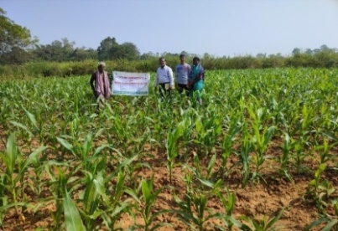  Demonstration on Weed Management in maize | 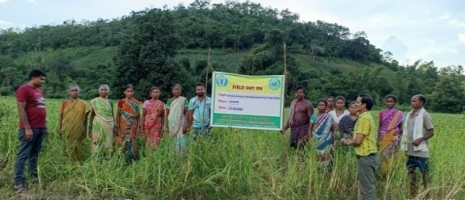  Field day on weed management in Finger millet
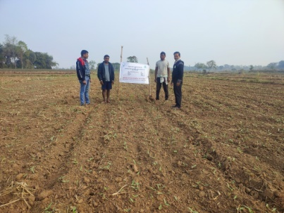  Demonstration on INM in Blackgram | 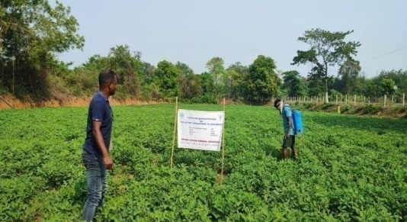  Demonstration on collar rot management in Groundnut
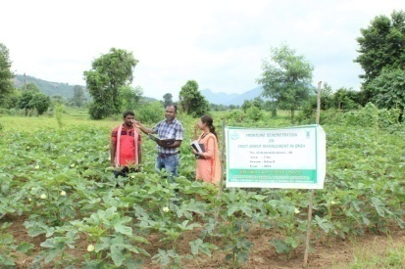  Demonstration on fruit borer management in okra | 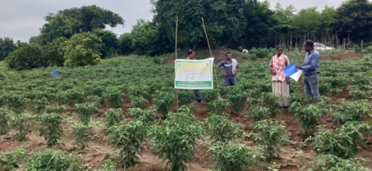  Demonstration on Integrated Pest Management of thrips and mite in chilli
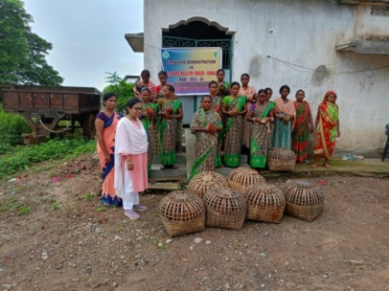  Demonstration on Poultry in backyard | 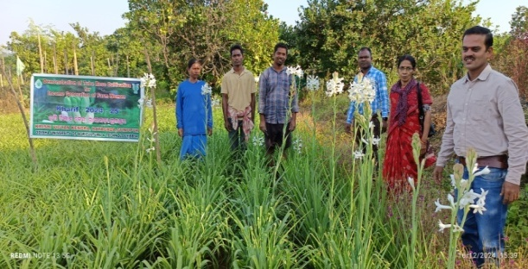  Demonstration on Tuberose cultivation for income generation
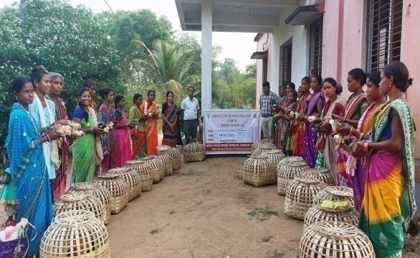  Frontline demonstration under TSP | 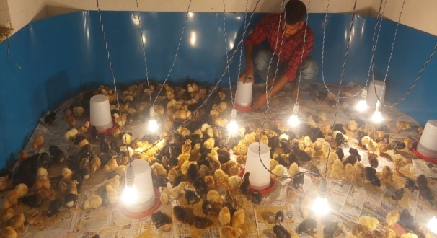
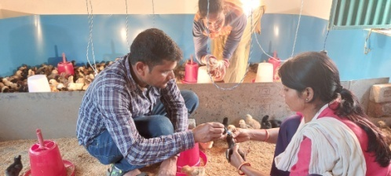
Demonstration on brooding management in chicks

Technical Feedback on the demonstrated technologies

Sl. No | Crop | Feed Back
 | Maize | Application of Tembotrione + Atrazine at 20 DAS and one hand weeding has resulted in 12.3 % yield increment along with BC ratio 1.68.
 | Finger millet | Application of Pre-emergence Bensulfuron methyl + Pretilachlor followed by 2,4-D ethyl ester has resulted in 20 % yield increment along with BC ratio from 1.61 to 1.74.
 | Blackgram | Use of Soil Test based fertilizer application, integration with organic and seed inoculation of Rhizobium gave 18.6% higher yield
 | Chilli | IPM through soil application of neem cake, installation of blue sticky trap, need based alternate application of Difenthiuron and Spiromesifen at 10 days interval starting from 30 DAT resulted 32 % increase in yield and with BC ratio 3.43.
 | Okra | Application of Chlorantraniliprole twice in okra at 30 and 45 DAS successfully reduced the fruit borer infestation from 33 % to 6% with 30.93% yield increase.
 | Groundnut | Recorded less disease incidence as well as 31.09% more yield as compared to FP through seed treatment with Carboxin + Thiram and alternate spraying with Chlorothalonil and Carbendazim.
 | Poultry in backyard | Rearing of poultry Rainbow rooster and Sonali breed in backyard fetches Rs. 380/- more than desi bird.
 | Tube rose | Small and marginal farm women can adopt tube rose cultivation for economic sustainability.

Extension and Training activities under FLD

Sl.No. | Activity | Date | No. of activities organized | Number of participants | Remarks
1. | Field days | 15.10.2024, 16.10.2024, 25.10.2025, 30.10.2024, 13.11.2024, 30.12.2024, 04.03.2025, 11.03.2025, 20.03.2025, 25.03.2025, 28.03.2025, 29.03.2025 | 12 | 300 | -
2. | Farmers Training | 27.06.2024, 06.08.2024, 02.09.2024,13.09.2024, 23.09.2024, 24.09.2024  24.10.2024, 27.11.2024, 26.12.2024, 06.01.2025, 17.01.2025, 13.02.2025, 17.03.2025, 19.03.2025 | 14 | 350 | -
3. | Media coverage | - | - | - | -
4. | Training for extension functionaries | - | - | - | -

Performance of the demonstration under CFLD on Pulse and Oilseed Crops during Kharif 2024 and Rabi 2023-24:

- Technical Parameters:
Sl.  No. | Crop demonstrated | Existing (Farmer's) variety name | Existing yield  (q/ha) | Yield gap (Kg/ha)  w.r.to |  |  | Name of Variety + Technology  demonstrated | Number of farmers | Area in ha | Yield obtained (q/ha) |  |  | Yield gap minimized  (%)
 |  |  |  | District  yield (D) | State  yield (S) | Potential  yield (P)
 |  |  |  |  |  |  |  |  |  | Max. | Min. | Av. | D | S | P
1 | Groundnut | OG 52-1 | 14.5 | 18 | 16.5 | 25 | High yielding variety- Kadiri Lepakshi used, INM,IPM & IDM | 150 | 60 | 20.9 | 18.1 | 19.5 | 8.3 | 18.2 | -22
2 | Sesame | Uma | 4.7 | 4.27 | 4.12 | 8.0 | High yielding variety- Kalinga sesame 3-1 used, INM, IPM and IDM | 200 | 80 | - | - | - | - | - | -

- Economic parameters
Sl.  No. | Variety demonstrated & Technology demonstrated | Farmer’s Existing plot |  |  |  | Demonstration plot
Sl.  No. | Variety demonstrated & Technology demonstrated | Gross Cost  (Rs/ha) | Gross return  (Rs/ha) | Net Return  (Rs/ha) | B:C  ratio | Gross Cost  (Rs/ha) | Gross return  (Rs/ha) | Net Return  (Rs/ha) | B:C  ratio
1. | High yielding variety Kadiri Lepakshi, integrated nutrient, pest and disease management | 61000 | 84825 | 23825 | 1.39 | 64500 | 114075 | 49575 | 1.77
2 | High yielding variety- Kalinga sesame 3-1 used, INM, IPM and IDM | Continuing

- Socio-economic impact parameters
Sl.  No. | Crop and variety  Demonstrated | Total Produce  Obtained (kg) | Produce sold  (Kg/household) | Selling  Rate  (Rs/Kg) | Produce used for own sowing (Kg) | Produce distributed to other farmers (Kg) | Purpose for which income gained was utilized | Employment Generated (Mandays/house hold)
1 | Groundnut and Kadiri Lepakshi | 1950 | 1800 | 60 | 100 | 50 | Health, Homed and Education | 3
2 | Sesame | Continuing

- Oilseed Farmers’ perception of the intervention demonstrated
Sl.  No. | Technologies demonstrated  (with name) | Farmers' Perception parameters
Sl.  No. | Technologies demonstrated  (with name) | Suitability to their farming system | Likings  (Preference) | Affordability | Any negative effect | Is Technology acceptable to all in the group/village | Suggestions, for change/improvement, if any
1 | Groundnut variety Kadiri Lepakshi, apply gypsum @ 300 kg/ha as basal, Chloropyriphos@ 25kg/ha for Termite control, spray Fipronil@ 2ml/l for control of leaf cutting catterpiller and Chlorothalonil 75% WP @ 2 gm/l for control of collar rot | As rainfed upland,  it is a suitable crop | Most Liking | Yes | No | Yes | Requirement of tikka disease resistant high yielding variety of groundnut
2 | Sesame variety Kalinga Sesame3-1, apply profenphos@ 1l/ha for leafwebber, use of Neem oil @ 1.5 l/ha for pest control, spray propiconazole@ 500ml/ha for powder mildew, Spray Copper Oxychloride @3gm/l for blight, spray Thaimethoxam@ 0.25gm/l for phylloid and sucking pest management, spray of Zinc Sulphate 12%, 7. 0.1% spray of Boron (20%B) at reproductive stage | Continuing

- Specific Characteristics of Technology and Performance

Specific Characteristic | Performance | Performance of Technology vis-a vis Local Check | Farmers Feedback
Groundnut var. Kadiri Lepakshi is high yielder (25q/ha), mature within 110 days, high oil content (49%), 75-77% shelling percentage | Drought tolerant – withstands up to 35 days dry spell, uniform maturity, high SMK%, attractive pods, moderate stature and tolerant to low light conditions | High yield and oil content | Good
Sesame Var. Kalinga sesame 3-1 | Continuing
- Extension activities under FLD conducted:
Sl. No. | Extension Activities organized | Date and place of activity | Number of farmer attended
Groundnut
1 | Training/Groundnut | 05.08.2024/Badagatiguda | 25
2 | Training/ Groundnut | 08.08.2024/LLPur | 25
3 | Training/ Groundnut | 21.08.2024/Patuguda | 25
4 | Training/ Groundnut | 23.08.2024/Goranda | 25
5 | Training/ Groundnut | 30.09.2024/ Pradhaniguda | 25
6 | Training/ Groundnut | 03.10.2024/Majhikudia | 25
7 | Field Day/ Groundnut | 18.11.2024/LLPur | 50
8 | Field Day/ Groundnut | 25.11.2024/Patuguda | 50
9 | Field Day/ Groundnut | 30.11.2024/Goranda | 50
10 | Field Day/ Groundnut | 2.12.2024/Majhikudia | 50
11 | Field Day/ Groundnut | 14.12.2024/Badagatiguda | 50
12 | Field Day/ Groundnut | 22.12.2024/Pradhaniguda | 50
Sesame
1 | Training/Sesame | 11.02.2025//Majhikudia | 25
2 | Training/ Sesame | 12.02.2025/Bissamcuttack | 25
3 | Training/ Sesame | 17.02.2025/Jaripanga | 25
4 | Training/ Sesame | 29.03.2025/ Gadhiakhola | 25
5 | Field Day/ Sesame | 19.03.2025/ Jaripanga | 50
6 | Field Day/ Sesame | 26.03.2025/Bissamcuttack | 50
7 | Field Day/ Sesame | 27.03.2025/Majhikudia | 50
8 | Field Day/ Sesame | 29.03.2025/Gadhiakhola | 50

- Sequential good quality photographs (as per crop stages i.e. growth & development)
- Farmers' training photographs
- Quality Action Photographs of field visits/field days and technology demonstrated.

J. Details of budget utilization

Crop  (provide crop wise information ) | Items | Budget  Received  (Rs.) | Budget  Utilization  (Rs.) | Balance  (Rs.)
Groundnut | i) Critical input |  | 771020
Groundnut | ii) TA/DA/POL etc. for monitoring |  | 118404
Groundnut | iii) Extension Activities (Field day) |  | 32250
Groundnut | iv) Publication of literature |  | 18000
 | Total | 1164500 | 939674 | 224798
Sesame | i) Critical input |  | 165300
Sesame | ii) TA/DA/POL etc. for monitoring |  | 19800
Sesame | iii) Extension Activities (Field day) |  | 24620
Sesame | iv) Publication of literature
 | Total | 640000 | 209720

  - Achievements on Training (Including the sponsored and FLD training programmes):

- Farmers and farm women (on campus)

Thematic Area | No. of Courses | No. of Participants |  |  |  |  |  |  |  |  |  | Grand Total
Thematic Area | No. of Courses | Other |  |  | SC |  |  |  | ST
 | No. of Courses | M | F | T | M | F |  | T | M | F | T | M | F | T
I. Crop Production
Weed Management | 2 | 2 |  | 2 |  |  |  |  | 41 | 7 | 48 | 43 | 7 | 50
Resource Conservation Technologies
Cropping Systems
Crop Diversification
Integrated Farming
Micro irrigation/irrigation
Seed production
Nursery management
Integrated Crop Management
Soil & water conservation
Integrated Nutrient Management | 1 |  |  |  |  |  |  |  | 21 | 4 | 25 | 21 | 4 | 25
Production of organic inputs | 1 | 2 | 0 | 2 | 1 | 0 |  | 1 | 4 | 18 | 22 | 7 | 18 | 25
Others
Total | 4 | 4 | 0 | 4 | 1 | 0 |  | 1 | 66 | 29 | 95 | 71 | 29 | 100
II. Horticulture
a) Vegetable Crops
Production of low volume and high value crops | 2 | 2 | 0 | 2 |  |  |  |  | 41 | 7 | 48 | 43 | 7 | 50
Off season vegetables
Nursery raising
Exotic vegetables
Export potential vegetables
Grading and standardization
Protective cultivation
Others
Total (a) | 2 | 2 | 0 | 2 |  |  |  |  | 41 | 7 | 48 | 43 | 7 | 50
b) Fruits
Training and Pruning
Layout and Management of Orchards
Cultivation of Fruit | 3 | 3 | 0 | 3 | 0 | 3 |  | 3 | 45 | 24 | 69 | 48 | 27 | 75
Management of young plants/orchards
Rejuvenation of old orchards
Export potential fruits
Micro irrigation systems of orchards
Plant propagation techniques
Others
Total (b) | 3 | 3 | 0 | 3 | 0 | 3 |  | 3 | 45 | 24 | 69 | 48 | 27 | 75
c) Ornamental Plants
Nursery Management
Management of potted plants
Export potential of ornamental plants
Propagation techniques of Ornamental Plants
Others
Total (c)
d) Plantation crops
Production and Management technology | 1 | 2 | 0 | 2 | 0 | 0 |  | 0 | 21 | 2 | 23 | 23 | 2 | 25
Processing and value addition
Others
Total (d) | 1 | 2 | 0 | 2 | 0 | 0 |  | 0 | 21 | 2 | 23 | 23 | 2 | 25
e) Tuber crops
Production and Management technology
Processing and value addition
Others
Total (e)
f) Spices
Production and Management technology
Processing and value addition
Others
Total (f)
g) Medicinal and Aromatic Plants
Nursery management
Production and management technology
Post harvest technology and value addition
Others
Total (g)
Total(a-g) | 6 | 7 | 0 | 7 | 0 | 3 |  | 3 | 107 | 33 | 140 | 114 | 36 | 150
III. Soil Health and Fertility Management
Soil fertility management
Integrated water management
Integrated Nutrient Management
Production and use of organic inputs
Management of Problematic soils
Micro nutrient deficiency in crops
Nutrient Use Efficiency
Balance Use of fertilizer
Soil & water testing
others
Total
IV. Livestock Production and Management
Dairy Management
Poultry Management
Piggery Management
Rabbit Management
Animal Nutrition Management
Disease Management
Feed & fodder technologies
Production of quality animal products
Others
Total
V. Home Science/Women empowerment
Household food security by kitchen gardening and nutrition gardening
Design and development of low/minimum cost diet
Designing and development for high nutrient efficiency diet
Minimization of nutrient loss in processing
Processing & cooking
Gender mainstreaming through SHGs
Storage loss minimization techniques
Value addition
Women empowerment
Location specific drudgery reduction technologies
Rural Crafts
Women and child care
Others  (Entrepreneurship development through paddy straw mushroom cultivation  ) | 1 |  |  |  |  |  |  |  | 0 | 25 | 25 | 0 | 25 | 25
Total | 1 |  |  |  |  |  |  |  | 0 | 25 | 25 | 0 | 25 | 25
VI. Agril. Engineering
Farm machinery & its maintenance
Installation and maintenance of micro irrigation systems
Use of Plastics in farming practices
Production of small tools and implements
Repair and maintenance of farm machinery and implements
Small scale processing and value addition
Post Harvest Technology
Others
Total
VII. Plant Protection
Integrated Pest Management | 1 |  |  |  |  |  |  |  | 23 | 2 | 25 | 23 | 2 | 25
Integrated Disease Management
Biocontrol of pests and diseases
Production of bio control agents and bio pesticides
Others (Integrated Pest and Disease Management) | 7 | 7 | 1 | 8 |  |  |  |  | 126 | 16 | 142 | 133 | 17 | 150
Total | 8 | 8 | 1 | 9 |  |  |  |  | 168 | 23 | 191 | 176 | 24 | 200
VIII. Fisheries
Integrated fish farming
Carp breeding and hatchery management
Carp fry and fingerling rearing
Composite fish culture
Hatchery management and culture of freshwater prawn
Breeding and culture of ornamental fishes
Portable plastic carp hatchery
Pen culture of fish and prawn
Shrimp farming
Edible oyster farming
Pearl culture
Fish processing and value addition
Others
Total
IX. Production of Input at site
Seed Production
Planting material production
Bio0agents production
Bio0pesticides production
Bio0fertilizer production
Vermi0compost production
Organic manures production
Production of fry and fingerlings
Production of Bee0colonies and wax sheets
Small tools and implements
Production of livestock feed and fodder
Production of Fish feed
Mushroom production
Apiculture
Others
Total
X. Capacity Building and Group Dynamics
Leadership development
Group dynamics
Formation and Management of SHGs
Mobilization of social capital
Entrepreneurial development of farmers/youths
WTO and IPR issues
Others
Total
XI. Agro forestry
Production technologies
Nursery management
Integrated Farming Systems
Others
Total
XII. Others (Pl. Specify)
GRAND TOTAL | 19 | 19 | 1 | 20 | 1 |  | 3 | 4 | 341 | 110 | 451 | 361 | 114 | 475

B) Rural Youth (on campus)

Thematic Area | No. of Courses | No. of Participants |  |  |  |  |  |  |  |  |  | Grand Total
Thematic Area | No. of Courses | Other |  |  | SC |  |  |  | ST
 | No. of Courses | M | F | T | M | F |  | T | M | F | T | M | F | T
Nursery Management of Horticulture crops | 1 |  |  |  |  |  |  |  | 10 | 5 | 15 | 10 | 5 | 15
Training and pruning of orchards | 1 |  |  |  |  |  |  |  | 10 | 5 | 15 | 10 | 5 | 15
Protected cultivation of vegetable crops | 1 | 2 | 0 | 2 |  |  |  |  | 13 | 0 | 13 | 15 | 0 | 15
Commercial fruit production
Integrated farming
Seed production | 1 |  |  |  |  |  |  |  | 15 | 0 | 15 | 15 | 0 | 15
Production of organic inputs | 1 |  |  |  |  |  |  |  | 10 | 5 | 15 | 10 | 5 | 15
Planting material production | 1 |  |  |  |  |  |  |  | 15 | 0 | 15 | 15 | 0 | 15
Vermiculture
Mushroom Production
Beekeeping | 1 | 1 |  | 1 |  |  |  |  | 9 | 5 | 15 | 10 | 5 | 15
Sericulture
Repair and maintenance of farm machinery and implements
Value addition
Small scale processing
Post Harvest Technology
Tailoring and Stitching
Rural Crafts
Production of quality animal products
Dairying
Sheep and goat rearing
Quail farming
Piggery
Rabbit farming
Poultry production
Ornamental fisheries
Composite fish culture
Freshwater prawn culture
Shrimp farming
Pearl culture
Cold water fisheries
Fish harvest and processing technology
Fry and fingerling rearing
Others (Crop diversification, Rhizobium culture use) | 2 |  |  |  |  |  |  |  | 28 | 2 | 30 | 28 | 2 | 30
Integrated Pest and Disease management in vegetable crops | 1 |  |  |  |  |  |  |  | 13 | 2 | 15 | 13 | 2 | 15
Use of Bio-pesticides in different field crops | 1 |  |  |  |  |  |  |  | 13 | 2 | 15 | 13 | 2 | 15
Stored grain pest management | 1 |  |  |  |  |  |  |  | 15 |  | 15 | 15 |  | 15
Paddy straw mushroom cultivation to enhance income generation of SHGs | 1 |  |  |  |  |  |  |  | 0 | 15 | 15 | 0 | 15 | 15
Total | 13 | 3 | 0 | 3 |  |  |  |  | 151 | 41 | 193 | 154 | 41 | 195

C) Extension Personnel (on campus)

Thematic Area | No. of Courses | No. of Participants |  |  |  |  |  |  |  |  |  | Grand Total
Thematic Area | No. of Courses | Other |  |  | SC |  |  |  | ST
 | No. of Courses | M | F | T | M | F |  | T | M | F | T | M | F | T
Productivity enhancement in field crops | 1 | 3 | 0 | 3 | 1 |  | 1 | 2 | 5 | 0 | 5 | 9 | 1 | 10
Integrated Pest Management
Integrated Nutrient management
Rejuvenation of old orchards
Protected cultivation technology
Production and use of organic inputs | 1 | 3 | 0 | 3 | 0 |  | 0 | 0 | 7 | 0 | 7 | 10 | 0 | 10
Care and maintenance of farm machinery and implements
Gender mainstreaming through SHGs
Formation and Management of SHGs
Women and Child care
Low cost and nutrient efficient diet designing
Group Dynamics and farmers organization
Information networking among farmers
Capacity building for ICT application
Management in farm animals
Livestock feed and fodder production
Household food security
Other
Integrated Approach for Pest and Disease Management in Cotton to minimize residual effect on environment | 1 | 3 | 3 | 6 |  |  |  |  | 3 | 1 | 4 | 6 | 4 | 10
Invasive Pest and their Management | 1 | 3 |  | 3 |  |  |  |  | 7 |  | 7 | 10 | 0 | 10
Xeriscapeing and land scapeing | 1 | 1 | 1 | 2 |  |  | 1 | 1 | 5 | 2 | 7 | 6 | 4 | 10
Hi tech hort tech. | 1 | 1 | 1 | 2 |  |  | 1 | 1 | 5 | 2 | 7 | 6 | 4 | 10
Scientific beekeeping | 1 | 2 | 0 | 2 | 0 |  | 0 | 0 | 18 | 0 | 18 | 20 | - | 20
Total | 7 | 16 | 5 | 21 | 1 |  | 3 | 4 | 50 | 5 | 55 | 67 | 13 | 80
D) Farmers and farm women (off campus)

Thematic Area | No. of Courses | No. of Participants |  |  |  |  |  |  |  |  |  | Grand Total
Thematic Area | No. of Courses | Other |  |  | SC |  |  |  | ST
 | No. of Courses | M | F | T | M | F |  | T | M | F | T | M | F | T
I. Crop Production
Weed Management | 5 | 6 | 2 | 8 | 3 | 0 |  | 3 | 89 | 25 | 114 | 98 | 27 | 125
Resource Conservation Technologies | 2 |  |  |  |  |  |  |  | 45 | 5 | 50 | 45 | 5 | 50
Cropping Systems | 2 | 4 | 0 | 4 | 5 | 0 |  | 5 | 41 | 8 | 20 | 49 | 9 | 50
Crop Diversification | 3 |  |  |  |  |  |  |  | 70 | 5 | 75 | 70 | 5 | 75
Integrated Farming | 3 | 9 | 3 | 12 | 2 | 0 |  | 2 | 57 | 4 | 61 | 68 | 7 | 75
Micro irrigation/irrigation
Seed production | 1 |  |  |  |  |  |  |  | 25 | 0 | 25 | 25 | 0 | 25
Nursery management
Integrated Crop Management
Soil & water conservation
Integrated nutrient Management | 4 |  |  |  |  |  |  |  | 40 | 60 | 100 | 40 | 63 | 100
Production of organic inputs
Others
Total | 20 | 19 | 5 | 24 | 10 | 0 |  | 10 | 367 | 107 | 445 | 395 | 116 | 500
II. Horticulture
a) Vegetable Crops
Production of low volume and high value crops | 2 | 1 |  | 1 |  |  |  |  | 23 | 26 | 49 | 24 | 26 | 50
Off season vegetables | 3 |  |  |  |  |  |  |  | 68 | 7 | 75 | 68 | 7 | 75
Nursery raising | 2 | 6 | 4 | 10 | 5 | 0 |  | 5 | 32 | 3 | 35 | 43 | 7 | 50
Exotic vegetables
Export potential vegetables
Grading and standardization
Protective cultivation
Others
Total (a) | 7 | 7 | 4 | 11 | 5 | 0 |  | 5 | 123 | 36 | 159 | 135 | 40 | 175
b) Fruits
Training and Pruning | 1 | 4 | 1 | 5 | 0 | 0 |  | 0 | 17 | 3 | 20 | 21 | 4 | 25
Layout and Management of Orchards
Cultivation of Fruit | 2 | 11 | 0 | 11 | 3 | 2 |  | 5 | 27 | 7 | 34 | 41 | 9 | 50
Management of young plants/orchards
Rejuvenation of old orchards
Export potential fruits
Micro irrigation systems of orchards
Plant propagation techniques
Others
Total (b) | 3 | 15 | 1 | 16 | 3 | 2 |  | 5 | 44 | 10 | 54 | 62 | 13 | 75
c) Ornamental Plants
Nursery Management
Management of potted plants
Export potential of ornamental plants
Propagation techniques of Ornamental Plants
Others
Total (c)
d) Plantation crops
Production and Management technology
Processing and value addition
Others
Total (d)
e) Tuber crops
Production and Management technology
Processing and value addition
Others
Total (e)
f) Spices
Production and Management technology
Processing and value addition
Others
Total (f)
g) Medicinal and Aromatic Plants
Nursery management
Production and management technology
Post harvest technology and value addition
Others
Total (g)
Total(a-g) | 10 | 22 | 5 | 27 | 8 | 2 |  | 10 | 167 | 46 | 213 | 197 | 53 | 250
III. Soil Health and Fertility Management
Soil fertility management
Integrated water management
Integrated Nutrient Management
Production and use of organic inputs
Management of Problematic soils
Micro nutrient deficiency in crops
Nutrient Use Efficiency
Balance Use of fertilizer
Soil & water testing
others
Total
IV. Livestock Production and Management
Dairy Management
Poultry Management
Piggery Management
Rabbit Management
Animal Nutrition Management
Disease Management
Feed & fodder technologies
Production of quality animal products
Others
Total
V. Home Science/Women empowerment
Household food security by kitchen gardening and nutrition gardening | 2 |  |  |  |  |  |  |  | 0 | 50 | 50 | 0 | 50 | 50
Design and development of low/minimum cost diet
Designing and development for high nutrient efficiency diet
Minimization of nutrient loss in processing
Processing & cooking
Gender mainstreaming through SHGs | 3 |  |  |  |  |  |  |  | 0 | 75 | 75 | 0 | 75 | 75
Storage loss minimization techniques
Value addition
Women empowerment
Location specific drudgery reduction technologies | 1 | 0 | 7 | 7 |  |  |  |  | 0 | 18 | 18 | 0 | 25 | 25
Rural Crafts
Women and child care
Others  Training programme on Nutrition gardening for nutrition security of tribal farm families | 1 |  |  |  |  |  |  |  | 0 | 25 | 25 | 0 | 25 | 25
Total | 7 | 0 | 7 | 7 |  |  |  |  | 0 | 168 | 168 | 0 | 175 | 175
VI. Agril. Engineering
Farm machinery & its maintenance
Installation and maintenance of micro irrigation systems
Use of Plastics in farming practices
Production of small tools and implements
Repair and maintenance of farm machinery and implements
Small scale processing and value addition
Post Harvest Technology
Others
Total
VII. Plant Protection
Integrated Pest Management | 5 | 10 | 0 | 10 | 7 | 0 |  | 7 | 95 | 13 | 108 | 112 | 13 | 125
Integrated Disease Management | 5 | 23 | 5 | 28 | 12 | 0 |  | 12 | 47 | 38 | 85 | 82 | 43 | 125
Bio-control of pests and diseases | 1 | 8 | 0 | 8 | 3 | 0 |  | 3 | 9 | 5 | 14 | 20 | 5 | 25
Production of bio control agents and bio pesticides
Others (Integrated Pest and Disease Management) | 6 | 18 | 4 | 22 | 7 | 0 |  | 7 | 109 | 12 | 121 | 134 | 16 | 150
Total | 17 | 59 | 9 | 68 | 29 | 0 |  | 29 | 260 | 68 | 328 | 348 | 77 | 425
VIII. Fisheries
Integrated fish farming
Carp breeding and hatchery management
Carp fry and fingerling rearing
Composite fish culture
Hatchery management and culture of freshwater prawn
Breeding and culture of ornamental fishes
Portable plastic carp hatchery
Pen culture of fish and prawn
Shrimp farming
Edible oyster farming
Pearl culture
Fish processing and value addition
Others
Total
IX. Production of Input at site
Seed Production
Planting material production
Bio-agents production
Bio-pesticides production
Bio-fertilizer production
Vermi-compost production
Organic manures production
Production of fry and fingerlings
Production of Bee-colonies and wax sheets
Small tools and implements
Production of livestock feed and fodder
Production of Fish feed
Mushroom production
Apiculture
Others
Total
X. Capacity Building and Group Dynamics
Leadership development
Group dynamics
Formation and Management of SHGs
Mobilization of social capital
Entrepreneurial development of farmers/youths
WTO and IPR issues
Others
Total
XI. Agro forestry
Production technologies
Nursery management
Integrated Farming Systems
Others
Total
XII. Others (Pl. Specify)
GRAND TOTAL | 16 | 1 |  | 1 | 1 |  |  | 1 | 199 | 199 | 398 | 201 | 202 | 400
E) RURAL YOUTH (Off Campus)

Thematic Area | No. of Courses | No. of Participants |  |  |  |  |  |  |  |  |  | Grand Total
Thematic Area | No. of Courses | Other |  |  | SC |  |  |  | ST
 | No. of Courses | M | F | T | M | F |  | T | M | F | T | M | F | T
Nursery Management of Horticulture crops
Training and pruning of orchards
Protected cultivation of vegetable crops
Commercial fruit production
Integrated farming
Seed production
Production of organic inputs
Planting material production
Vermiculture
Mushroom Production
Beekeeping
Sericulture
Repair and maintenance of farm machinery and implements
Value addition
Small scale processing
Post Harvest Technology
Tailoring and Stitching
Rural Crafts
Production of quality animal products
Dairying
Sheep and goat rearing
Quail farming
Piggery
Rabbit farming
Poultry production
Ornamental fisheries
Composite fish culture
Freshwater prawn culture
Shrimp farming
Pearl culture
Cold water fisheries
Fish harvest and processing technology
Fry and fingerling rearing
Others
Total

F) Extension Personnel (Off Campus)

Thematic Area | No. of Courses | No. of Participants |  |  |  |  |  |  |  |  |  | Grand Total
Thematic Area | No. of Courses | Other |  |  | SC |  |  |  | ST
 | No. of Courses | M | F | T | M | F |  | T | M | F | T | M | F | T
Productivity enhancement in field crops
Integrated Pest Management
Integrated Nutrient management
Rejuvenation of old orchards
Protected cultivation technology
Production and use of organic inputs
Care and maintenance of farm machinery and implements
Gender mainstreaming through SHGs
Formation and Management of SHGs
Women and Child care
Low cost and nutrient efficient diet designing
Group Dynamics and farmers organization
Information networking among farmers
Capacity building for ICT application
Management in farm animals
Livestock feed and fodder production
Household food security
Other
Total

Consolidated table (ON and OFF Campus)
i. Farmers & Farm Women
Thematic Area | No. of Courses | No. of Participants |  |  |  |  |  |  |  |  |  | Grand Total
Thematic Area | No. of Courses | Other |  |  | SC |  |  |  | ST
 | No. of Courses | M | F | T | M | F |  | T | M | F | T | M | F | T
I. Crop Production
Weed Management | 7 | 8 | 2 | 10 | 3 | 0 |  | 3 | 130 | 32 | 162 | 141 | 34 | 175
Resource Conservation Technologies | 2 |  |  |  |  |  |  |  | 45 | 5 | 50 | 45 | 5 | 50
Cropping Systems | 2 | 4 | 0 | 4 | 5 | 0 |  | 5 | 41 | 8 | 20 | 49 | 9 | 50
Crop Diversification | 3 |  |  |  |  |  |  |  | 70 | 5 | 75 | 70 | 5 | 75
Integrated Farming | 3 | 9 | 3 | 12 | 2 | 0 |  | 2 | 57 | 4 | 61 | 68 | 7 | 75
Micro irrigation/irrigation
Seed production | 1 |  |  |  |  |  |  |  | 25 | 0 | 25 | 25 | 0 | 25
Nursery management
Integrated Crop Management
Soil & water conservation
Integrated nutrient Management | 5 |  |  |  |  |  |  |  | 61 | 64 | 125 | 61 | 67 | 125
Production of organic inputs | 1 | 2 | 0 | 2 | 1 | 0 |  | 1 | 4 | 18 | 22 | 7 | 18 | 25
Others
Total | 24 | 23 | 5 | 28 | 11 | 0 |  | 11 | 433 | 136 | 540 | 466 | 145 | 600
II. Horticulture
a) Vegetable Crops
Production of low volume and high value crops | 4 | 3 | 0 | 3 |  |  |  |  | 64 | 33 | 97 | 67 | 33 | 100
Off-season vegetables | 3 |  |  |  |  |  |  |  | 68 | 7 | 75 | 68 | 7 | 75
Nursery raising | 2 | 6 | 4 | 10 | 5 | 0 |  | 5 | 32 | 3 | 35 | 43 | 7 | 50
Exotic vegetables
Export potential vegetables
Grading and standardization
Protective cultivation
Others
Total (a) | 9 | 9 | 4 | 13 | 5 | 0 |  | 5 | 164 | 43 | 207 | 178 | 47 | 225
b) Fruits
Training and Pruning | 1 | 4 | 1 | 5 | 0 | 0 |  | 0 | 17 | 3 | 20 | 21 | 4 | 25
Layout and Management of Orchards
Cultivation of Fruit | 5 | 14 | 0 | 14 | 3 | 5 |  | 8 | 72 | 31 | 103 | 89 | 36 | 125
Management of young plants/orchards
Rejuvenation of old orchards
Export potential fruits
Micro irrigation systems of orchards
Plant propagation techniques
Others
Total (b) | 6 | 18 | 1 | 19 | 3 | 5 |  | 8 | 89 | 34 | 123 | 110 | 40 | 150
c) Ornamental Plants
Nursery Management
Management of potted plants
Export potential of ornamental plants
Propagation techniques of Ornamental Plants
Others
Total (c)
d) Plantation crops
Production and Management technology | 1 | 2 | 0 | 2 | 0 | 0 |  | 0 | 21 | 2 | 23 | 23 | 2 | 25
Processing and value addition
Others
Total (d) | 1 | 2 | 0 | 2 | 0 | 0 |  | 0 | 21 | 2 | 23 | 23 | 2 | 25
e) Tuber crops
Production and Management technology
Processing and value addition
Others
Total (e)
f) Spices
Production and Management technology
Processing and value addition
Others
Total (f)
g) Medicinal and Aromatic Plants
Nursery management
Production and management technology
Post harvest technology and value addition
Others
Total (g)
Total(a-g) | 16 | 29 | 5 | 34 | 8 | 5 |  | 13 | 274 | 79 | 353 | 311 | 89 | 400
III. Soil Health and Fertility Management
Soil fertility management
Integrated water management
Integrated Nutrient Management
Production and use of organic inputs
Management of Problematic soils
Micro nutrient deficiency in crops
Nutrient Use Efficiency
Balance Use of fertilizer
Soil & water testing
others
Total
IV. Livestock Production and Management
Dairy Management
Poultry Management
Piggery Management
Rabbit Management
Animal Nutrition Management
Disease Management
Feed & fodder technologies
Production of quality animal products
Others
Total
V. Home Science/Women empowerment
Household food security by kitchen gardening and nutrition gardening | 2 |  |  |  |  |  |  |  | 0 | 50 | 50 | 0 | 50 | 50
Design and development of low/minimum cost diet
Designing and development for high nutrient efficiency diet
Minimization of nutrient loss in processing
Processing & cooking
Gender mainstreaming through SHGs | 3 |  |  |  |  |  |  |  | 0 | 75 | 75 | 0 | 75 | 75
Storage loss minimization techniques
Value addition
Women empowerment
Location specific drudgery reduction technologies | 1 | 0 | 7 | 7 |  |  |  |  | 0 | 18 | 18 | 0 | 25 | 25
Rural Crafts
Women and child care
Others  (Entrepreneurship development through paddy straw mushroom cultivation  ) | 1 |  |  |  |  |  |  |  | 0 | 25 | 25 | 0 | 25 | 25
Training programme on Nutrition gardening for nutrition security of tribal farm families | 1 |  |  |  |  |  |  |  | 0 | 25 | 25 | 0 | 25 | 25
Total | 8 | 0 | 7 | 7 |  |  |  |  | 0 | 193 | 193 | 0 | 200 | 200
VI. Agril. Engineering
Farm machinery & its maintenance
Installation and maintenance of micro irrigation systems
Use of Plastics in farming practices
Production of small tools and implements
Repair and maintenance of farm machinery and implements
Small scale processing and value addition
Post Harvest Technology
Others
Total
VII. Plant Protection
Integrated Pest Management | 6 | 10 | 0 | 10 | 7 | 0 |  | 7 | 118 | 15 | 133 | 135 | 15 | 150
Integrated Disease Management | 5 | 23 | 5 | 28 | 12 | 0 |  | 12 | 47 | 38 | 85 | 82 | 43 | 125
Biocontrol of pests and diseases | 1 | 8 | 0 | 8 | 3 | 0 |  | 3 | 9 | 5 | 14 | 20 | 5 | 25
Production of bio control agents and bio pesticides
Others (Integrated Pest and Disease Management) | 13 | 25 | 5 | 30 | 7 | 0 |  | 7 | 235 | 28 | 263 | 267 | 33 | 300
Total | 25 | 66 | 10 | 76 |  |  |  |  | 409 | 86 | 495 | 504 | 96 | 600
VIII. Fisheries
Integrated fish farming
Carp breeding and hatchery management
Carp fry and fingerling rearing
Composite fish culture
Hatchery management and culture of freshwater prawn
Breeding and culture of ornamental fishes
Portable plastic carp hatchery
Pen culture of fish and prawn
Shrimp farming
Edible oyster farming
Pearl culture
Fish processing and value addition
Others
Total
IX. Production of Input at site
Seed Production
Planting material production
Bio-agents production
Bio-pesticides production
Bio-fertilizer production
Vermi-compost production
Organic manures production
Production of fry and fingerlings
Production of Bee-colonies and wax sheets
Small tools and implements
Production of livestock feed and fodder
Production of Fish feed
Mushroom production
Apiculture
Others
Total
X. Capacity Building and Group Dynamics
Leadership development
Group dynamics
Formation and Management of SHGs
Mobilization of social capital
Entrepreneurial development of farmers/youths
WTO and IPR issues
Others
Total
XI. Agro forestry
Production technologies
Nursery management
Integrated Farming Systems
Others
Total
XII. Others (Pl. Specify)
GRAND TOTAL | 73 | 118 | 27 | 145 | 19 |  | 5 | 24 | 1116 | 494 | 1581 | 1281 | 530 | 1800

ii. RURAL YOUTH (On and Off Campus)

Thematic Area | No. of Courses | No. of Participants |  |  |  |  |  |  |  |  |  | Grand Total
Thematic Area | No. of Courses | Other |  |  | SC |  |  |  | ST
 | No. of Courses | M | F | T | M | F |  | T | M | F | T | M | F | T
Nursery Management of Horticulture crops | 1 |  |  |  |  |  |  |  | 10 | 5 | 15 | 10 | 5 | 15
Training and pruning of orchards | 1 |  |  |  |  |  |  |  | 10 | 5 | 15 | 10 | 5 | 15
Protected cultivation of vegetable crops | 1 | 2 | 0 | 2 |  |  |  |  | 13 | 0 | 13 | 15 | 0 | 15
Commercial fruit production
Integrated farming
Seed production | 1 |  |  |  |  |  |  |  | 15 | 0 | 15 | 15 | 0 | 15
Production of organic inputs | 1 |  |  |  |  |  |  |  | 10 | 5 | 15 | 10 | 5 | 15
Planting material production | 1 |  |  |  |  |  |  |  | 15 | 0 | 15 | 15 | 0 | 15
Vermiculture
Mushroom Production
Beekeeping | 1 | 1 |  | 1 |  |  |  |  | 9 | 5 | 15 | 10 | 5 | 15
Sericulture
Repair and maintenance of farm machinery and implements
Value addition
Small scale processing
Post Harvest Technology
Tailoring and Stitching
Rural Crafts
Production of quality animal products
Dairying
Sheep and goat rearing
Quail farming
Piggery
Rabbit farming
Poultry production
Ornamental fisheries
Composite fish culture
Freshwater prawn culture
Shrimp farming
Pearl culture
Cold water fisheries
Fish harvest and processing technology
Fry and fingerling rearing
Others (Crop diversification, Rhizobium culture use) | 2 |  |  |  |  |  |  |  | 28 | 2 | 30 | 28 | 2 | 30
Integrated Pest and Disease management in vegetable crops | 1 |  |  |  |  |  |  |  | 13 | 2 | 15 | 13 | 2 | 15
Use of Bio-pesticides in different field crops | 1 |  |  |  |  |  |  |  | 13 | 2 | 15 | 13 | 2 | 15
Stored grain pest management | 1 |  |  |  |  |  |  |  | 15 |  | 15 | 15 |  | 15
Paddy straw mushroom cultivation to enhance income generation of SHGs | 1 |  |  |  |  |  |  |  | 0 | 15 | 15 | 0 | 15 | 15
Total | 13 | 3 | 0 | 3 |  |  |  |  | 151 | 41 | 193 | 154 | 41 | 195

iii. Extension Personnel (On and Off Campus)

Thematic Area | No. of Courses | No. of Participants |  |  |  |  |  |  |  |  |  | Grand Total
Thematic Area | No. of Courses | Other |  |  | SC |  |  |  | ST
 | No. of Courses | M | F | T | M | F |  | T | M | F | T | M | F | T
Productivity enhancement in field crops | 1 | 3 | 0 | 3 | 1 |  | 1 | 2 | 5 | 0 | 5 | 9 | 1 | 10
Integrated Pest Management
Integrated Nutrient management
Rejuvenation of old orchards
Protected cultivation technology
Production and use of organic inputs | 1 | 3 | 0 | 3 | 0 |  | 0 | 0 | 7 | 0 | 7 | 10 | 0 | 10
Care and maintenance of farm machinery and implements
Gender mainstreaming through SHGs
Formation and Management of SHGs
Women and Child care
Low cost and nutrient efficient diet designing
Group Dynamics and farmers organization
Information networking among farmers
Capacity building for ICT application
Management in farm animals
Livestock feed and fodder production
Household food security
Other
Integrated Approach for Pest and Disease Management in Cotton to minimize residual effect on environment | 1 | 3 | 3 | 6 |  |  |  |  | 3 | 1 | 4 | 6 | 4 | 10
Invasive Pest and their Management | 1 | 3 |  | 3 |  |  |  |  | 7 |  | 7 | 10 | 0 | 10
Xeriscapeing and land scapeing | 1 | 1 | 1 | 2 |  |  | 1 | 1 | 5 | 2 | 7 | 6 | 4 | 10
Hi tech hort tech. | 1 | 1 | 1 | 2 |  |  | 1 | 1 | 5 | 2 | 7 | 6 | 4 | 10
Total | 6 | 14 | 5 | 19 | 1 |  | 3 | 4 | 32 | 5 | 37 | 47 | 13 | 60

Please furnish the details of training programmes as Annexure in the proforma given below

Discipline | Clientele |  | Title of the training programme | Duration in days | Venue (Off / On Campus) | Number of participants |  |  | Number of SC/ST
 |  |  |  |  |  | Male | Female | Total | Male | Female | Total
Home Science | Farmers/farm women | Entrepreneurship development through paddy straw mushroom cultivation |  | 1 | On campus | 0 | 25 | 25 | 0 | 25 | 25
Plant protection | Farmers/farm women | Some important pest and diseases of field crops and their management |  | 1 | Off campus | 14 | 11 | 25 | 14 | 11 | 25
Crop production | Farmers/ farm women | Integrated weed Management in Maize |  | 1 | On campus | 17 | 8 | 25 | 17 | 8 | 25
Home Science | Rural youth | Paddy straw mushroom cultivation to enhance income generation of SHGs |  | 1 | On campus | 0 | 15 | 15 | 0 | 15 | 15
Plant protection | Rural youth | Training programme on Skill training on scientific beekeeping to rural youth |  | 1 | On campus | 18 | 12 | 30 | 17 | 12 | 29
Crop production | Farmers/farm women | Integrated Weed Management in cotton |  | 1 | On campus | 23 | 2 | 25 | 21 | 2 | 23
Crop production | Extension personnel | Introduction of seed production in pigeon pea |  | 1 | On campus | 9 | 1 | 10 | 6 | 1 | 7
Crop production | Farmers/farm women | Integrated Weed Management in Groundnut |  | 1 | On campus | 20 | 5 | 25 | 20 | 5 | 25
Crop production | Farmers/farm women | Integrated Weed Management in Ragi |  | 1 | Off campus | 19 | 6 | 25 | 19 | 6 | 25
Home Science | Farmers/farm women | Nutrition gardening for nutrition security of tribal farm families |  | 1 | Off campus | 0 | 25 | 25 | 0 | 25 | 25
Plant protection | Farmers/farm women | Integrated pest management in cotton |  | 1 | On campus | 20 | 5 | 25 | 19 | 5 | 24
Horticulture | Farmers/farm women | Package of practices on cultivation of dragon fruit |  | 1 | On campus | 12 | 13 | 25 | 12 | 13 | 25
Home Science | Farmers/farm women | Skill training on Paddy straw mushroom cultivation and mushroom spawn production |  | 1 | On campus | 14 | 16 | 30 | 12 | 14 | 26
Crop production | Rural youth | Vocational training on vermicomposting |  | 1 | On campus | 12 | 18 | 30 | 12 | 18 | 30
Plant protection | Extension personnel | Integrated approach for pest and disease management for cotton to minimize residual effect on environment. (In service) |  | 1 | On campus | 6 | 4 | 10 | 3 | 1 | 4
Plant protection | Farmers/farm women | Training programme on integrated pest and disease management in rice |  | 1 | Off campus | 17 | 8 | 25 | 17 | 8 | 25
Plant protection | Rural youth | Training programme on integrated pest and disease management in Vegetable crops (RY) |  | 1 | On campus | 13 | 2 | 15 | 13 | 2 | 15
Horticulture | Farmers/farm women | Agro-techniques for chilli cultivation |  | 2 | Off campus | 16 | 9 | 25 | 16 | 8 | 24
Horticulture | Rural youth | Vocational training on plant propagation technique for rural youth |  | 5 | On campus | 18 | 12 | 30 | 18 | 12 | 30
Home Science | Farmers/farm women | Training on Gender mainstreaming through SHGs |  | 2 | On campus | 0 | 25 | 25 | 0 | 25 | 25
Crop production | Farmers/farm women | Integrated nutrient management in pigeon pea |  | 1 | Off campus | 8 | 17 | 25 | 8 | 17 | 25
Horticulture | Farmers/farm women | Agro techniques for Guava production |  | 2 | On campus | 17 | 8 | 25 | 17 | 7 | 24
Horticulture | Rural youth | High density planting in fruit crops |  | 2 | On campus | 10 | 5 | 15 | 10 | 5 | 15
Plant protection | Farmers/farm women | Integrated pest and disease management in rice. |  | 2 | Off campus | 9 | 16 | 25 | 9 | 16 | 25
Plant protection | Farmers/farm women | Integrated Pest and Disease Management in pulse crops |  | 1 | On campus | 18 | 7 | 25 | 18 | 7 | 25
Plant protection | Farmers/farm women | Training for master trainers for Scientific beekeeping |  | 1 | On campus | 20 | 0 | 20 | 18 | 0 | 18
Crop production | Farmers/farm women | Utilization of residual moisture and nutrient management in rice pulse paira cropping. |  | 2 | Off campus | 3 | 22 | 25 | 3 | 22 | 25
Crop production | Rural youth | NADEP composting and its application |  | 1 | On campus | 10 | 5 | 15 | 10 | 5 | 15
Horticulture | Farmers/farm women | Scientific cultivation practices on onion |  | 1 | On campus | 22 | 3 | 25 | 21 | 3 | 24
Plant protection | Rural youth | Vocational training on Mechanical and biological management of pests and diseases in field crops |  | 1 | On campus | 21 | 9 | 30 | 21 | 9 | 30
Plant protection | Farmers/farm women | Training programme on integrated pest and disease management in cotton |  | 1 | Off campus | 18 | 7 | 25 | 18 | 7 | 25
Plant protection | Farmers/farm women | Training programme on integrated pest and disease management in winter vegetable crops. |  | 1 | On campus | 19 | 6 | 25 | 12 | 5 | 17
Crop production | Farmer/Farm women | INM in sunflower |  | 1 | Off campus | 17 | 8 | 25 | 17 | 8 | 25
Crop production | Farmer/Farm women | Preparation of Bio-inputs of Natural farming |  | 1 | On campus | 7 | 18 | 25 | 5 | 18 | 23
Plant protection | Farmer/Farm women | Integrated pest and disease management in oilseed crops |  | 1 | Off campus | 20 | 5 | 25 | 20 | 5 | 25
Plant protection | Farmer/Farm women | Integrated pest and disease management in fruit crops. |  | 1 | On campus | 22 | 3 | 25 | 22 | 3 | 25
Crop production | Farmer/Farm women | Crop diversification in rainfed upland |  | 1 | Off campus | 25 | 0 | 25 | 25 | 0 | 25
Crop production | Farmer/Farm women | INM in greengram |  | 1 | On campus | 21 | 4 | 25 | 21 | 4 | 25
Plant protection | Rural youth | Scientific Beekeeping (RY) |  | 1 | On campus | 10 | 5 | 15 | 9 | 5 | 14
Plant protection | Farmer/Farm women | Identification of pest and their management in fruit crops. |  | 1 | On campus | 23 | 2 | 25 | 23 | 2 | 25
Crop production | Farmer/Farm women | Integrated Nutrient Management in Blackgram |  | 1 | Off campus | 12 | 13 | 25 | 12 | 13 | 25
Plant protection | In -service | Use of invasive pest and their management |  | 2 | On campus | 10 | 0 | 10 | 7 | 0 | 7
Plant protection | Farmers/farm women | Integrated pest and disease management in groundnut |  | 1 | On campus | 24 | 1 | 25 | 24 | 1 | 25
Plant protection | Farmers/farm women | Integrated pest and disease management in greengram and blackgram |  | 1 | On campus | 25 | 0 | 25 | 25 | 0 | 25
Plant protection | Rural youth | Use of bio-pesticide in different field crop |  | 1 | On campus | 13 | 2 | 15 | 13 | 2 | 15
Plant protection | Farmers/farm women | District level training programme on Strengthening of FPOs |  | 1 | On campus | 20 | 5 | 25 | 14 | 5 | 19
Horticulture | Extension personnel | In-service training on “Xeriscapeing, vertical gardening and new technologies in landscaping” |  | 1 | On campus | 6 | 4 | 10 | 5 | 3 | 8
Horticulture | Extension personnel | In-service training on “Hi - Tech Horticultural Technologies in Banana” |  | 1 | On campus | 6 | 4 | 10 | 5 | 3 | 8
Plant protection | Rural youth | Integrated Pest Management in field crops (STRY) |  | 1 | On campus | 13 | 2 | 15 | 12 | 2 | 14
Plant protection | Farmers/farm women | Training on Use of bio-pesticides in different field crops (RY) |  | 1 | Off campus | 15 | 0 | 15 | 15 | 0 | 15
Plant protection | Farmers/farm women | Invasive pests and their management (In-service) |  | 1 | On campus | 10 | 0 | 10 | 5 | 0 | 5
Crop production | Rural youth | Use and importance of Rhizobium culture in pulse crop |  | 1 | On campus | 13 | 2 | 15 | 13 | 2 | 15
Crop production | Farmers/farm women | Integrated Nutrient Management in rice |  | 1 | Off campus | 18 | 7 | 25 | 18 | 7 | 25
Plant protection | Farmers/farm women | District level training programme on Strengthening of FPOs |  | 1 | On campus | 22 | 3 | 25 | 18 | 2 | 20
Horticulture | Rural youth | Importance of protected cultivation in green house /shade net house (RY) |  | 1 | Off campus | 15 | 0 | 15 | 15 | 0 | 15
Horticulture | Rural youth | Plant propagation techniques in fruit crops |  | 1 | On campus | 10 | 5 | 15 | 10 | 5 | 15
Horticulture | Farmers/farm women | Cultivation practices on cashew cultivation |  | 1 | On campus | 23 | 2 | 25 | 21 | 2 | 23
Plant protection | Farmers/farm women | Integrated Pest and Disease Management in mango |  | 1 | On campus | 25 | 0 | 25 | 25 | 0 | 25
Plant protection | Rural youth | Stored grain pest management (RY) |  | 2 | On campus | 15 | 0 | 15 | 15 | 0 | 15
Crop production | Rural youth | Seed Production of sunflower (RY) |  | 2 | On campus | 15 | 0 | 15 | 15 | 0 | 15
Crop production | Rural youth | Crop diversification in rainfed agriculture (RY) |  | 2 | On campus | 15 | 0 | 15 |  | 0 | 15
Crop production | Extension personnel | Preparation of Bio-inputs of Natural farming |  | 2 | On campus | 7 | 3 | 10 | 7 | 0 | 7
Horticulture | Farmers/farm women | Agro-techniques for tomato cultivation |  | 1 | On campus | 21 | 4 | 25 | 20 | 4 | 24
Horticulture | Farmers/farm women | Scientific cultivation for cultivation of okra |  | 1 | On campus | 19 | 6 | 25 | 17 | 6 | 23
Horticulture | Farmers/farm women | Scientific cultivation for cultivation of marigold |  | 1 | On campus | 8 | 17 | 25 | 8 | 17 | 25

H) Vocational training programmes for Rural Youth

a) Details of training programmes for Rural Youth
Crop / Enterprise | Identified Thrust Area | Training title* | Duration (days) | No. of Participants |  |  | Self employed after training |  |  | Number of persons employed else where
 |  |  |  | Male | Female | Total | Type of units | Number  of units | Number of persons employed
Be keeping | Income generating activity | Scientific be keeping | 5 | 15 | 15 | 30 | Apiary | 12 | 12 | -
Paddy straw mushroom | Income generating activity | Paddy straw mushroom cultivation and mushroom spawn production | 5 | 14 | 16 | 30 | Paddy straw mushroom cultivation | 14 | 14 | -
Vermicomposting | Income generating activity | Vermicomposting | 5 | 12 | 18 | 30 | Vermicomposting | 7 | 7 | -
Fruit, flower and vegetable | Income generating activity | Plant propagation technique | 5 | 18 | 12 | 30 | Plant nursery | - | - | -
Field crops | Management of pests and diseases | Mechanical and biological management of pests and diseases in field crops | 5 | 21 | 9 | 30 | - | - | - | -
*training title should specify the major technology /skill transferred

b) Details of participation
Thematic Area | No. of Courses | No. of Participants |  |  |  |  |  |  |  |  | Grand Total
Thematic Area | No. of Courses | Other |  |  | SC |  |  | ST
 | No. of Courses | M | F | T | M | F | T | M | F | T | M | F | T
Crop production and management
Commercial floriculture
Commercial fruit production
Commercial vegetable production
Integrated crop management
Organic farming
Other (Mechanical and biological management of pests and diseases in field crops) | 1 | 0 | 0 | 0 | 0 | 0 | 0 | 21 | 9 | 30 | 21 | 9 | 30
Total | 1 | 0 | 0 | 0 | 0 | 0 | 0 | 21 | 9 | 30 | 21 | 9 | 30
Post harvest technology and value addition
Value addition
Other
Total
Livestock and fisheries
Dairy farming
Composite fish culture
Sheep and goat rearing
Piggery
Poultry farming
Other
Total
Income generation activities
Vermicomposting | 1 | 0 | 0 | 0 | 0 | 0 | 0 | 12 | 18 | 30 | 12 | 18 | 30
Production of bioagents, biopesticides, biofertilizers etc.
Repair and maintenance of farm machinery & implements
Rural Crafts
Seed production
Sericulture
Mushroom cultivation  (Paddy straw mushroom cultivation and mushroom spawn production) | 1 | 3 | 1 | 4 | 1 | 0 | 1 | 10 | 15 | 25 | 14 | 16 | 30
Nursery, grafting etc. (Plant propagation technique) | 1 | 0 | 0 | 0 | 0 | 0 | 0 | 12 | 18 | 30 | 12 | 18 | 30
Tailoring, stitching, embroidery, dying etc.
Agril. Para-workers, para-vet training
Other ()
Total | 3 | 3 | 1 | 4 | 1 | 0 | 1 | 34 | 51 | 85 | 38 | 52 | 90
Agricultural Extension
Capacity building and group dynamics
Other
Total
Grand Total | 5 | 3 | 1 | 4 | 1 | 0 | 1 | 67 | 78 | 145 | 71 | 79 | 150
I) Sponsored Training Programmes
a) Details of Sponsored Training Programme
Sl.No | Title | Thematic area | Month | Duration (days) | Client | No. of courses | No. of participants | Sponsoring Agency
Sl.No | Title | Thematic area |  |  | PF/RY/ EF | No. of courses | No. of participants | Sponsoring Agency
 | Skill Training for Rural Youth (STRY) on Integrated Pest Management in field crops | Integrated Pest Management | February  (Dt.28.02.2025 to Dt.06.03.2025) | 6+1 days | RY | 1 | 15 | CDAO -cum -PD ATMA,  Rayagada.

b) Details of participation

Thematic Area | No. of Courses | No. of Participants |  |  |  |  |  |  |  |  | Grand Total
Thematic Area | No. of Courses | Other |  |  | SC |  |  | ST
 | No. of Courses | M | F | T | M | F | T | M | F | T | M | F |  | T
Crop production and management
Increasing production and productivity of crops
Commercial production of vegetables
Production and value addition
Fruit Plants
Ornamental plants
Spices crops
Soil health and fertility management
Production of Inputs at site
Methods of protective cultivation
Other (Integrated Pest Management in crops) | 1 | 1 | 0 | 1 | 0 | 0 | 0 | 12 | 2 | 14 | 13 |  | 2 | 15
Total | 1 | 1 | 0 | 1 | 0 | 0 | 0 | 12 | 2 | 14 | 13 |  | 2 | 15
Post harvest technology and value addition
Processing and value addition
Other
Total
Farm machinery
Farm machinery, tools and implements
Other
Total
Livestock and fisheries
Livestock production and management
Animal Nutrition Management
Animal Disease Management
Fisheries Nutrition
Fisheries Management
Other
Total
Home Science
Household nutritional security
Economic empowerment of women
Drudgery reduction of women
Other
Total
Agricultural Extension
Capacity Building and Group Dynamics
Other
Total
Grant Total
Good quality photographs of training activity:

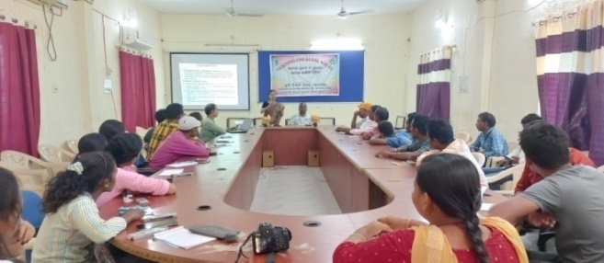 | 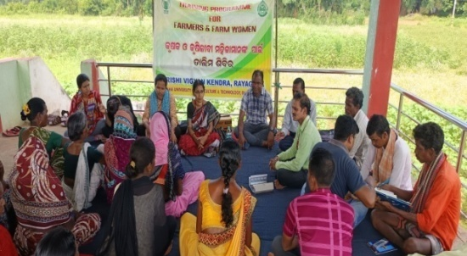
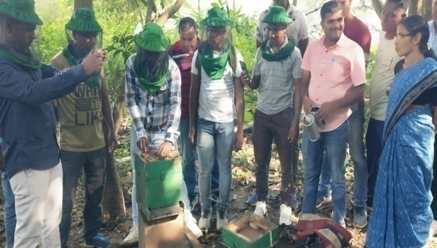 | 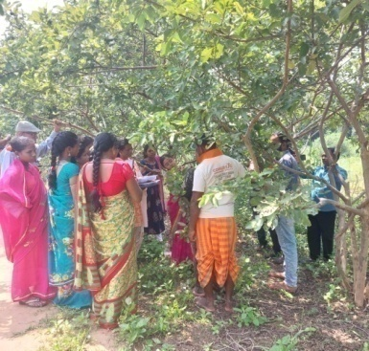
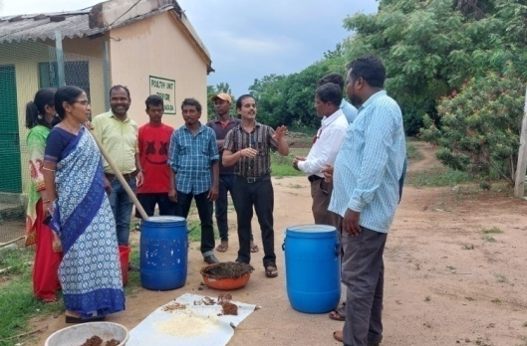 | 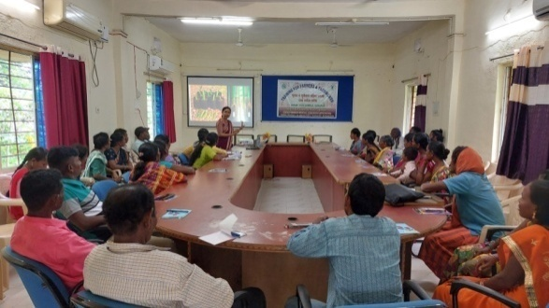
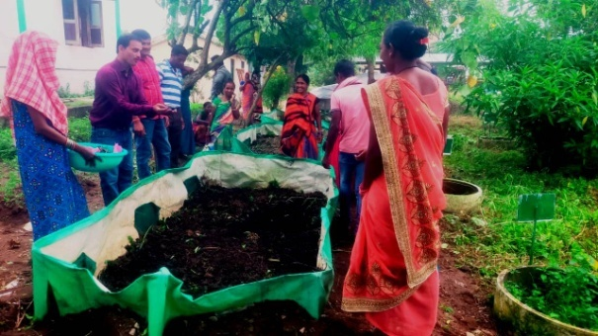 | 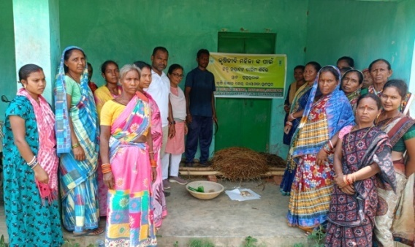
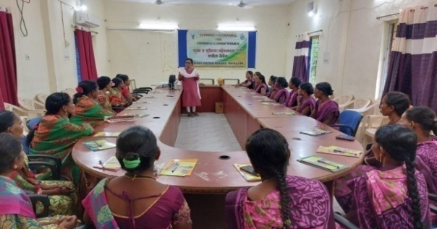 | 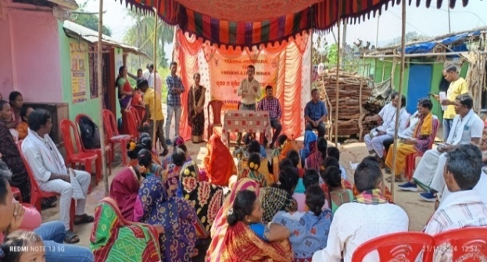
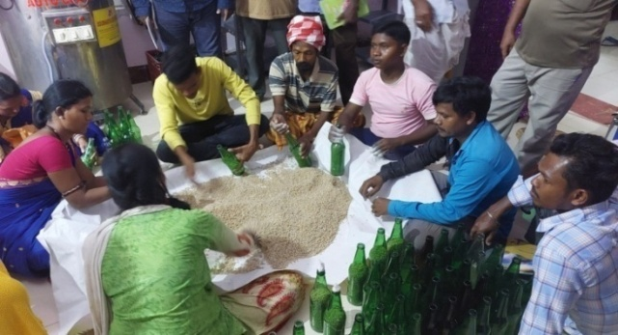 | 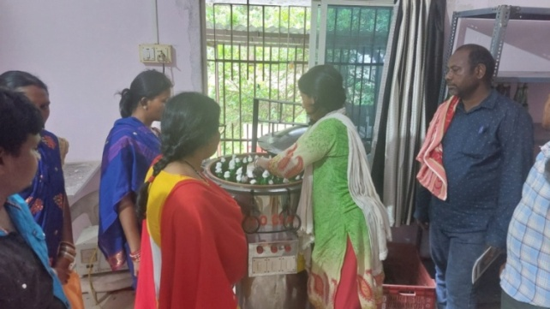
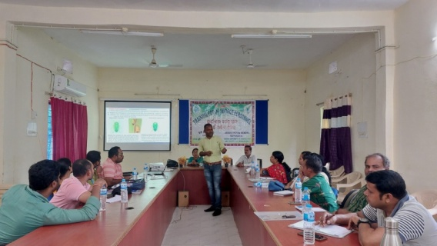 | 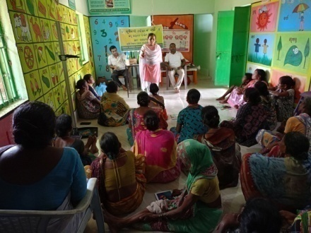
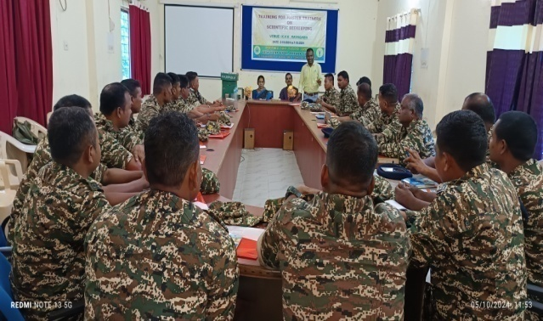 | 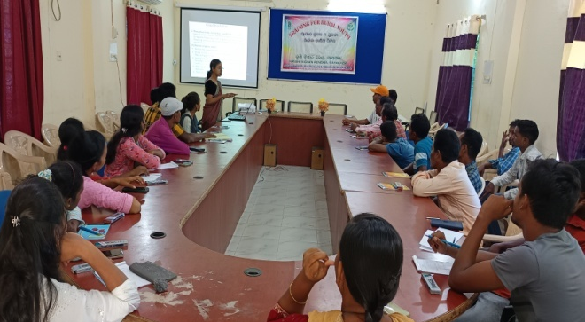

3.4. A. Extension Activities (including activities of FLD programmes)
Nature of Extension Activity | No. of activities | Farmers |  |  |  | Extension Officials |  |  | Total
Nature of Extension Activity | No. of activities | M | F | T | SC/ ST  (% of total) | Male | Female | Total | Male | Female | Total
Field Day | 16 | 557 | 214 | 784 | 78 | 13 | 3 | 16 | 570 | 230 | 800
Kisan Mela | 1 | 76 | 54 | 130 | 94 | - | - | - | 76 | 54 | 130
Kisan Ghosthi | - | - | - | - | - | - | - | - | - | - | -
Exhibition | 10 | - | - | - | - | - | - | - | - | - | Mass
Film Show | 11 | 585 | 344 | 929 | 81 | 19 | 5 | 24 | 604 | 349 | 953
Method Demonstrations | 14 | 239 | 181 | 420 | 100 | 7 | 3 | 10 | 246 | 184 | 430
Farmers Seminar | - | - | - | - | - | - | - | - | - | - | -
Workshop | - | - | - | - | - | - | - | - | - | - | -
Group meetings | 24 | 80 | 163 | 243 | 77 | - | - | - | 80 | 163 | 243
Lectures delivered as resource persons | 43 | - | - | - | - | 65 | 74 | 139 | - | - | Mass
Advisory Services | 44 | 22447 | 12251 | 34968 | 91 | 137 | 55 | 192 | 27620 | 15004 | 42626
Scientific visit to farmers field | 538 | 4217 | 625 | 4842 | 74 | 3 | 4 | 7 | 4220 | 629 | 4849
Farmers visit to KVK | 3073 | 1321 | 1752 | 3073 | 92 | - | - | - | 1321 | 1752 | 3073
Diagnostic visits | 235 | 1114 | 257 | 1130 | 93 | 508 | 17 | 525 | 1622 | 274 | 1655
Exposure visits | 13 | 293 | 40 | 333 | 96 | 149 | 266 | 414 | 442 | 305 | 747
Ex-trainees Sammelan | - | - | - | - | - | - | - | - | - | - | -
Soil health Camp | - | - | - | - | - | - | - | - | - | - | -
Animal Health Camp | - | - | - | - | - | - | - | - | - | - | -
Agri mobile clinic | - | - | - | - | - | - | - | - | - | - | -
Soil test campaigns | - | - | - | - | - | - | - | - | - | - | -
Farm Science Club Conveners meet | - | - | - | - | - | - | - | - | - | - | -
Self Help Group Conveners meetings | 26 | - | 260 | 260 | 100 | - | 5 | 5 | - | 265 | 265
Mahila Mandals Conveners meetings | - | - | - | - | - | - | - | - | - | - | -
Celebration of important days (specify)  World Environment Day, Mahila Kisan Divas,  ICAR Foundation day, OUAT Foundation day, National Unity Day, World Food Day, World Soil Day, Women in Agriculture Day, Kisan Diwas | 9 | 199 | 141 | 340 | 86 | 9 | - | 9 | 208 | 141 | 349
Sankalp Se Siddhi | - | - | - | - | - | - | - | - | - | - | -
Swatchta Hi Sewa | 6 | 91 | 76 | 167 | 84 | 5 | 6 | 11 | 96 | 82 | 183
Mahila Kisan Divas | 1 | - | 25 | 25 | 100 | 3 | 2 | 5 | 3 | 27 | 30
Any Other (Specify)  PM KISAN Yojana (live telecast of Pradhan Mantri Kisan Samman Nidhi Yojana), Live Webcast of 18th Installment Release of the PM-KISAN scheme, live streaming of nationwide launch of National Pest surveillance system, Live Webcast of 19th Installment Release of the PM-KISAN scheme (Kisan Sammaan Samaroh), PPV FRA, Parthenium awareness week, Vigilance Awareness week, Celebration of Jan Jatiya Gaurav Diwas-2024, Swachhata programme Special Campaign 4.0, Plantation programme under ‘Ek Ped Maa Ke Naam’  Live Webcast of episode of Krishi Choupal, District level Project Launching Workshop- cum- FPO Conclave | 13 | 7641 | 1565 | 9206 | 82 | 28 | 3 | 31 | 7669 | 1568 | 9237
Total | 4077 | 38860 | 17948 | 56850 | 91 | 946 | 443 | 1388 | 44777 | 21027 | 65570

B. Other Extension activities
Nature of Extension Activity | No. of activities
Newspaper coverage | 18
Radio talks | -
TV talks | 6
Popular articles | -
Extension Literature | 2
Other, if any (Pamplet, Leaflet) | 7

Good quality photographs of Extension activity:
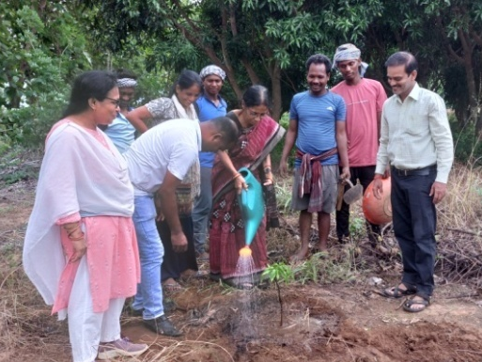  World Environment Day | 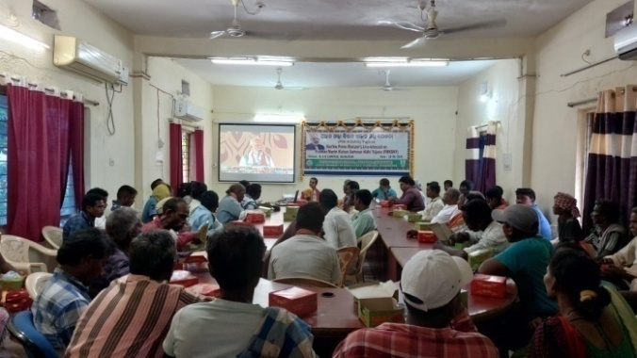  Webcasting of PM Kisan Nidhi Programmes
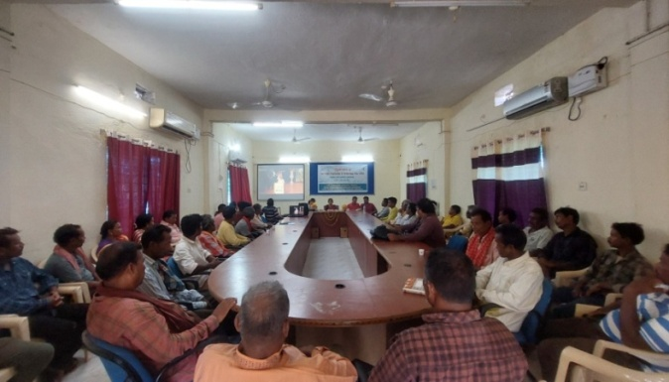 Celebration of 96th ICAR Foundation Day | 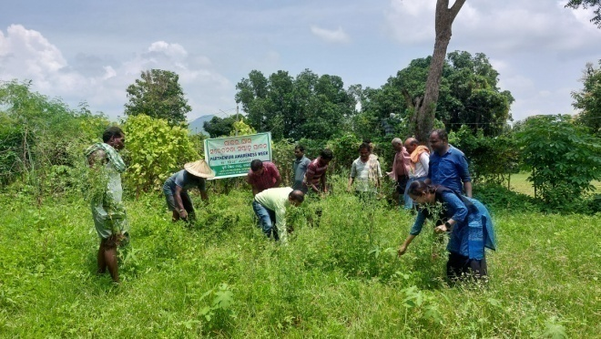 Parthenium Awareness Week
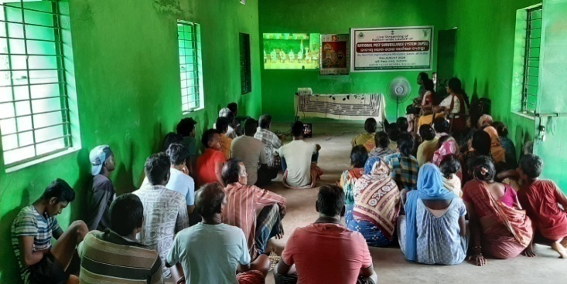  Webcasting of National Pest Survellience System | 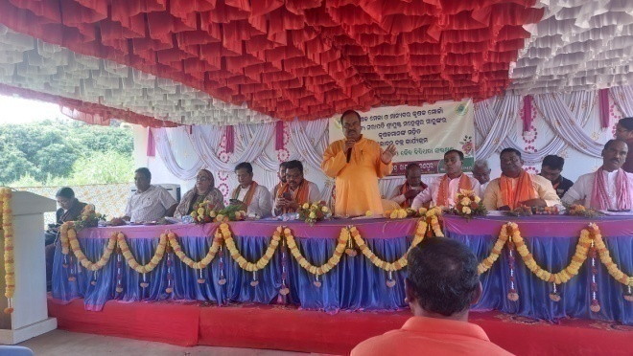 Kisan Mela
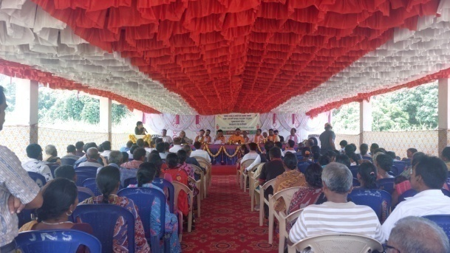  Interaction with farmers and farm women | 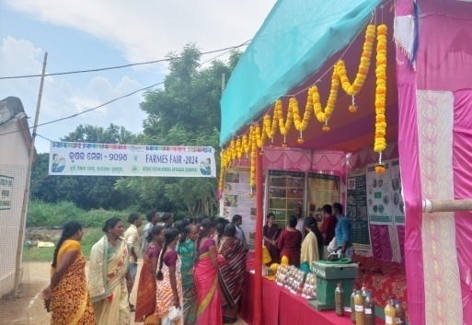  Exhibition stall
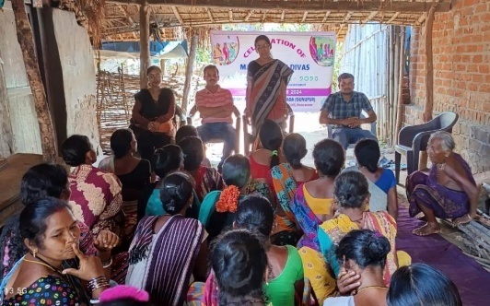  Mahila Kisan Divas | 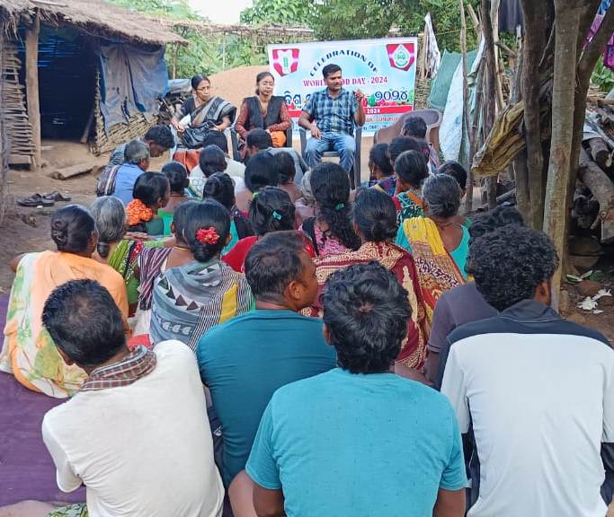  World Food day
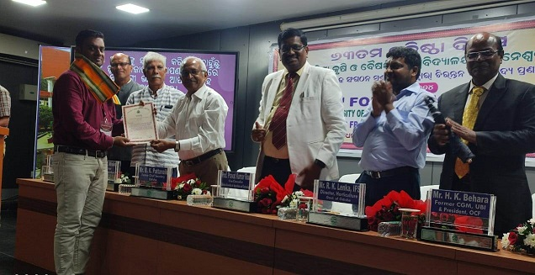  FPO member awarded during OUAT Foundation Day | 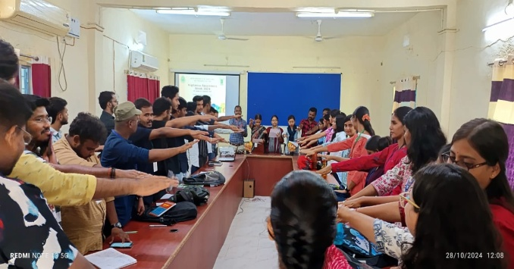  Vigilance Awareness Week
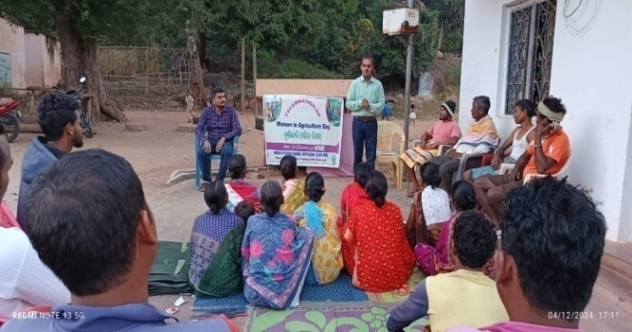  Women in Agriculture Day | 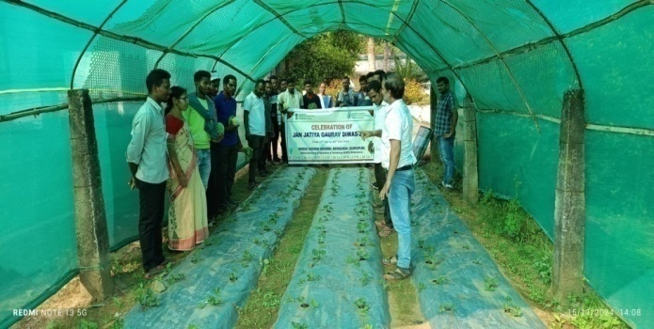  Celebration of Jan Jatiya Gaurav Diwas-2024
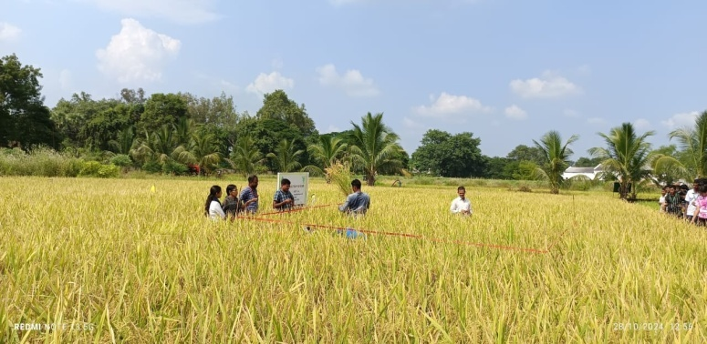  Exposure visit | 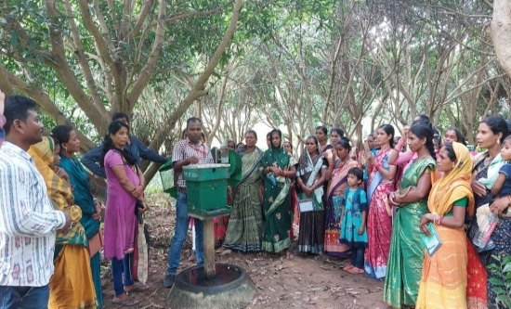  Exposure visit
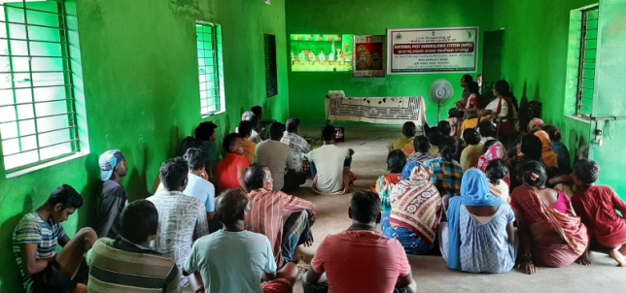
Webcasting of National Pest Survellience System

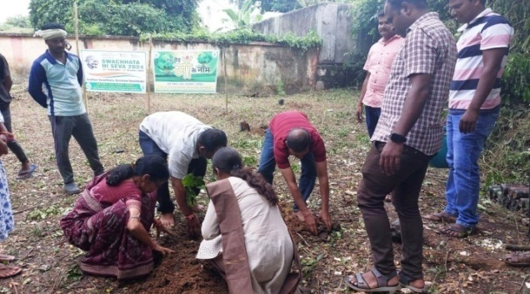  'Ek Ped Maa Ke Naam' (Plant4Mother) plantation programme | 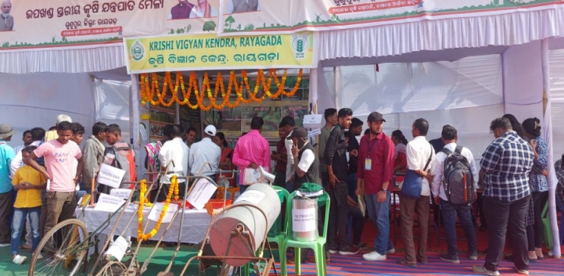  Exhibition stall during Sub-Divisional Level Mela on Farm Mechanization
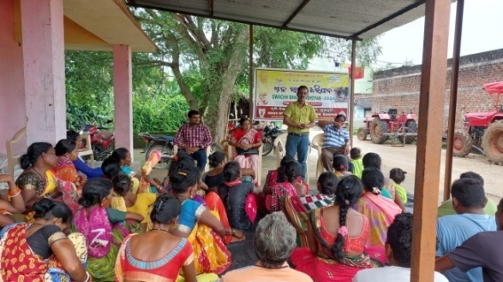  Swachhata Hi Seva Awareness programme at village Rupapadar | 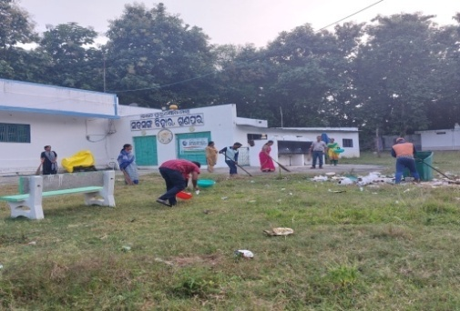  Swachhata Hi Seva programme at Satsanga Bihar campus
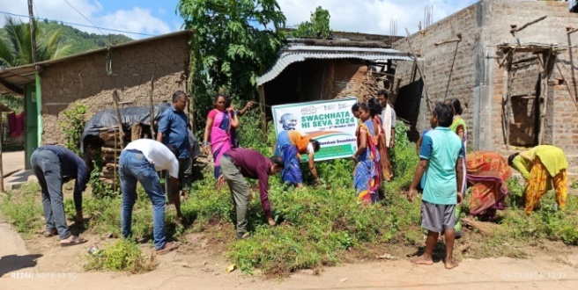  Swachhata programme under Special campaign 4.0 : Cleanliness drive at village Patuguda | 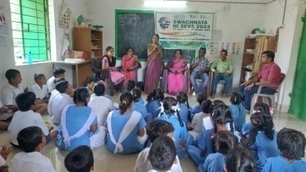  Awareness on environmental cleanliness (through lectures by KVK scientists, song and dance), Govt. Upper Primary School, Turkaniguda

3.5 a. Production and supply of Technological products

Village seed

Crop | Variety | Quantity of seed  (q) | Value  (Rs) | No. of farmers involved in village seed production | Number of farmers  to whom seed provided
 |  |  |  |  | SC |  | ST |  | Other |  | Total
 |  |  |  |  | M | F | M | F | M | F | M | F
- | - | - | - | - | - | - | - | - | - | - | - | -
Total

KVK farm

Crop | Variety | Quantity of seed  (q) | Value  (Rs) | Number of farmers  to whom seed provided
 |  |  |  | SC |  | ST |  | Other |  | Total
 |  |  |  | M | F | M | F | M | F | M | F
Rice | MTU 1156 | 126.2 | 492180.00 | - | - | - | - | - | - | - | -
Finger millet | Arjuna | 4.0 | 27600.00 | - | - | - | - | - | - | - | -
Pigeon pea | LRG 52 | - | - | - | - | - | - | - | - | - | -
Greengram | Virat | - | - | - | - | - | - | - | - | - | -
Grand Total |  | 130.2 | 519780 | - | - | - | - | - | - | - | -
Good quality photographs of seed production:

Production of planting materials by the KVKs

Crop | Variety | No. of planting materials | Value  (Rs) | Number of farmers  to whom planting material provided
 |  |  |  | SC |  | ST |  | Other |  | Total
 |  |  |  | M | F | M | F | M | F | M | F
Vegetable seedlings
Cauliflower | Nalini | 10000
Cabbage | Pragati | 11500
Tomato | Arka Rakshak, Arka Samrat and VNR-3357 | 19600
Brinjal | Akshita and Utkal | 22900
Chilli | Arka Meghna, Arkha Saanvi, VCH- 01 | 25730
Onion |  | 23000
Knol Khol | Oni | 10000
Others (Drumstick) | ODC-3 | 2000
Fruits
Mango
Guava
Lime
Papaya | Red lady | 1670
Banana | Bantala, Pata Kapura and Champa | 500
Others
Ornamental plants (Marigold) | Arka Bhanu, Ceracola | 30000
Medicinal and Aromatic
Plantation
Spices
Turmeric
Tuber
Elephant yams
Fodder crop saplings | Hybrid Napier
Forest Species
Others, pl. specify
Total
Good quality photographs of planting materials:

Production of Bio-Products

Name of product | Quantity | Value (Rs.) | No. of Farmers benefitted
Name of product | Kg | Value (Rs.)
 |  |  | SC |  | ST |  | Other |  | Total
 |  |  | M | F | M | F | M | F | M | F
Bio-fertilizers | 4310 | 36000.00
Bio-pesticide | -
Bio-fungicide | -
Bio-agents | 71.75 | 18000.00
Others, please specify. | -
Total

Good quality photographs of bio-products:

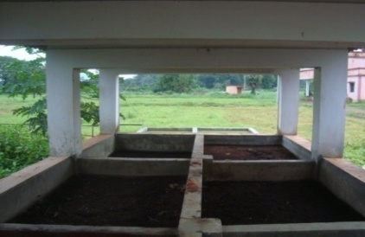 | 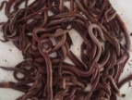

Production of livestock materials
Particulars of Live stock | Name of the breed | Number | Value (Rs.) | No. of Farmers benefitted
 |  |  |  | SC |  | ST |  | Other |  | Total
 |  |  |  | M | F | M | F | M | F | M | F
Dairy animals
Cows
Buffaloes
Calves
Others (Pl. specify)
Small ruminants
Sheep
Goat
Other, please specify
Poultry | Rainbow rooster and Sonali | 900 | 58500 | - | - | - | 90 | - | - | - | 90
Broilers
Layers
Duals (broiler and layer)
Japanese Quail
Turkey
Emu
Ducks
Others (Pl. specify)
Piggery
Piglet
Hog
Others (Pl. specify)
Fisheries
Indian carp
Exotic carp
Mixed carp
Fish fingerlings
Spawn
Others (Pl. specify)
Grand Total | Rainbow rooster and Sonali | 900 | 58500 | - | - | - | 90 | - | - | - | 90
Good quality photographs of livestock and fisheries:

3.5. b. Seed Hub Programme - “Creation of Seed Hubs for Increasing Indigenous Production of Pulses in India”
i) Name of Seed Hub Centre:

Name of Nodal Officer : | -
Address : | -
e-mail : | -
Phone No. :  Mobile : | -

ii) Quality Seed Production Reports
Season | Crop | Variety | Production (q)
Season | Crop | Variety | Target | Area sown (ha) | Production | Category of Seed  (F/S, C/S)
Kharif 2023
Rabi 2021-22
Summer/Spring 2023
Kharif 2023
Rabi 2022-2023

iii) Financial Progress
Fund received  (2020-21, 2021-22, 2022-23 and 2023-24) | Expenditure (Rs. in lakhs) |  | Unspent balance  (Rs. in lakhs) | Remarks
Fund received  (2020-21, 2021-22, 2022-23 and 2023-24) | Infrastructure | Revolving fund | Unspent balance  (Rs. in lakhs) | Remarks
2020-21 | - | - | - | -
2021-22
2022-23
2023-24

iv) Infrastructure Development

Item | Progress
Seed processing unit | -
Seed storage structure | -

3.6. (A) Literature Developed/ Published (with full title, author & reference)

Item | Title | Author’s name | Number | Circulation
Research paper
Seminar/conference/ symposia papers
Books | Scientific cultivation of groundnut | Dr. N. Ramu | 300 | 250
Books | Gramina Mahila Mananka Atmaniyukti pain pala chhatu chasa | Mrs. M. Sarangi | 300 | 200
Books | Phala O Paniparibaru Mulyayukta Padartha Prashuta | Mrs. M. Sarangi | 300 | 200
Bulletins
News letter | Bansadhara | Senior Scientist and Head, KVK | 500 | 400
Popular Articles | -
Book Chapter | -
Extension Pamphlets/ literature | Natural farming | Dr. N. Ramu | 2000 | 2000
Technical reports | Annual Report, Achievement report, Tribal Sub-Plan, DFI, FPO, Report on Extension Activities | - | - | -
Electronic Publication (CD/DVD etc.) | - | - | - | -
TOTAL

N.B.: Please enclose a copy of each. In case of literature prepared in local language please indicate the title in English

(B) Details of HRD programmes undergone by KVK personnel:

Sl. No. | Name of programme | Name of course | Name of KVK personnel and designation | Date and Duration | Organized by
1. | Capacity building Training | Capacity building programme on Efficient Administrative and Financial Management | Mrs. Gitanjali Das  Junior Steno-cum –Computer Operator | 19.06.2024 to 05.07.2024 | ICAR- National Institute of Abiotic Stress Management, Baramati, Pune, Maharastra
2. | National seminar | National seminar on Resource management for climate resilient sustainable food production system | Dr. Naram Ramu, SMS (Agronomy) | 06.03.2025 to 07.03.2025 | Odisha Chapter Indian Society of Agronomy in collaboration with OUAT, Bhubaneswar
3. | National seminar | National seminar on Resource management for climate resilient sustainable food production system | Dr. Anindita Roy, SMS (Horticulture) | 06.03.2025 to 07.03.2025 | Odisha Chapter Indian Society of Agronomy in collaboration with OUAT, Bhubaneswar

3.7. Success stories/Case studies, if any (two or three pages write-up on 1-2 best case(s) with suitable action photographs)
IFS Unit enhanced livelihood status of a tribal farmer

Name of farmer | Sri Pradip Kumar Mandangi
Address | Village- L. L. Pur, Block- Gudari Dist.- Rayagada, State- Odisha  PIN – 765025
Contact details (Phone, mobile, email Id) | 9438050091
Landholding (in ha.) | 1.0
Name and description of the farm/ enterprise | Mr. Mandangi was growing Paddy, Cotton, Pigeon pea, Greengram, sesame and ragi in 1.0 ha round the year from where he got Rs. 40000/- per annum.
Economic impact | Mr. Mandangi received an amount of 0.8 lakh from different field crops and Rs. 133000/- from other units. After intervention of KVK and Line departments for technological guidance and financial support Mr. Mandangi is now getting around Rs. 213000/- per annum from the above said units.
Social impact | Mr. Mandangi is a showcase for his model IFS unit with higher return. Presently he is motivating farmers and farm women as well as rural youth of different blocks to adopt on 1 acre model of IFS unit.
Environmental impact | He cultivates the crops by using less quantity of chemical fertilizers and more use of organic manure which are no adverse impact on atmospheric condition.
Horizontal/ Vertical spread | KVK assessed and demonstrated improved varieties of rice, pigeon pea, sweet corn, greengram, blackgram, sesame, ragi and introduced high value vegetable in his IFS unit and also demonstrated on IDM, INM and IPDM in different fruits and vegetables. Under IFS he is also having fishery, poultry, duckery, dairy and mushroom unit.
Good quality photographs (2-3) | 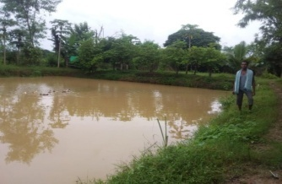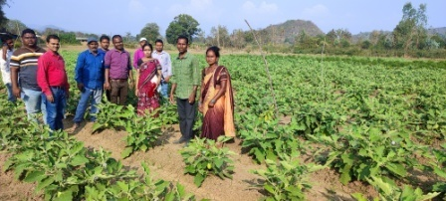  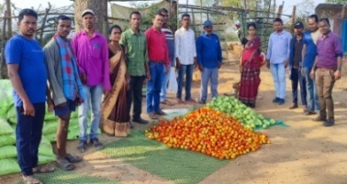

Flower cultivation a boon for Mr. K. Siba Kumar

Name of farmer | Mr. K. Siba Kumar
Address | Village: Kuturu, block-Gunupur, Dist.- Rayagada, State- Odisha, PIN – 765025
Contact details (Phone, mobile, email Id) | 9437779631
Landholding (in ha.) | 6.8
Name and description of the farm/ enterprise | Mr. Siba Kumar was growing Paddy- 6 acre, Cotton - 4 acre, Cashew -2 acre and vegetable -4 acre from which he got Rs. 80000/- per annum.
Economic impact | KVK assessed and demonstrated high value vegetable, fruits and flowers such as crysanthum, crossandra, tuberose and marigold. With time to time supervision and guidance of KVK scientists, Mr. Siba Kumar included scientific approaches i.e. INM, IDM and IPDM in vegetables, fruit and flower fields. He is also practicing intercropping method in vegetable field.  Mr. Kumar received an amount of 1.5 lakh from different field crops and Rs. 95000.00 from flower cultivation.
Social impact | Mr. Kumar has bagged 1st prize in rose show during 2023-24. He is role model of agri-entrepreneur in Rayagada district.
Environmental impact
Horizontal/ Vertical spread | The cultivation of high yielding and high value vegetables has been spread in 5 villages and farmers very much interested to cultivate the same crops in large scale due to more profit and high market demand.
Good quality photographs (2-3) | 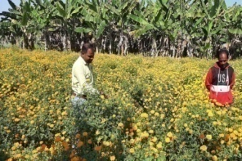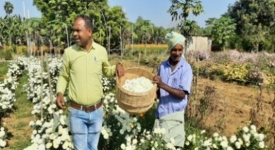  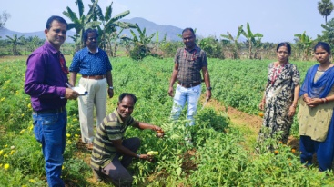

3.8. Give details of innovative methodology or innovative technology of Transfer of Technology developed and used during the year

Sl. No. | Name/ Title of the technology | Name/ Details of the Innovator(s) | Brief details of the Innovative Technology
- | - | - | -

3.9. a. Give details of indigenous technology practiced by the farmers in the KVK operational area which can be considered for technology development (in detail with suitable photographs)

Sl. No. | Crop / Enterprise | ITK Practiced | Purpose of ITK
- | - | - | -

b. Give details of organic farming practiced by the farmer

Sl. No. | Crop / Enterprise | Area (ha)/ No. covered | Production | No. of farmers involved | Market available (Y/N)
- | - | - | - | - | -

3.10. Indicate the specific training need analysis tools/methodology followed by KVKs

Sl. No. | Brief details of the tool/ methodology followed | Purpose for which the tool was followed
- | - | -

3.11. a. Details of equipment available in Soil and Water Testing Laboratory

Sl. No | Name of the Equipment | Qty.
1. | Mridaparikhyak | 1

3.11.b. Details of samples analyzed so far :
Number of soil samples analyzed |  |  | No. of Farmers | No. of Villages | Amount realized  (in Rs.)
Through mini soil testing kit/labs | Through soil testing laboratory | Total
1 | - | 262 | 749 | 18 | -

3.11. c. Details on World Soil Day

Sl.  No. | Activity | No. of Participants | No. of VIPs | Name (s) of VIP(s) | Number of Soil Health Cards distributed | No. of farmers benefitted
1. | Seminar/ Lecture | 150 | 1 | Smt. Saraswati Majhi, Zilla Parishad Chairman | 25 | 120

3.12. Activities of rain water harvesting structure and micro irrigation system

No of training programme | No of demonstrations | No of plant material produced | Visit by the farmers | Visit by the officials
- | - | - | - | -
3.13. Technology week celebration

Type of activities | No. of activities | Number of participants | Related crop/ livestock technology
Distribution of QPM | 10 | 232 | Tomato, Brinjal, Chilli, Cabbage, Cauliflower, Capsicum, Papaya, Drumstick, Banana
Mushroom spawn and vegetable seed kit distribution for kitchen garden | 2 | 260 | Demonstration on paddy straw & oyster mushroom cultivation and nutritional gardening
Visit of Demo units | 2 | 40 | Natural farming unit, Strawberry unit, Nursery raising of vegetables  Vermicompost production,  Azolla cultivation, Backyard poultry rearing, Honey bee rearing  Kitchen gardening
Distribution of Newsletter/booklet/ leaflet/Literature | 8 | 532 | Newsletter/booklet/ leaflet/Literature

3.14. RAWE/ FET programme - is KVK involved? (Y/N): N

No of student trained | No of days stayed
- | -

ARS trainees trained | No of days stayed
- | -
3.15. List of VIP visitors (Minister/ MP/MLA/DM/VC/Zila Sabhadipati/Other Head of Organization/Foreigners)

Date | Name of the person | Purpose of visit
30.09.2024 | Sj. Maheswar Sahu  BJP leader & President Krushak Morcha | Kisan Mela and Plantation programme under 'Ek Ped Maa Ke Naam'
16.02.2024  19.12.2024 | Dr. P.K. Mohanty  JD, UEBP, DEE, OUAT, Bhubaneswar | SAC Meeting
19.12.2024 | Dr. Gyanaloka Das  ADR, RRTTS, G.Udayagiri, Kandhamal | SAC Meeting
19.12.2024 | Mr. Manoj Pradhan  CDAO-cum-PD ATMA, Rayagada | SAC Meeting, Research- Extension Linkage meeting, PM Kisan programme
19.12.2024 | Mr. Dayanidhi Rout  DDH, Rayagada | SAC Meeting, Research- Extension Linkage meeting, PM Kisan programme, District level Project Launching Workshop- cum- FPO Conclave
19.12.2024 | Mr. Hadibandhu Bhoi  CDVO, Rayagada | SAC Meeting, Research- Extension Linkage meeting, PM Kisan programme, District level Project Launching Workshop- cum- FPO Conclave
19.12.2024 | Mr. Santosh Ku. Samal  DDM, NABARD, Rayagada | SAC Meeting, Research- Extension Linkage meeting, PM Kisan programme, District level Project Launching Workshop- cum- FPO Conclave
19.12.2024 | Sushama Prasadi  CDPO, Gunupur | SAC Meeting
19.12.2024 | Dr. Dayanidhi Bag  PD, Watershed | SAC Meeting, PM Kisan programme
19.12.2024 | Brundaban Behera  ADO, Gunupur | SAC Meeting, Research- Extension Linkage meeting, PM Kisan programme, District level Project Launching Workshop- cum- FPO Conclave
19.12.2024 | Jagannath Bindhani  ADH, Gunupur | SAC Meeting, Research- Extension Linkage meeting

- IMPACT

  - Impact of KVK activities (Not to be restricted for reporting period).

Name of specific technology/skill transferred | No. of participants | % of adoption | Change in income (Rs.)
Name of specific technology/skill transferred | No. of participants | % of adoption | Before (Rs./Unit) | After (Rs./Unit)
Scientific beekeeping | 97 | 33 | 0 | 6400
Natural farming | 175 | 18 | - | -
Sweet corn | 75 | 83 | 27000 | 69500
Mushroom cultivation | 380 | 13 | 0 | 160
Pigeon pea var. LRG-52 | 186 | 84 | 9500 | 24000
Use of herbicide in field crops | 125 | 68 | 8900 | 22200
Soil testing and making of soil health card | 1110 | 92 | 12350 | 20000
Mechanical and bio-logical management of pest and diseases of field crops | 30 | 100 | - | -
Vermicompost | 190 | 40 | - | 18000
NB: Should be based on actual study, questionnaire/group discussion etc. with ex-participants

4.2. Cases of large scale adoption
(Please furnish detailed information for each case)
Horizontal spread of technologies
Technology | Horizontal spread
Pigeon pea var. LRG- 52 | 450 ha and 1231 farmers
Mushroom production (Paddy straw) | 380 farmers, farm women, rural youth and SHGs
Drought tolerant rice variety | 300 ha and 650 farmers and farm women

Give information in the same format as given below

Name of farmer
Address
Contact details (Phone, mobile, email Id)
Landholding (in ha.)
Name and description of the farm/ enterprise
Economic impact
Social impact
Environmental impact
Horizontal/ Vertical spread
Good quality photographs (2-3)

4.3. Details of impact analysis of KVK activities carried out during the reporting period

Sl. No. | Brief details of technology | Impact of the technology in subjective terms | Impact of the technology in objective terms

4.4. Details of innovations recorded by the KVK

Thematic area
Name of the Innovation
Details of Innovator
Back ground of innovation
Technology details
Practical utility of innovation

4.5. Details of entrepreneurship development

Entrepreneurship development
Name of the enterprise | Scientific beekeeping
Name & complete address of the entrepreneur | Krupasindhu Jilakara, Vill-Badasigudu, Block-Rayagada, Dist.- Rayagada
Role of KVK with quantitative data support: | STRY training, regular monitoring and supervision with input support of box, bee colony with accessories and honey extractor
Timeline of the entrepreneurship development | July 2024 to till date
Technical Components of the Enterprise | Supply of input and skill training on its management i.e regular and periodic bottom board cleaning, maintaining healthy and populous colony, regular and periodic dearth feeding, removal of old combs and allowing new comb construction, need based brood comb alteration and need based colony union or division are recommended for scientific beekeeping with Apis cerana indica.
Status of entrepreneur before and after the enterprise | Only farming
Present working condition of enterprise in terms of raw materials availability, labour availability, consumer preference, marketing the product etc. (Economic viability of the enterprise): | In addition to honey extraction 6 lt./ box, 2 nos. of new colony/ box. Mr. Jilakara bagged 13- 15% more yield from maize, pigeon pea vegetable and mango.
Horizontal spread of enterprise | CRPF battalion Muniguda and Nectar Odisha at Rayagada

4.6. Any other initiative taken by the KVK

5. LINKAGES
5.1. Functional linkage with different organizations

Name of organization | Nature of linkage
Agriculture, Horticulture | Convergence meeting Training of farmers, farm women, rural youth and extension functionaries, demonstration on improved technology, participation in exhibition & mela, e-pest surveillance, verification of inputs & enterprise
Veterinary | Convergence meeting, participation in exhibition & mela, demonstration on improved technology
Fisheries | Convergence meeting, participation in exhibition & mela
ITDA | Training
NGOs | Capacity building training and demonstration
Nectar Odisha at Rayagada | Capacity building and demonstration
FPO Platform | Convergence meeting, training

5.2. List of special programmes undertaken during 2024 by the KVK, which have been financed by ATMA/ Central Govt/ State Govt./NABARD/NHM/NFDB/Other Agencies (information of previous years should not be provided)

a) Programmes for infrastructure development

Name of the programme/ scheme | Purpose of programme | Date/ Month of initiation | Funding agency | Amount (Rs.)
- | - | - | - | -
(b) Programme for other activities (training, FLD, OFT, Mela, Exhibition etc.)

Name of the programme/ scheme | Purpose of programme | Date/ Month of initiation | Funding agency | Amount (Rs.)
STRY | Skill development of rural youth on Integrated pest management in field crop and vegetable crops | 28.02.2025 to 06.03.2025 | PD- ATMA | 42000.00

- PERFORMANCE OF INFRASTRUCTURE IN KVK

6.1. Performance of demonstration units (other than instructional farm)

Sl. No. | Name of demo Unit | Year of estt. | Area (Sq.mt) | Details of production |  |  | Amount (Rs.) |  | Remarks
 |  |  |  | Variety/ breed | Produce | Qty. | Cost of inputs | Gross income | Remarks
 | Vermicompost unit | 2010-11 | 36.11 | Vermi-compost  Vermin (Eisenia foetida) | Vermi-compost  Vermin | 43.1  q  71.75 kg | 6000.00  - | 36000  18000 | -
 | Poultry unit | 2010-11 | 24.3 | Rainbow rooster and Sonali bird | Chicks | 900 | 45200 | 58500 | Day one old chicks rearing
 | Azolla unit | 2011-12 | 9.2 | Azolla | Green manure | 960.0 kg | - | - | -
 | Mushroom spawn production unit | 2010-11 | 27.6 | Paddy straw and  Oyster mushroom spawn | Mushroom spawn | 2555bottles |  | 46125 | -
 | Poly house | 2010-11 | 9.11 | - | Flower, fruit and vegetableseedlings | 156900 nos. |  |  | -
 | Medicinal garden | 2017-18 | 600 | 64 species | - | - | - | - | -
 | Honey bee | 2019-20 | 10 nos. box | Apis cerana indica | Honey  Colony | - | - | - | -
 | Total |  |  |  |  |  |  |  | -

6.2. Performance of Instructional Farm (Crops)
Name  Of the crop | Date of sowing | Date of harvest | Area (ha) | Details of production |  |  | Amount (Rs.) |  | Remarks
 |  | Date of harvest | Area (ha) | Variety | Type of Produce | Qty.(q) | Cost of inputs | Gross income | Remarks
Rice | 26.06.2024 | 12.11.2024 | 3.0 | MTU-1156 | Foundation | 126.2 |  | 492180.00 | -
Finger millet | 04.06.2024 | 03.10.2024 | 0.5 | Arjuna | Foundation | 4.0 |  | 27600.00 | -
Pigeon pea | 21.06.2024 | 10.03.2025 | 1.0 | LRG 52 | Foundation | 6.5 (Approx.) | - | - | -
Greengram | 27.01.2025 | Continuing | 3.0 | Virat | Certified | - | - | - | -

  - Performance of Production Units (bio-agents / bio-pesticides/ bio-fertilizers etc.,)

Sl.  No. | Name of the Product | Qty. (Kg) | Amount (Rs.) |  | Remarks
Sl.  No. | Name of the Product | Qty. (Kg) | Cost of inputs | Gross income | Remarks
1. | Bio-fertilizers (Vermicompost) | 4310 | 6000.00 | 36000.00 | -
 | Bio-agents (Vermin) | 71.75 | - | 18000 | -

  - Performance of instructional farm (livestock and fisheries production)

Sl.  No. | Name  of the animal / bird / aquatics | Details of production |  |  | Amount (Rs.) |  | Remarks
Sl.  No. | Name  of the animal / bird / aquatics | Breed | Type of Produce | Qty. | Cost of inputs | Gross income | Remarks
1. | Poultry bird | Rainbow rooster and Sonali | Chicks rearing | 900 | 45200 | 58500 | Day one old chicks rearing

  - Utilization of hostel facilities
Accommodation available (No. of beds): 30

Months | No. of trainees stayed | Trainee days  (days stayed) | Reason for short fall (if any)
December 2024 | 20 | 2 | -
January 2025 | 20 | 3 | -
February 2025 | 20 | 3 | -
March 2025 | 15 | 6 | -
March 2025 | 20 | 3 | -
Total : | 95 | 17 | -
(For whole of the year)

  - Utilization of staff quarters: NA
Whether staff quarters has been completed:
No. of staff quarters:
Date of completion:
Occupancy details:
Months | Q I | Q II | Q III | QIV | Q V | QVI
- FINANCIAL PERFORMANCE

7.1. Details of KVK Bank accounts
Bank account | Name of the bank | Location | Account Number
Krishi Vigyan Kendra, Rayagada  (Contingency ) | SBI, Gunupur | At/PO- Gunupur  District- Rayagada | 11116545568
Krishi Vigyan Kendra, Rayagada  (Revolving fund ) | SBI, Gunupur | At/PO- Gunupur  District- Rayagada | 30772185783
Krishi Vigyan Kendra, Rayagada  CFLD (Pulses ) | SBI, Gunupur | At/PO- Gunupur  District- Rayagada | 42268435297
Krishi Vigyan Kendra, Rayagada  CFLD (Oilseeds ) | SBI, Gunupur | At/PO- Gunupur  District- Rayagada | 42268433233
Krishi Vigyan Kendra, Rayagada  (RKVY RPL/Upscaling ) | SBI, Gunupur | At/PO- Gunupur  District- Rayagada | 42669627100
Krishi Vigyan Kendra, Rayagada  (RKVY Skill Development ) | SBI, Gunupur | At/PO- Gunupur  District- Rayagada | 42669612003
DAMU, KVK, Rayagada | Bank of Maharashtra, Rayagada | Rayagada | 60427381585

  - Utilization of funds under CFLD on Oilseed (Rs. In Lakhs)

Item | Released by ICAR |  | Expenditure |  | Unspent balance as on -
Item | Kharif | Rabi | Kharif | Rabi | Unspent balance as on -
Groundnut | 902250 | - | 902250 |  | Nil
Sesame | - | 902250 | - | 247144 | 655106

7.3. Utilization of funds under CFLD on Pulses (Rs. In Lakhs)
Item | Released by ICAR |  | Expenditure |  | Unspent balance as on 1st April 2013
Item | Kharif | Rabi | Kharif | Rabi | Unspent balance as on 1st April 2013
- | - | - | - | - | -

  - Utilization of KVK funds during the year 2024-25 (Not audited)

Sl.  No. | Particulars | Sanctioned | Released | Expenditure
A. Recurring Contingencies
1 | Pay & Allowances | - | 9636000 | 9993983
2 | Traveling allowances | 120000 | 120000 | 120000
3 | HRD | 20000 | 20000 | 9000
4 | Contingencies
A | Stationary, telephone, postage and other | 240000 | 280000 | 280000
B | POL | 240000 | 280000 | 280000
C | Training | 180000 | 180000 | 180000
D | Meals and refreshment | 180000 | 180000 | 180000
E | Training materials | 180000 | 180000 | 180000
F | FLD | 90000 | 90000 | 90000
G | OFT | 90000 | 90000 | 90000
H | TSP | 1550000 | 1500000 | 1500000
I | Swachhata Expenditure | 32000 | 32000 | 32000
J | PM Kisan | 37190 | 37190 | 37190
TOTAL (A)
B. Non-Recurring Contingencies
1 | Library | 10000 | 10000 | 10000
TOTAL (B) |  | 10000 | 10000 | 10000
C. REVOLVING FUND |  | - | - | -
GRAND TOTAL (A+B+C) |  | 2369190 | 11995190 | 12342173

7.5. Status of revolving fund (Rs. in lakh) for last five years

Year | Opening balance as on 1st April | Income during the year | Expenditure during the year | Net balance in hand as on 1st April of each year (Kind + cash)
2020-21 | 20674 | 581016 | 498850 | 187840
2021-22 | 187840 | 724876 | 737744 | 91395
2022-23 | 91395 | 511620 | 498312 | 35601
2023-24 | 35601 | 1108012 | 821254 | 287700
2024-25 | 287700 | 557310 | 600467 | 244543

  - (i) Number of SHGs formed by KVKs
(ii) Association of KVKs with SHGs formed by other organizations indicating the area of SHG activities
(iii) Details of marketing channels created for the SHGs

  - Joint activity carried out with line departments and ATMA

Name of activity | Number of activity | Season | With line department | With ATMA | With both
- | - | - | - | - | -

8. Other information

8.1. Prevalent diseases in Crops

Name of the disease | Crop | Date of outbreak | Area affected (in ha) | % Commodity loss | Preventive measures taken for area (in ha)
Sheath blight | Rice | 28.09.2017 | 465 | 12% | Spraying of Azoxystrobin+Difenoconazole @ 1 ml/litre
BLB | Rice | 05.10.2017 | 525 | 13% | Spraying of Copper Oxychloride @ 3gm + Plantomycin @ 1 g/lit of water
Blast | Ragi | 14.07.2020 | 165 | 5% | Spraying of Tricyclazole @ 0.6 g/lt.
YMV | Green gram | 02.02.2018 | 214 | 11% | Installation of yellow sticky trap and spraying of Azadirachtin 0.15@ 3ml/lit or Flonicamid 50 WG @ 0.4g/lit water
Collar rot | Groundnut | 3.08.2019 | 135 | 6% | Seed treatment with Carboxin 37.5%+Thiram 37.5% @ 2.5gm/kg and alternative spraying osChlorothalonil75%WP@1.5g/lit and Carbendazim @ 2gm/lit.
Wilting | Tomato | 10.11.2017 | 179 | 12% | Seed treatment with Metalaxyl+Mancozeb 72% WP @ 2gm/kg, Copper oxychloride 3g+ Plantomycin @ 0.5g/lit water
Wilting | Brinjal | 10.01.2018 | 108 | 9% | Seed treatment with Metalaxyl+Mancozeb 72% WP @ 2gm/kg, Copper oxychloride 3g+ Plantomycin @ 0.5g/lit water
YVMV | Okra | 10.02.2017 | 625 | 16% | Installation of yellow sticky trap and spraying of Acetamiprid 20% SP @ 0.3g/litre.

8.2. Prevalent diseases in Livestock/Fishery
Name of the disease | Species affected | Date of outbreak | Number of death/ Morbidity rate (%) | Number of animals vaccinated | Preventive measures taken in pond (in ha)
- | - | - | - | - | -

9.1. Nehru Yuva Kendra (NYK) Training

Title of the training programme | Period |  | No. of the participant |  | Amount of Fund Received (Rs)
 | From | To | M | F
- | - | - | - | - | -

9.2. PPV & FR Sensitization training Programme (Training-cum-awareness programme under PPV & FR has been conducted at KVK, Kandhamal with collaboration of KVK Rayagada and Gajapati)
Date of organizing the programme | Resource Person | No. of participants | Registration (crop wise)
 |  |  | Name of crop | No. of registration
29.03.2025 | - | 15 | - | -

9.3. mKisan Portal (National Farmers’ Portal/ SMS Portal)

Type of message | No. of messages | No. of farmers covered
Crop | 29 | 42626
Livestock | 2 | 42626
Fishery | - | 42626
Weather | 9 | 42626
Marketing | - | 42626
Awareness | 1 | 42626
Training information | - | 42626
Other | 4 | 42626
Total | 45 | 42626

9.4. KVK Portal and Mobile App

Sl. No. | Particulars | Description
1. | No. of visitors visited the portal | -
2. | No. of farmers registered in the portal | -
3. | Mobile Apps developed by KVK | -
4. | Name of the App | -
5. | Language of the App | -
6. | Meant for crop/ livestock/ fishery/ others | -
7. | No. of times downloaded | -

9.5. a. Observation of Swachh Bharat Programme
Date/ Duration of Observation | Activities undertaken
15.09.2024 to 02.10.2024 | Swachhata Pledge during Swachhta Hi Seva
17.09.2029 | Swachhata Pledge and massive plantation programme under ‘Ek Ped Maa Ke Naam’
18.09.2024 | Swachhata Hi Seva programme involving school children
19.09.2024 | Swachhata Hi Seva programme on zero waste event through SHG mobilization
21.09.2024 | Awareness on cleanliness at village, surroundings and in field
20.09.2024 | Cleanliness drive at community worship centre Satsang Bihar
22.09.2024 | Awareness on cleanliness drive at institution, office, market place, railway station and public places as a part of Swachhata Hi Seva Campaign-2024
02.10.2024 to 08.10.2024 | Swachhata programme under Special Campaign 4.0  In KVK instructional farm
09.10.2024 to 15.10.2024 | Swachhata programme under Special Campaign 4.0  Village: Armada, Block: Ramnaguda
09.10.2024 to 15.10.2024 | Swachhata programme under Special Campaign 4.0  Village: Patuguda, Block: Padmapur
16.10.2024 to 22.10.202 | Swachhata programme under Special Campaign 4.0  Village: Kalma, Block: Gunupur
Last day of every week | Cleaning of KVK premises and instructional farm, administrative building, cleaning & sanitation drive in adopted villages, stock taking of waste management, cleanliness of road, drainage, pond, well etc., , cleaning of public places, awareness camp conducted in the adopted villages

b. Details of Swachhta activities with expenditure

Activities | Number | Expenditure (in Rs.)
- Digitization of office records/ e-office | - | -
- Basic maintenance | 9 | 600.00
- Sanitation and SBM | 6 | -
- Cleaning and beautification of surrounding areas | 8 | -
- Vermicomposting/  Composting of biodegradable waste management & other activities on generate of wealth for waste | 7 | 15390.00
- Used water for agriculture/ horticulture application | - | -
- Swachhta Awareness at local level | 6 | 13810.00
- Swachhta Workshops | 1
- Swachhta Pledge | 4 | -
- Display and Banner | 5 | 1000.00
- Foster healthy competition | - | -
- Involvement of print and electronic media | 2 | -
- Involving the farmers, farm women and village youth in the adopted villages (no. of adopted village) | 329 (5 nos. village) | -
- No of Staff members involved in the activities | 11 | -
- No. of VIP/VVIPs involved in the activities | - | -
16. Any other specific activity (in details) | - | -
Total | - | 30800.00

9.6. Observation of National Science day

Date of Observation | Activities undertaken
- | -

9.7. Programme with Seema Suraksha Bal/ BSF
Title of Programme | Date | No. of participants
Training for master trainers for Scientific beekeeping | 28.02.2025 to 06.03.2025 | 20

9.8. Agriculture Knowledge in rural school

Name and address of school | Date of visit to school | Areas covered | Teaching aids used
Govt. Upper Primary School, village- Turkaniguda, block- Gunupur, district- Rayagada | 18.09.2024 | Swachhata, vermicomposting, organic farming, natural farming | -
Give good quality 1-2 photograph(s)

9.9. Details of ‘Pre-Rabi Campaign’ / ‘Pre-Kharif Campaign’ Programme

Date of programme | No. of Union Ministers attended the programme | No. of Hon’ble MPs (Loksabha/ Rajyasabha) participated | No. of State Govt. Ministers | Participants (No.) |  |  |  |  |  |  | Coverage by Door Darshan (Yes/No) | Coverage by other channels (Number)
 |  |  |  | MLAs Attended the programme | Chairman ZilaPanchayat | Distt. Collector/ DM | Bank Officials | Farmers | Govt. Officials, PRI members etc. | Total | Coverage by Door Darshan (Yes/No) | Coverage by other channels (Number)
- | - | - | - | - | - | - | - | - | - | - | - | -
Please provide good quality photographs:
9.10. Details of Swachhta Hi Suraksha/ Swachhta Pakhwada programme organized

Sl.  No. | Activity | No. of villages Involved | No. of Participants | No. of VIPs | Name (s) of VIP(s)
- | 11 | 9 | 329 | - | -
Please provide good quality photographs:

9.11. Details of Mahila Kisan Divas programme organized

Sl.  No. | Activity | No. of villages Involved | No. of Participants | No. of VIPs | Name (s) of VIP(s)
1. | Celebration of Mahila Kisan Divas | 1 | 25 | - | -
Please provide good quality photographs:

Mahila Kisan Divas

9.12. No. of Progressive/ Innovative/ Lead farmer identified (category wise)

Sl.  No. | Name of Farmer | Address of the farmer with contact no. | Innovation/ Leading in enterprise
 | - Siba Kumar | At- Kuturu PO- Gunupur  Mob- 7894073177 | Floriculture
 | Anusai Sabara | At/Po: Putasing, Gunupur, Mob No.:9439336200 | Organic vegetable cultivation
 | Dayanidhi Sabar | At/PO- Laxmanaguda | Mushroom production
 | Arababu Nimala | At- Kukurguda PO- Gothalpadar  Mob- 8280483386 | Mushroom production
 | Kulampir Sabar | At- Podosing, PO- Chalkamba  Mob No.- 7848803351 | Mushroom production, honey bee rearing and vegetable cultivation
 | Pitabasa Sabar | At- Bhalerikudia PO- Bagsola  Mob No.- 9778366873 | Mushroom production
 | Banabasi Sabar | At- Dandaguda PO- Chalkamba  Mob- 9937964464 | Mushroom production and vegetable cultivation
 | Balram Gomango | At/PO- Ghanantri Block- Gunupur  Mob. No.- 6372253447 | Mushroom production, honey bee rearing
 | Pramod Kumar Patra | At/PO- Gunupur Mob. No.- 9040320464 | Crop production and vegetables
 | K. P. Bebarta | At/Po: Gunupur, Mob No: 9437338471 | Oil Palm Cultivation, Oil seed and vegetables
 | Bhaskar Nimala | At/PO: Pradhaniguda, Dist: Rayagada , Odisha, Mob.No: 9078125736 | Sweet corn
 | Gobinda Pantia | At/- Pradhaniguda, PO: Gunupur, Dist- Rayagada | Nutritional garden
 | Mahesh Bidika | At- B.Gumargeda  Mob No.- 9348374472 | Beekeeping
 | Sangita Dash | At/Po: Chalkamba, Mob No.:7978945876 | Mushroom production
 | Sarathi Bhuyan | Nuagaon Dist: Rayagada , Odisha,  Mob No.-8895903380 | Cashew Cultivation
 | Sankar Nimalu | At/- Pradhaniguda, Gunupur, Mob No.:8144915889 | Crop production and vegetables
 | Pramod Kar | Kalma Dist: Rayagada , Odisha,  Mob No.-8455074171 | Arhar
 | Khirod Sabara | Rupapadar Dist: Rayagada Odisha, | Cashew nut
 | Sadashiv Majhi | At/Po: Jaripanga, Mob No.:8917431071 | Crop production and honey bee rearing
 | Sushila Mohapatra | At/Po: Gumuda, Ramnaguda, Mob No.:9437722226 | Mushroom production
 | Narayan Sabar | Village- Rupapadar | Vegetable cultivation
 | Partha Panda | At- Gulumunda  7077880193 | Crop production and vegetables
 | Bibhu Prasad Satapathy | At/PO- Gothalpadar  7847031936 | IFS
 | Phalguni Sabar | At- Laxmipur  6371161069 | Mushroom grower
 | Tanka Sabar | At- Ramnaguda  7077425246 | Mushroom grower
 | Debendranath Mishra | At-0 Turkaniguda  9439838421 | Crop production and vegetables
 | Giridhar Bidika | At- Gudari  6370976004 | Mushroom grower
 | Bharav Das | At- Turkaniguda  9040204971 | Crop production and vegetables
 | Rajendra Kumar Nimalu | Pradhaniguda  Dist: Rayagada, Odisha  Mob no- 9437263404 | Beekeeping
 | Bibhisen Sabar | At- Amiti  7325825288 | Mushroom grower
 | Laxman Murthy Nimalu | At/- Pradhaniguda, PO: Gunupur, Dist- Rayagada | Sweet corn
 | Priyanjali Gomango | At- Sitriguda  8763691073 | Beekeeping
 | Mohan Rao Sabar | Chalkamba Dist: Rayagada Odisha,  Mob No- 6370646230 | Mushroom grower
 | Sumitra Kadraka | At- Butingi  8599018403 | Beekeeping
 | Premika Patika | At- Bada Sangidi  6372105468 | Beekeeping
 | Sibaprasad Labla | At- Nalpanda  8249687783 | Crop production and vegetables
 | Nimala Gopal | At- Armada  7735376654 | Gotary
 | Chandra Mohan Sabar | At- Tikarapada  PO- Ukumba  Mob- 6372487088 | Integrated Farming System
 | Trinath Mandangi | At- Khalagumuda  PO- Gumuda  Mob- 6371551070 | Integrated Farming System
 | Sadananda Sabar | At- Bagsola  7682948026 | Pisciculture
 | Sarat Kumar Sabar | At- Limameda  PO- Gunupur  Mob- 8093055540 | Integrated Farming System
 | Pradeep Mandangi | At - L.L. Pur  PO-Gudari  Mob- 9337957493 | Integrated Farming System
 | Chandrasekhar Sabar | At- Srirampur  PO- Nilamguda  Mob- 7847000065 | Crop production, Vegetable cultivation and nursery raising of hybrid vegetables

9.13. Revenue generation
Sl.No. | Name of Head | Income(Rs.) | Sponsoring agency
1. | - | - | -

9.14. Resource Generation:
Sl.No. | Name of the programme | Purpose of the programme | Sources of fund | Amount  (Rs. lakhs) | Infrastructure created
- | - | - | - | - | -

9.15. Performance of Automatic Weather Station in KVK
Date of establishment | Source of funding i.e. IMD/ICAR/Others (pl. specify) | Present status of functioning
19.04.2021 | IMD | Functioning

9.16. Contingent crop planning

Name of the state | Name of district/ KVK | Thematic area | Number of programmes organized | Number of Farmers contacted | A brief about contingent plan executed by the KVK
Odisha | Rayagada | Deficit rainfall | 8 | 228 | Change in crop/cropping system:-  Shifting from traditional crops/varieties to short duration low water requiring crops like cowpea, blackgram, greengram by substituting rice totally. If the main crop is failed cultivation or resowing with fodder (Berseem, Napier) is the best option. Fodders can be harvested at any stage keeping in view sowing of the next Rabi season crop.  Agronomic measures:-  The recommended dose of nitrogen application should be reduced by 40% and should be applied, as basal and full-recommended dose of P and K should be placed as basal. Furrow sowing of crops at closure plant -to-plant (10cm) distance with wider inter-row spacing (40-50cm) is recommended.

10. Report on Cereal Systems Initiative for South Asia (CSISA)

- Year:
- Introduction / General Information:

 | Title | Objective | Treatment details | Date of sowing | Replication | Result with photographs
Experiment 1
Experiment 2
Experiment 3
…
..
Others (If any)
Please provide good quality photographs:

11. Details of DAPST/ TSP

- Achievements of physical output under TSP during 2024

Progress of DAPST for the year 2024 (Jan. to Dec., 2024)
Name of KVK
Sl.No. | Item/Activity |  | Units | Targets/Achievements |  | No. of Beneficiaries
Sl.No. |  |  | Units | Annual Targets | Achievements | Annual Targets | Achievements
1 | Trainings (Capacity building/ Skill Development etc.) |  | No.
1 | 1.1 | 1-3 days | No. | 72 | 72 | 1520 | 1575
1 | 1.2 | 4-10 days | No. | 12 | 6 | 360 | 165
1 | 1.3 | 2-4 weeks | No.
1 | 1.4 | More than 4 weeks | No.
2 | On Farm Trials (OFTs) |  | No.
3 | Front Line Demonstrations (FLDs) and other demonstrations |  | No. | 32 | 24 | 576 | 436
4 | Awareness camps, exposure visits etc. |  | No. | 4 |  | 4 | 70
5 | Input Distribution
5 | 5.1 | Seeds (Field Crops) | Tonnes | - | 18.9 | - | 215
5 | 5.2 | Seeds (High Value Crops, spices etc.) | kg
5 | 5.3 | Seeds (Root & Tuber Crops) | tonnes
5 | 5.4 | Nursery plants | No. | 200000 | 202500 | 2000 | 2000
5 | 5.5 | Cutting , slips, suckers, etc | No.
5 | 5.6 | Mushroom Spawns/ Bio-Fertilizers (in Packets) | Packets | 5000 | 5144 | 500 | 437
5 | 5.7 | Honey Bee Colonies | No. | 20 | 20 | 10 | 10
5 | 5.8 | Animals-large (Cattle/ Buffalo/ camel/horse/donkey/Mithun/Yak etc.) | No.
5 | 5.9 | Animals-small (pig, sheep, goat etc.) | No.
5 | 5.1 | Poultry chicks / duckling etc | No. | 1000 | 750 | 1000 | 95
5 | 5.11 | Fish Spawns/ fingerlings | No.
5 | 5.12 | Small equipment's (upto Rs 2000) | No. | 100 | 0 | 100 | 0
5 | 5.13 | Medium Equipment's/ machinery (upto Rs 25000) | No.
5 | 5.14 | Large Equipment's / machinery (> Rs. 25000) | No.
5 | 5.15 | Infrastructure / Civil Works/ Ponds etc | No.
5 | 5.16 | Setting up plant nursery/ seed farm/ hatchery | No.
5 | 5.17 | Land development/ Reclamation / Conservation | hectares
5 | 5.18 | Fertilizers (NPK)/ Secondary fertilizers | tonnes
5 | 5.19 | Micro nutrients | tonnes
5 | 5.2 | FYM/ Vermicompost | tonnes | 2 | 2 |  | 40
5 | 5.21 | Soil amendments (Gypsum, lime etc.) | tonnes
5 | 5.22 | Plant protection chemicals | kg | 60 | 60 |  | 200
5 | 5.23 | Plant growth Promoter | kg | 10 | 10 |  | 10
5 | 5.24 | Animal Feed | tonnes
5 | 5.25 | Animal Fodder | tonnes
5 | 5.26 | Animal medicines | doses
5 | 5.27 | Any other (Liquid PSB etc.) | Litre |  | 250 |  | 10
6 | Services/Facilitation
6 | 6.1 | Animal Health Camps | No. | 2 | 0 | 20 | 0
6 | 6.2 | Artificial Insemination / Vaccination | No.
6 | 6.3 | Veterinary Services (Hospitalization, on-site treatment, PD, surgery etc) | No.
6 | 6.4 | Testing samples of Soil, plant, water, feed, fodder and livestock | No. | 300 | 254 | 1000 | 941
6 | 6.5 | Promotion of agri-entrepreneurship | No. | 4 | 4 | 4 | 4
6 | 6.6 | Promotion of IFS, IOFS, Natural Farming, Nutrigarden, kitchen garden, orchards etc | No. | 10 | 10 | 10 | 10
6 | 6.7 | Creation of market links of farm produces | No.
6 | 6.8 | Use of Institute Facilities (Processing etc.) (in Hours) | Hours
6 | 6.9 | Subsidies/ Assistance (50% of Project cost, Max. Rs 10,000/beneficiary) | No.
7 | Distribution of Literature |  | No. | 3500 | 5720 | 3500 | 5720
8 | Employment generation for livelihood |  | (Man-months) | 1252 | 526 | 1252 | 526
9 | Fellowship, Stipends or Scholarship |  | No.
10 | Area oriented R&D Activity (project addressing the problems of agri. Sector faced by the SC/STs and benefit directly, which is measurable and identifiable |  | No. of projects
11 | Monitoring & Evaluation of DAPSC/ST (upto 3%)
12 | Any other (specify)

- Fund received under TSP in 2024-25 (Rs. In lakh): 1500000.00

12. Details of DAPSC/ SCSP

- Achievements of physical output under SCSP during 2024
Progress of DAPSC for the year 2024 (Jan. to Dec., 2024)
Name of KVK
Sl.No. | Item/Activity |  | Units | Targets/Achievements |  | No. of Beneficiaries
Sl.No. |  |  | Units | Annual Targets | Achievements | Annual Targets | Achievements
1 | Trainings (Capacity building/ Skill Development etc.) |  | No.
1 | 1.1 | 1-3 days | No.
1 | 1.2 | 4-10 days | No.
1 | 1.3 | 2-4 weeks | No.
1 | 1.4 | More than 4 weeks | No.
2 | On Farm Trials (OFTs) |  | No.
3 | Front Line Demonstrations (FLDs) and other demonstrations |  | No.
4 | Awareness camps, exposure visits etc. |  | No.
5 | Input Distribution
5 | 5.1 | Seeds (Field Crops) | Tonnes
5 | 5.2 | Seeds (High Value Crops, spices etc.) | kg
5 | 5.3 | Seeds (Root & Tuber Crops) | tones
5 | 5.4 | Nursery plants | No.
5 | 5.5 | Cutting , slips, suckers, etc | No.
5 | 5.6 | Mushroom Spawns/ Bio-Fertilizers (in Packets) | Packets
5 | 5.7 | Honey Bee Colonies | No.
5 | 5.8 | Animals-large (Cattle/ Buffalo/ camel/horse/donkey/Mithun/Yak etc.) | No.
5 | 5.9 | Animals-small (pig, sheep, goat etc.) | No.
5 | 5.1 | Poultry chicks / duckling etc | No.
5 | 5.11 | Fish Spawns/ fingerlings | No.
5 | 5.12 | Small equipment's (upto Rs 2000) | No.
5 | 5.13 | Medium Equipment's/ machinery (upto Rs 25000) | No.
5 | 5.14 | Large Equipment's / machinery (> Rs. 25000) | No.
5 | 5.15 | Infrastructure / Civil Works/ Ponds etc | No.
5 | 5.16 | Setting up plant nursery/ seed farm/ hatchery | No.
5 | 5.17 | Land development/ Reclamation / Conservation | hectares
5 | 5.18 | Fertilizers (NPK)/ Secondary fertilizers | tonnes
5 | 5.19 | Micro nutrients | tonnes
5 | 5.2 | FYM/ Vermicompost | tonnes
5 | 5.21 | Soil amendments (Gypsum, lime etc.) | tonnes
5 | 5.22 | Plant protection chemicals | kg
5 | 5.23 | Plant growth Promoter | kg
5 | 5.24 | Animal Feed | tonnes
5 | 5.25 | Animal Fodder | tonnes
5 | 5.26 | Animal medicines | doses
5 | 5.27 | Any other (Liquid PSB etc.) | Litre
6 | Services/Facilitation
6 | 6.1 | Animal Health Camps | No.
6 | 6.2 | Artificial Insemination / Vaccination | No.
6 | 6.3 | Veterinary Services (Hospitalization, on-site treatment, PD, surgery etc) | No.
6 | 6.4 | Testing samples of Soil, plant, water, feed, fodder and livestock | No.
6 | 6.5 | Promotion of agri-entrepreneurship | No.
6 | 6.6 | Promotion of IFS, IOFS, Natural Farming, Nutrigarden, kitchen garden, orchards etc | No.
6 | 6.7 | Creation of market links of farm produces | No.
6 | 6.8 | Use of Institute Facilities (Processing etc.) (in Hours) | Hours
6 | 6.9 | Subsidies/ Assistance (50% of Project cost, Max. Rs 10,000/beneficiary) | No.
7 | Distribution of Literature |  | No.
8 | Employment generation for livelihood |  | (Man-months)
9 | Fellowship, Stipends or Scholarship |  | No.
10 | Area oriented R&D Activity (project addressing the problems of agri. Sector faced by the SC/STs and benefit directly, which is measurable and identifiable |  | No. of projects
11 | Monitoring & Evaluation of DAPSC/ST (upto 3%)
12 | Any other (specify)

- Fund received under SCSP in 2024-25 (Rs. In lakh):

13. Progress report of NICRA KVK (Technology Demonstration component) during the period
(Applicable for KVKs identified under NICRA)
Natural Resource Management
Name of intervention undertaken | Numbers under taken | No of units | Area (ha) | No of farmers covered / benefitted |  |  |  |  |  |  |  |  |  | Remarks
 |  |  |  | SC |  | ST |  |  | Other |  | Total
 |  |  |  | M | F |  | M | F | M | F | M | F | T

Crop Management

Name of intervention undertaken | Area (ha) | No of farmers covered / benefitted |  |  |  |  |  |  |  |  |  | Remarks
 |  | SC |  | ST |  |  | Other |  | Total
 |  | M | F |  | M | F | M | F | M | F | T

Livestock and fisheries

Name of intervention undertaken | Number of animals covered | No of units | Area (ha) | No of farmers covered / benefitted |  |  |  |  |  |  |  |  |  | Remarks
 |  |  |  | SC |  | ST |  |  | Other |  | Total
 |  |  |  | M | F |  | M | F | M | F | M | F | T

Institutional interventions

Name of intervention undertaken | No of units | Area (ha) | No of farmers covered / benefitted |  |  |  |  |  |  |  |  |  | Remarks
 |  |  | SC |  | ST |  |  | Other |  | Total
 |  |  | M | F |  | M | F | M | F | M | F | T

Capacity building
Thematic area | No of Courses | No of beneficiaries
 |  | SC | ST |  |  | Other |  |  | Total
 |  | M | F | M | F |  | M | F | M | F | T

Extension activities
Thematic area | No of activities | No of beneficiaries
 |  | SC | ST |  |  | Other |  |  | Total
 |  | M | F | M | F |  | M | F | M | F | T

Detailed report should be provided in the circulated Performa

Technology (ies) popularized/ scaled up during the year

a)
b)
c)

14. Awards/Recognition received by the KVK

Sl. No. | Name of the Award | Year | Conferring Authority | Amount | Purpose
- | - | - | - | - | -

Award received by Farmers from the KVK district
Sl. No. | Name of the Award | Name of the Farmer | Year | Conferring Authority | Amount | Purpose
1. | Best progressive farmer awarded on the occasion of OUAT Farmers’ Fair | Mr.Tanka Sabar | 2024-25 | OUAT | - | Best progressive farmer awarded on the occasion of OUAT Farmers’ Fair

15. Any significant achievement of the KVK with facts and figures as well as quality photograph

- Number of commodity based organizations/ farmers’ cooperative society/ FPO formed/ associated with during last one year (Details of the group/society may be indicated)

Sl. No. | Name of the organization/ Society | Trust Deed No.& date | Date of Trust Registration  Address | Proposed Activity | Commodity Identified | No. of Members | Financial position  (Rupees in lakh) | Success indicator

- Integrated Farming System (IFS)
Details of KVK Demo. Unit
Sl.  No. | Module details (Component-wise) | Area under IFS (ha) | Production (Commodity-wise) | Cost of production in Rs. (Component-wise) | Value realized in Rs. (Commodity-wise) | No. of farmer adopted practicing IFS | % Change in adoption during the year
 | Sweet corn | 0.4 | Fish –3 q | 30200 | 41000 | 17 | 54
 | Coconut | 0.05 | 80 plants planted | - | - | 17 | 54
 | Banana | 0.05 | 200 plants planted | - | - | 17 | 54
 | Vegetable | 0.07 | Pumpkin and papaya | - | - | 17 | 54

- Information on Visit of Ministers to KVKs, if any (Please provide good quality photographs)

Date of Visit | Name of Hon’ble Minister | Name of Ministry | Salient points in his/ her observation  (2-3 bulleted points)
- | - | - | -

- a) Information on ASCI Skill Development Training Programme, if undertaken during 2024

Name of the Job role | Name of the certified Trainer of KVK for the Job role | Date of start of training | Date of completion of training | No. of participants |  |  |  |  |  | Whether uploaded to SIP Portal (Y/N) | Fund utilized for the training (Rs.)
 |  |  |  | SC |  | ST |  | Other |  | Whether uploaded to SIP Portal (Y/N) | Fund utilized for the training (Rs.)
 |  |  |  | M | F | M | F | M | F | Whether uploaded to SIP Portal (Y/N) | Fund utilized for the training (Rs.)
- | - | - | - | - | - | - | - | - | - | - | -
(Please provide good quality photographs)

b) Information on Skill Development Training Programme (Other than ASCI or less than 200 hrs., if any) if undertaken during 2024

Thematic area of training | Title of the training | Duration (in hrs.) | No. of participants |  |  |  |  |  |  |  |  | Fund utilized for the training (Rs.)
 |  |  | SC |  | ST |  | Other |  | Total
 |  |  | M | F | M | F | M | F | M | F | T
Integrated Pest Management | Integrated Pest Management in crops | 56 | - | - | 12 | 2 | 1 | - | 13 | 2 | 15 | 42000.00
- Information on NARI Project (if applicable)

Name of Nodal Officer | No. of OFT on specified aspects | Title(s) of OFT | No. of FLD on specified aspects | No. of capacity development programme on specified aspects | Total no. of farm women/ girls involved in the project | Details of Issues related to gender mainstreaming addressed through the project
- | - | - | - | - | - | -

- Any other programme organized by KVK, not covered above

Sl.  No. | Name of the programme | Date of the programme | Venue | Purpose | No. of participants
- | - | - | - | - | -

- Good quality action photographs of overall achievements of KVK during the year (best 10)

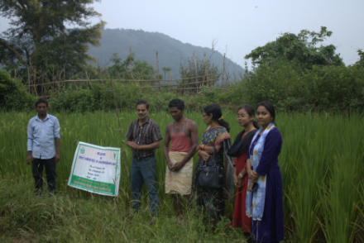  Assessment of medium duration rice varieties under rainfed condition | 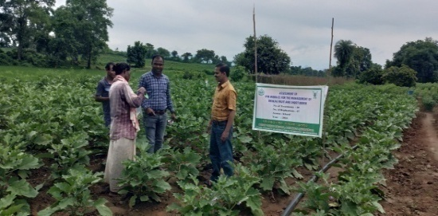  Assessment of IPM Modules for the management of Brinjal fruit and shoot borer
Field day on Weed management in finger millet | 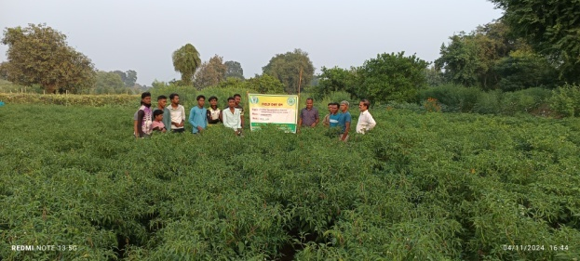  Field day on Integrated Pest Management of thrips and mite in chilli
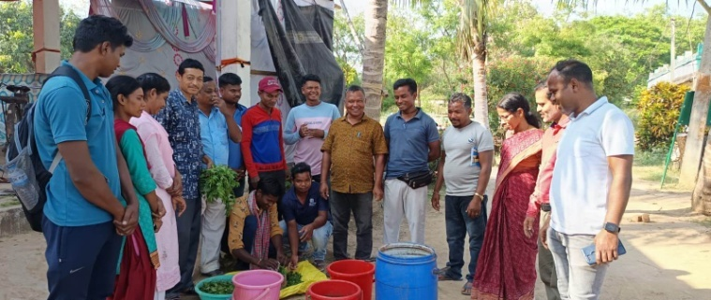  Preparation of Jivamrita and Bijamrita | Training to CRPF personnel on Scientific beekeeping
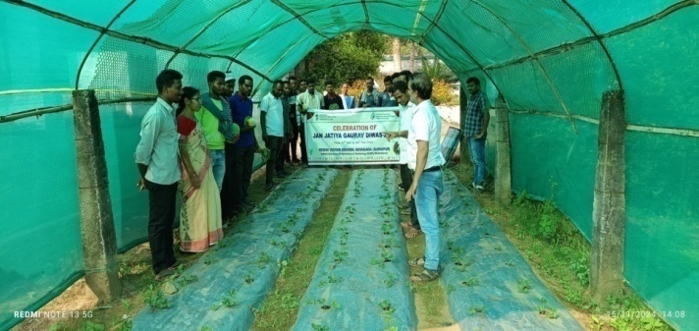  Strawberry Demo unit | 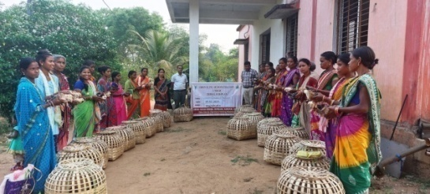  Demonstration on brooding management in chicks
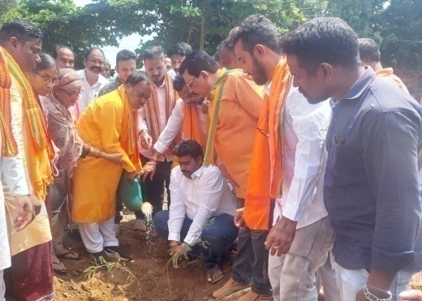  Plantation programme under 'Ek Ped Maa Ke Naam' by Sj. Maheswar Sahu, BJP leader & President Krushak Morcha | 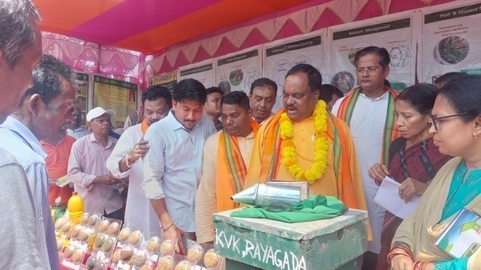  Exhibition stall during Kisan Mela
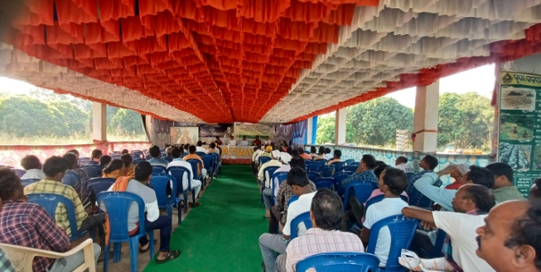  Live Webcast of 19th Installment Release of the PM-KISAN scheme (Kisan Sammaan Samaroh) | 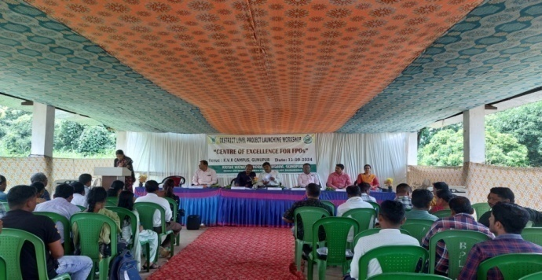  District level Project Launching Workshop- cum- FPO Conclave

***

